Weekly Market Report (November 09, 2012 – November 15, 2012)

MCX – COMDEX

Open: 3675.85 High: 3760.12 Low: 3675.81 Close: 3721.92 Previous close: 3676.10

MCX Comdex was up by 1.25% to 3721.92, MCX Energy was up by 1.33% to 3324.81 and MCX Metal was up by 0.96% to 5229.78.

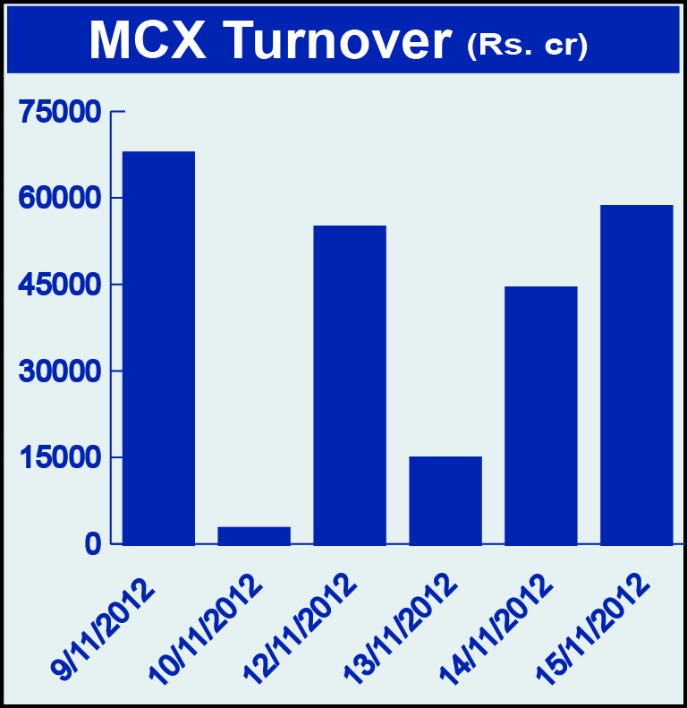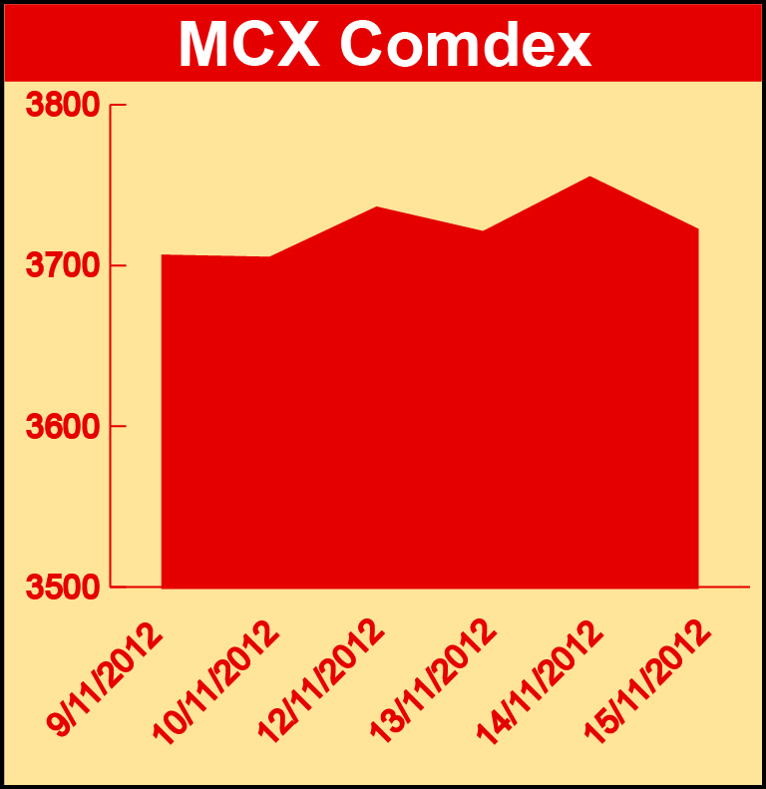

Bullion:
Gold December 12 contract was up by 0.37% to Rs 31456.00 per 10 grams, GoldM January 13 contract was up by 0.44% to Rs 31691.00 per 10 grams, Goldguinea November 12 contract was up by 0.59% to Rs 25174.00 per 8 grams, GoldPetal January 13 contract was up by 0.72% to Rs 3207.00 per grm and GoldPetalDel December 12 contract was up by 3.51% to Rs 3277.00 per grm. Silver December 12 contract was up by 1.72% to Rs 60910.00 per kg, SilverM November 12 contract was up by 1.68% to Rs 60912.00 per kg, SilverMIC November 12 contract was up by 1.69% to Rs 60914.00 per kg and Silver1000 January 13 contract was up by 2.95% to Rs 61523.00 per kg.

Metals
Copper November 12 contract was up by 0.90% to Rs 420.60 per kg, copperm November 12 contract was up by 0.90% to Rs 420.60 per kg, aluminium November 12 contract was up by 3.07% to Rs 107.50 per kg, alumini November 12 contract was up 3.07% to Rs 107.50 per kg, zinc November 12 contract was up by 2.26% to Rs 106.20 per kg, zinc mini November 12 contract was up by 2.31% to Rs 106.20 per kg while lead December 12 contract was down by 0.25% to Rs 120.65 per kg, lead mini January 13 contract was down by 0.37% to Rs 120.25 per kg, nickel November 12 contract was down by 0.22% to Rs 876.90 per kg and nickelm November 12 contract was down by 0.20% to Rs 877.10 per kg.

Energy
Crude oil January 13 contract was up by 0.89% to Rs 4785.00 per barrel, Natural gas November 12 contract was up by 5.62% to Rs 206.70 per MMBTU and Brcrude oil January 13 contract was up by 3.58% to Rs 5987.00 per barrel.

AGRICULTURE:
CPO December 12 contract was up by 2.37% to Rs 440.90 per 10 kgs, cardamom November 12 contract was up by 8.56% to Rs 861.20 per kg, menthaoil November 12 contract was up by 2.60% to Rs 1203.90 per kg, cotton December 12 contract was up by 0.31% to Rs 16250.00 per bales while steelRPR December 12 contract was down by 0.62% to Rs 30690.00 per MT and kapaskhali December 12 contract was down by 1.55% to Rs 1463.50 per 100 kgs.

For further information please contact:

 | Alok Gupta  AVP, Corporate Communication, MCX  Phone No.: +91 22 6731 8888  Mobile No.: +91 9930267906  Email: alok.gupta@mcxindia.com

