Weekly Market Report (November 04, 2011 – November 10, 2011)

MCX – COMDEX

Open: 3658.16 High: 3747.37 Low: 3642.04 Close: 3738.24 Previous close: 3657.60

MCX Comdex was up by 2.20% to 3738.24, MCX Metal was up by 0.63% to 4817.57 and MCX Energy was up by 5.98% to 3412.57.

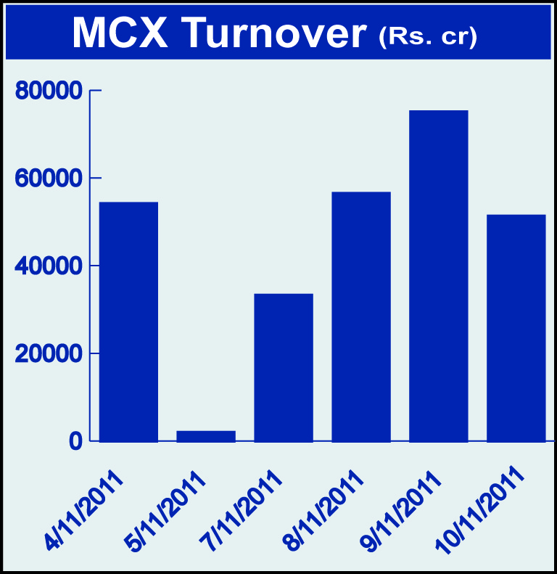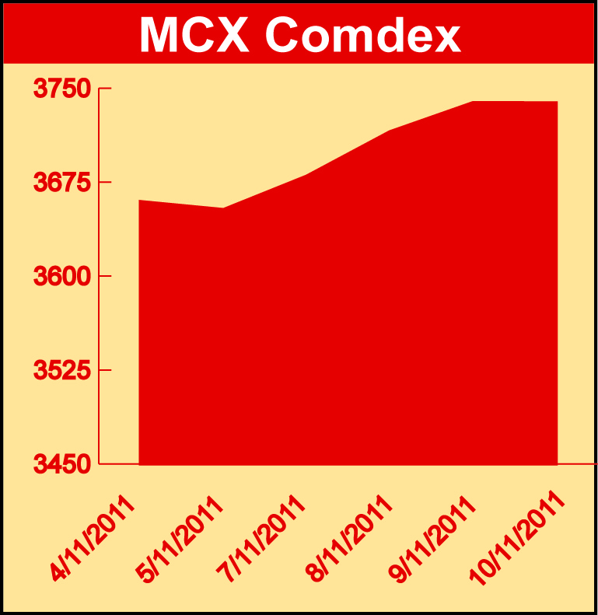

Bullion:
Gold December 11 contract was up by 2.54% to Rs 28700.00 per 10 grams, GoldM December 11 contract was up 2.54% to Rs 28703.00 per 10 grams, Goldguinea November 11 contract was up by 2.61% to Rs 22957.00 per 8 grams and GoldPetal November 11 contract was up by 2.48% to Rs 2891.00 per grm. Silver December 11 contract was up by 0.69% to Rs 57118.00 per kg, SilverM November 11 contract was up by 0.66% to Rs 57117.00 per kg and SilverMIC November 11 contract was up by 0.68% to Rs 57134.00 per kg.

Metals
Aluminium December 11 contract was up by 2.16% to Rs 108.65 per kg, alumini November 11 contract was up 2.08% to Rs 107.80 per kg and nickel November 11 contract was up by 0.72% to Rs 922.00 per kg while lead November 11 contract was down by 2.00% to Rs 98.25 per kg, lead mini November 11 contract was down by 2.00% to Rs 98.25 per kg, zinc December 11 contract was down by 0.46% to Rs 96.90 per kg, zinc mini November 11 contract was down by 0.42% to Rs 9695.95 per kg and copper November 11 contract was down by 2.84% to Rs 378.40 per kg.

Energy
Crude oil November 11 contract was up by 7.16% to Rs 4939.00 per barrel while natural gas December 11 contract was down by 0.46% to Rs 193.00 per MMBTU.

AGRICULTURE:
Sugar December 11 contract was up by 2.76% to Rs 2870.00 per 100 kgs, potatoTRWR November 11 contract was up by 1.37% to Rs 341.40 per 100 kgs CPO January 12 contract was up by 2.40% to Rs 491.60 per 10 kgs while menthaoil November 11 contract was down by 2.16% to Rs 1316.50 per kg, cotton January 12 contract was down by 3.31% to Rs 17510.00 per bales and cardamom January 12 contract was down by 7.37% to Rs 691.30 per kg.

For further information please contact:

 | Alok Gupta  Sr. Manager, Corporate Communication, MCX  Phone No.: +91 22 6731 8888  Mobile No.: +91 9930267906  Email: alok.gupta@mcxindia.com

Disclaimer:
Multi Commodity Exchange of India Limited is proposing, subject to market conditions and other considerations, a public offer of equity shares by way of an offer for sale and has filed a Draft Red Herring Prospectus ("DRHP") with the SEBI. The DRHP is available on the websites of SEBI at www.sebi.gov.in and the book running lead managers at www.edelcap.com, http://www.online.citibank.co.in/rhtm/citigroupglobalscreen1.htm and www.morganstanley.com/indiaofferdocuments. Investors should note that investment in equity shares involves a high degree of risk and for details in relation to risk factors, please see the section titled "Risk Factors" in the DRHP.

This advertisement may not be published or distributed in the U.S., Canada or Japan and is not an offer or solicitation of an offer for sale of securities in the U.S. These securities have not been and will not be registered under the U.S. Securities Act of 1933, as amended, and may not be offered or sold in the U.S. absent registration or an exemption from registration under such act.

