Weekly Market Report (March 18, 2011 – March 24, 2011)

MCX – COMDEX

Open: 3476.23 High: 3563.25 Low: 3473.02 Close: 3526.64 Previous close: 3474.58

MCX Comdex was up by 1.50% to 3526.64, MCX Energy was up by 1.77% to 3299.35 and MCX Metal was up by 2.46% to 4504.59.

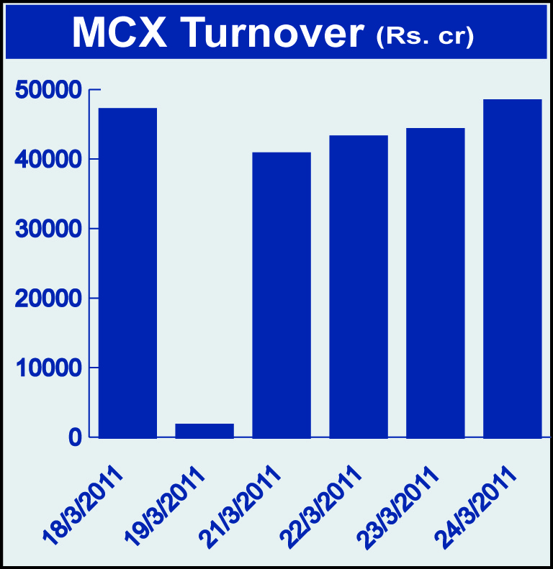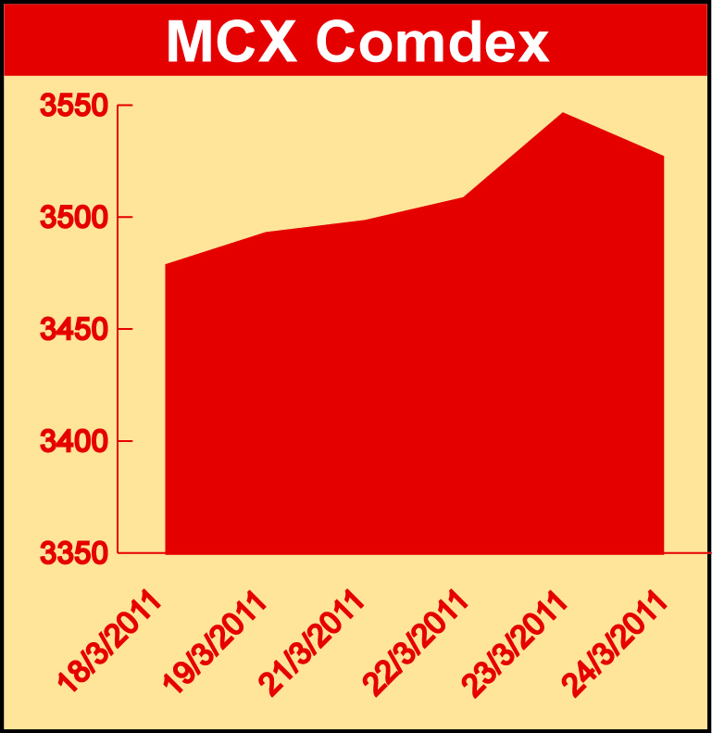

Bullion:
Gold April 11 contract was up by 0.60% to Rs 20846 per 10 grams, goldM May 11 contract was up 0.70% to Rs 21055 per 10 grams and goldguinea April 11 contract was up by 0.82% to Rs 16809 per 8 grams. Silver May 11 contract was up by 6.64% to Rs 55467 per kg, silverM April 11 contract was up by 6.67% to Rs 55485 per kg and silverMIC April 11 contract was up by 6.65% to Rs 55482 per kg.

Metals
Lead May 11 contract was up by 1.25% to Rs 121.70 per kg, lead mini May 11 contract was up by 1.08% to Rs 121.55 per kg, copper April 11 contract was up by 0.42% to Rs 438.15 per kg, zinc May 11 contract was up by 2.33% to Rs 110.00 per kg, zinc mini March 11 contract was up by 2.19% to Rs 107.35 per kg, aluminium May 11 contract was up by 4.36% to Rs 118.50 per kg, nickel May 11 contract was up by 3.35% to Rs 1229.50 per kg, alumini April 11 contract was up by 2.75% to Rs 117.50 per kg while ironore April 11 contract was down by 5.86% to Rs 6263.00 per DMT.

Energy
Natural gas May 11 contract was up by 2.24% to Rs 200.70 per MMBTU and crude oil May 11 contract was up by 1.51% to Rs 4781.00 per barrel.

AGRICULTURE:
Kapas April 11 contract was up by 1.12% to Rs 1180.40 per 20 kgs while cardamom April 11 contract was down by 0.98% to Rs 1114.10 per kg, potato May 11 contract was down by 0.53% to Rs 602.40 per 100 kgs, refsoyoil April 11 contract was down by 1.87% to Rs 598.75 per 10 kgs, CPO May 11 contract was down by 2.24% to Rs 511.20 per 10 kgs, potatoTRWR April 11 contract was down by 11.08% to Rs 426.20 per 100 kgs, menthaoil May 11 contract was down by 1.27% to Rs 954.90 per kg, guarseed April 11 contract was down by 1.67% to Rs 2762.00 per 100 kgs and sugar May 11 contract was down by 0.90% to Rs 2847.00 per 100 kgs.

For further information please contact:

 | Alok Gupta  Sr. Manager, Corporate Communication, MCX  Phone No.: +91 22 61511600  Mobile No.: +91 9930267906  Email: alok.gupta@mcxindia.com

