Weekly Market Report (April 20, 2012 – April 26, 2012)

MCX – COMDEX

Open: 3923.67 High: 3986.65 Low: 3916.06 Close: 3985.08 Previous close: 3924.10

MCX Comdex was up by 1.55% to 3985.08, MCX Energy was up by 4.07% to 3590.41 and MCX Metal was up by 2.26% to 5040.56.

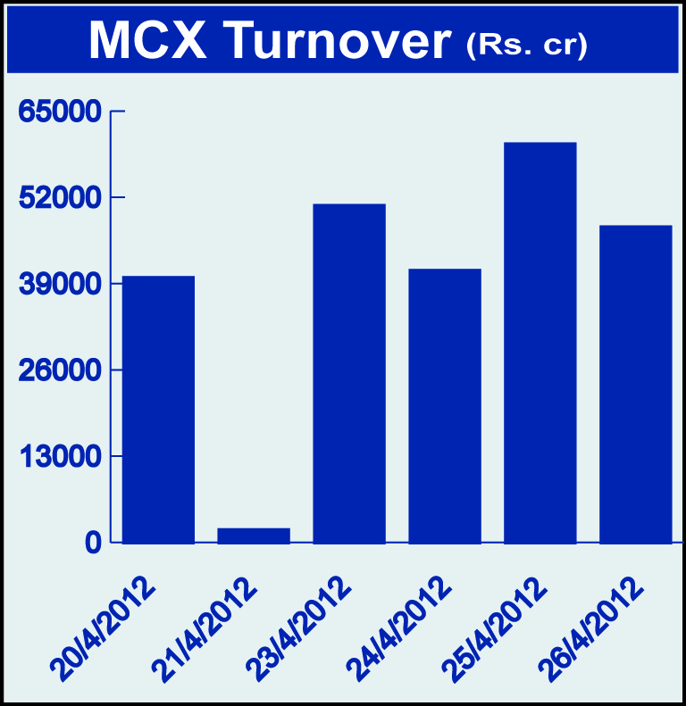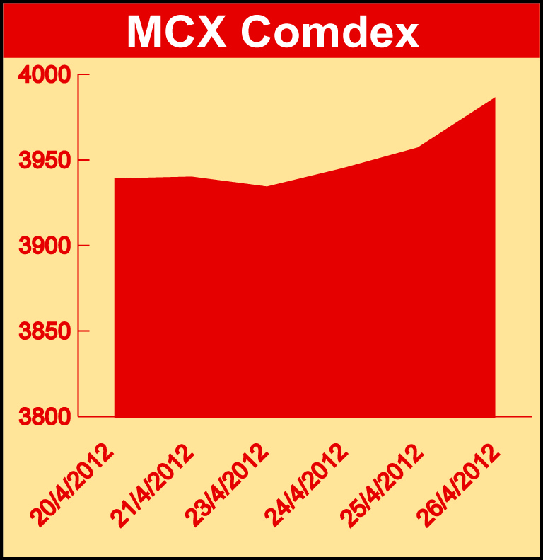

Bullion:
Gold June 12 contract was up by 1.34% to Rs 29030.00 per 10 grams, goldM May 12 contract was up by 1.62% to Rs 28904.00 per 10 grams, goldguinea April 12 contract was up 1.43% to Rs 23276.00 per 8 grams, GoldPetal April 12 contract was up by 1.17% to Rs 2854.00 per grm, GoldPetalDel April 12 contract was up by 3.43% to Rs 3044.00 per grm. Silver May 12 contract was down by 1.15% to Rs 55924.00 per kg, SilverM June 12 contract was down by 1.24% to Rs 57508.00 per kg and SilverMIC June 12 contract was down by 1.25% to Rs 57513.00 per kg.

Metals
Lead mini April 12 contract was up by 2.59% to Rs 110.70 per kg, lead April 12 contract was up by 2.64% to Rs 110.70 per kg, zinc April 12 contract was up by 2.02% to Rs 106.00 per kg, zinc mini April 12 contract was up by 2.02% to Rs 106.00 per kg, nickelm April 12 contract was up by 3.41% to Rs 952.90 per kg, nickel April 12 contract was up by 3.40% to Rs 952.90 per kg, copper April 12 contract was up by 4.29% to Rs 436.20 per kg, copperm April 12 contract was up by 4.28% to Rs 436.15 per kg, alumini May 12 contract was up 1.11% to Rs 109.20 per kg and aluminium June 12 contract was up by 1.15% to Rs 110.40 per kg.

Energy
Crude oil May 12 contract was up by 2.00% to Rs 5504.00 per barrel, natural gas May 12 contract was up by 10.08% to Rs 116.80 per MMBTU and BRcrudeoil May 12 contract was up by 1.78% to Rs 6305.00 per barrel.

Agriculture:
CPO June 12 contract was up by 1.53% to Rs 632.40 per 10 kgs, cotton June 12 contract was up by 3.14% to Rs 17730.00 per bales while potato June 12 contract was down by 6.21% to Rs 1121.50 per 100 kgs, cardamom June 12 contract was down by 6.26% to Rs 1190.70 per kg, potatoTRWR June 12 contract was down by 2.26% to Rs 946.00 per 100 kgs, menthaoil April 12 contract was down by 21.72% to Rs 1693.00 per kg and kapas April 12 contract was down by 2.07% to Rs 742.80 per 20 kgs.

For further information please contact:

 | Alok Gupta  AVP, Corporate Communication,  Phone No.: +91 22 6731 8888  Mobile No.: +91 9930267906  Email: alok.gupta@mcxindia.com

