Warsaw, 12 July 2012

400 Companies Listed on NewConnect

Press Release

- Elemental Holding, newly listed on the WSE’s alternative stock market, is the 400th issuer listed on NewConnect and the 421st new listing on NewConnect.

- In Q2 2012, 28 companies chose the WSE’s alternative trading platform to raise growth capital, 7 more than in Q1 2012.

Elemental Holding SA, a company which specialises in management of entities in the sector of recycling and trade in recyclable materials, is a company listed on NewConnect from today. It is the 400th issuer listed on the alternative stock market and the 52nd debut this year. The number of new listings on NewConnect crossed 400 already in May 2012 but due to market events, mainly including migrations to the WSE’s Main Market (17 companies), the number of listed companies reached that mark today.

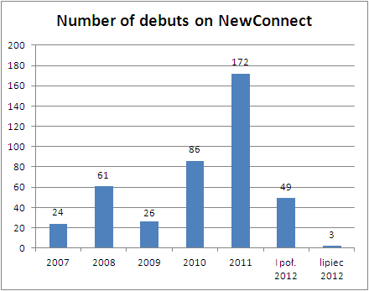
Source: WSE

According to the latest quarterly PwC IPO Watch Europe report, the Warsaw Stock Exchange with 33 IPOs in Q2 2012 once again ranked first in Europe by the number of IPOs. 28 IPOs took place on NewConnect, 7 more than in Q1 2012.

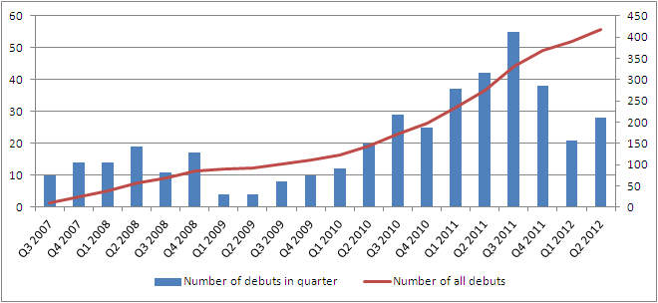
Source: WSE

Less than five years after NewConnect opened, the alternative stock market now lists 400 companies, including 393 Polish companies (most of which are registered in the Mazovian, Lower Silesian, and Silesian Region) and 7 foreign companies.

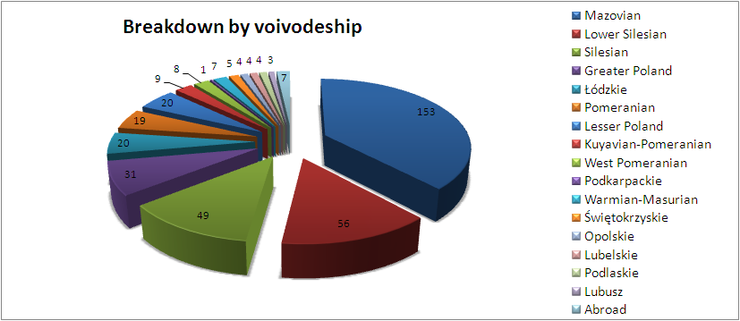
Source: WSE

The biggest number of companies listed on NewConnect operate in the sector of trade (64 companies), other services (51 companies) and media (35 companies). There are also many companies from the sectors of IT, financial services, technologies, and construction.

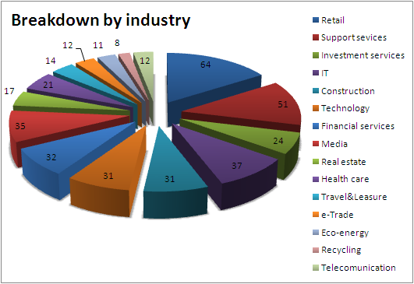
Source: WSE

In addition to the 400 listed companies, the alternative stock market has 91 Authorised Advisers, 35 market members, and over 50 data vendors and distributors of reports of companies listed on the alternative stock market.

# # #
Warsaw Stock Exchange
The Warsaw Stock Exchange is the biggest securities exchange in Central and Eastern Europe. The WSE organises trading on one of the most dynamically growing capital markets in Europe. The WSE operates a regulated market of shares and derivative instruments and the alternative stock market NewConnect for growing companies. The WSE is developing Catalyst, a market for issuers of corporate and municipal bonds, as well as an energy market. Since 9 November 2010, the WSE is a public company listed on the Warsaw Stock Exchange. For more information visit http://www.gpw.pl

