Weekly Market Report (September 28, 2012 – October 04, 2012)

MCX – COMDEX

Open: 3823.92 High: 3828.84 Low: 3675.64 Close: 3698.16 Previous close: 3824.39

MCX Comdex was down by 3.30% to 3698.16, MCX Metal was down by 1.88% to 5278.39 and MCX Energy was down by 2.80% to 3300.95.

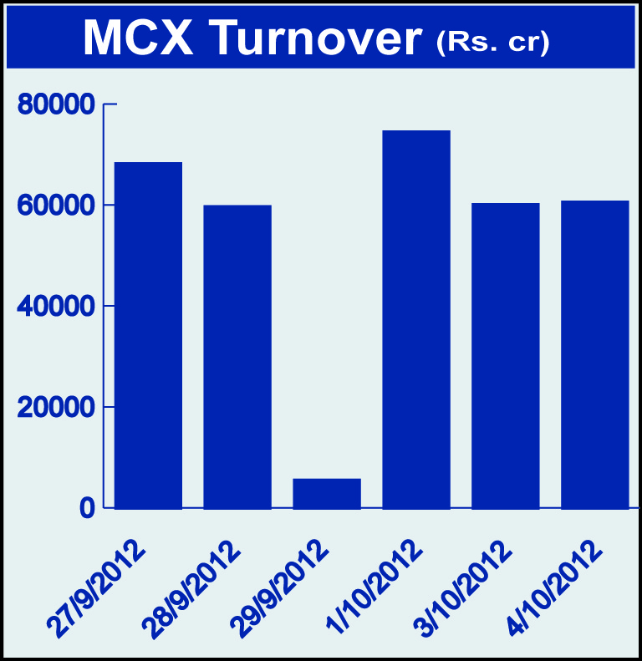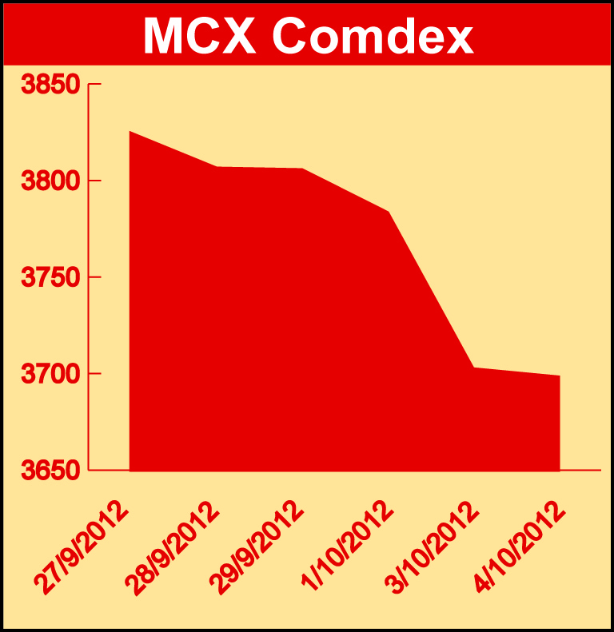

Bullion:
Gold October 12 contract was down by 2.00% to Rs 30722.00 per 10 grams, GoldM October 12 contract was down by 2.03% to Rs 30733.00 per 10 grams, Goldguinea November 12 contract was down 1.30% to Rs 25064.00 per 8 grams GoldPetal October 12 contract was down by 1.31% to Rs 3140.00 per grm and GoldPetalDel November 12 contract was down 4.02% to Rs 3220.00 per grm. Silver December 12 contract was down by 1.51% to Rs 62105.00 per kg, SilverM November 12 contract was down by 1.50% to Rs 62129.00 per kg, SilverMIC November 12 contract was down by 1.51% to Rs 62131.00 per kg and Silver1000 November 12 contract was down by 1.56% to Rs 62168.00 per kg.

Metals
Nickel November 12 contract was down by 1.25% to Rs 971.70 per kg, nickelm October 12 contract was down 1.21% to Rs 965.60 per kg, lead October 12 contract was down by 2.57% to Rs 117.55 per kg, lead mini October 12 contract was down by 2.57% to Rs 117.55 per kg, zinc October 12 contract was down 3.81% to Rs 106.15 per kg, zinc mini October 12 contract was down by 3.76% to Rs 106.20 per kg, copperm November 12 contract was down by 1.55% to Rs 433.25 per kg, copper November 12 contract was down by 1.56% to Rs 433.20 per kg, aluminium October 12 contract was down by 2.52% to Rs 108.50 per kg and alumini October 12 contract was down by 2.47% to Rs 108.50 per kg.

Energy
Natural gas October 12 contract was up by 1.32% to Rs 177.20 per MMBTU while BrCrude oil November 12 contract was down by 3.83% to Rs 5672.00 per barrel and crude oil October 12 contract was down by 3.38% to Rs 4721.00 per barrel.

AGRICULTURE:
Kapaskhali December 12 contract was up by 0.70% to Rs 1374.00 per 100 kgs while menthaoil October 12 contract was down by 3.37% to Rs 1184.40 per kg, cardamom December 12 contract was down by 10.64% to Rs 976.10 per kg, potatoTRWR October 12 contract was down by 4.92% to Rs 884.10 per 100 kgs, CPO October 12 contract was down by 13.26% to Rs 395.20 per 10 kgs, cotton October 12 contract was down by 2.53% to Rs 15810.00 per bales and potato October 12 contract was down by 11.68% to Rs 871.40 per 100 kgs.

For further information please contact:

 | Alok Gupta  AVP, Corporate Communication,  Phone No.: +91 22 6731 8888  Mobile No.: +91 9930267906  Email: alok.gupta@mcxindia.com

