Weekly Market Report (August 24, 2012 – August 30, 2012)

MCX – COMDEX

Open: 3862.42 High: 3941.64 Low: 3858.99 Close: 3887.69 Previous close: 3872.19

MCX Comdex was up by 0.40% to 3887.69, MCX Metal was up by 1.01% to 5127.48 and MCX Energy was down by 0.16% to 3575.68.

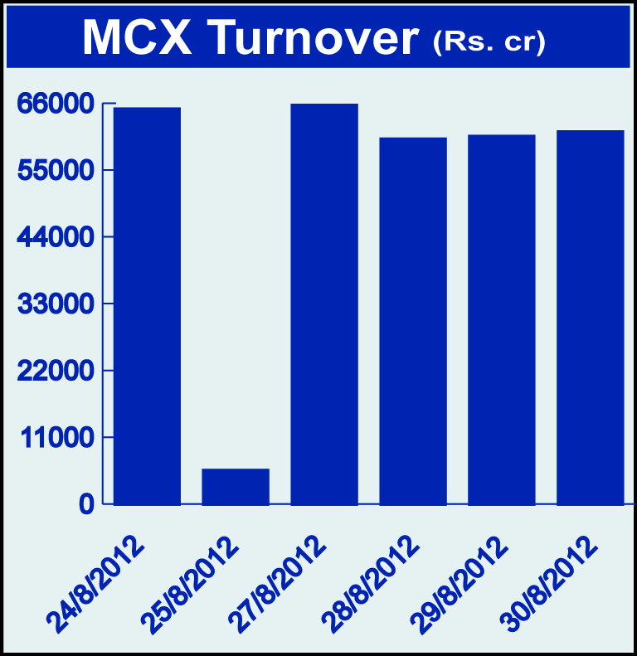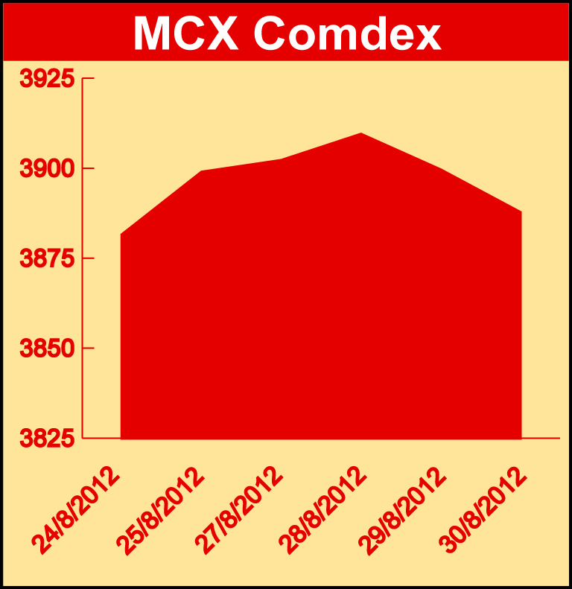

Bullion:
Gold October 12 contract was up by 0.11% to Rs 30837.00 per 10 grams, GoldM October 12 contract was up by 0.12% to Rs 308484.00 per 10 grams, Goldguinea August 12 contract was up by 0.69% to Rs 24822.00 per 8 grams GoldPetal August 12 contract was up by 0.68% to Rs 3097.00 per grm and GoldPetalDel August 12 contract was up 2.04% to Rs 3259.00 per grm. Silver September 12 contract was up by 0.31% to Rs 56953.00 per kg, SilverM August 12 contract was up by 0.31% to Rs 56953.00 per kg and SilverMIC August 12 contract was up by 0.31% to Rs 56950.00 per kg.

Metals
Aluminium August 12 contract was up by 0.15% to Rs 103.50 per kg, alumini August 12 contract was up by 0.15% to Rs 103.50 per kg, lead August 12 contract was up by 1.59% to Rs 108.55 per kg, lead mini August 12 contract was up by 1.59% to Rs 108.55 per kg while zinc October 12 contract was down 0.15% to Rs 101.20 per kg, zinc mini October 12 contract was down by 0.15% to Rs 101.20 per kg, copper August 12 contract was down by 0.07% to Rs 423.15 per kg, copperm August 12 contract was down by 0.07% to Rs 423.15 per kg, nickel September 12 contract was down by 0.90% to Rs 901.00 per kg and nickelm September 12 contract was down 0.89% to Rs 901.20 per kg.

Energy
BrCrude oil October 12 contract was down by 1.24% to Rs 6305.00 per barrel, natural gas October 12 contract was down by 1.56% to Rs 164.00 per MMBTU and crude oil October 12 contract was down by 0.78% to Rs 5310.00 per barrel.

AGRICULTURE:
Cardamom October 12 contract was up by 2.17% to Rs 1104.90 per kg, menthaoil August 12 contract was up by 2.17% to Rs 1345.60 per kg, maize September 12 contract was up by 5.27% to Rs 1527.50 per 100 kgs while CPO August 12 contract was down by 2.11% to Rs 552.30 per 10 kgs, cotton August 12 contract was down by 1.50% to Rs 17700.00 per bales, potato October 12 contract was down by 4.32% to Rs 1208.00 per 100 kgs and potatoTRWR September 12 contract was down by 5.28% to Rs 926.10 per 100 kgs.

For further information please contact:

 | Alok Gupta  AVP, Corporate Communication,  Phone No.: +91 22 6731 8888  Mobile No.: +91 9930267906  Email: alok.gupta@mcxindia.com

