Weekly Market Report (October 04, 2013 – October 10, 2013)

MCX – COMDEX

Open: 4061.58 High: 4103.95 Low: 3989.69
Close: 4021.98 Previous close: 4061.58

MCX Comdex was down by 0.97% to 4021.98, MCX Metal was down by 1.42% to 4862.74 and MCX Energy was down by 1.00% to 4388.69.

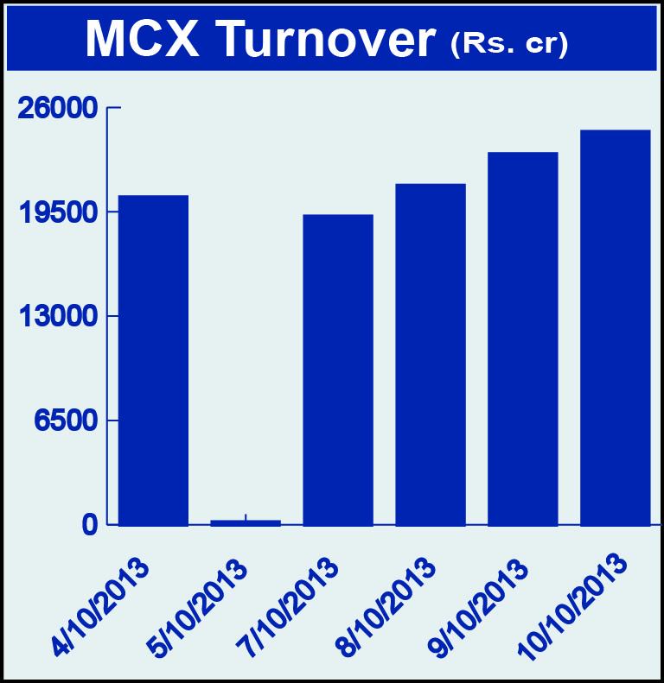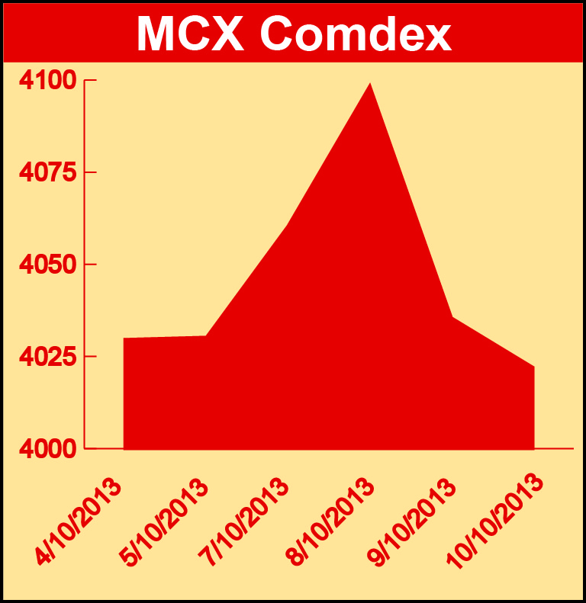

Bullion:
Gold December 13 contract was down by 2.09% to Rs 28857.00.00 per 10 grams, GoldM December 13 contract was down by 2.12% to Rs 29319.00.00 per 10 grams, Goldguinea November 13 contract was down by 1.76% to Rs 23624.00 per 8 grams, GoldPetal October 13 contract was down by 1.83% to Rs 2954.00 per grm and GoldPetalDel December 13 contract was down by 1.50% to Rs 3013.00 per grm. Silver December 13 contract was down 0.80% to Rs 48264.00 per kg, SilverM November 13 contract was down by 0.79% to Rs 48300.00 per kg, SilverMIC November 13 contract was down by 0.78% to Rs 48308.00 per kg and Silver1000 November 13 contract was up by 12.02% to Rs 54688.00 per kg.

Metals:
Aluminium October 13 contract was up by 1.25% to Rs 113.35 per kg, alumini November 13 contract was up 1.28% to Rs 114.90 per kg, nickel December 13 contract was up by 0.71% to Rs 867.20 per kg while nickelm December 13 contract was down by 0.31% to Rs 864.50 per kg, copper November 13 contract was down by 2.39% to Rs 443.55 per kg, copperm November 13 contract was down by 2.39% to Rs 443.6 per kg, lead October 13 contract was down by 0.71% to Rs 126.55 per kg, lead mini October 13 contract was down by 0.71% to Rs 126.55 per kg, zinc October 13 contract was down by 0.39% to Rs 114.85 per kg and zinc mini December 13 contract was down by 0.72% to Rs 117.00 per kg.

Energy:
Natural gas October 13 contract was up by 4.87% to Rs 230.50 per MMBTU while Crude oil October 13 contract was down by 1.80% to Rs 6337.00 per barrel.

Agriculture:
Kapaskhali November 13 contract was up by 3.05% to Rs 1657.00 per 100 kgs, CPO December 13 contract was up by 3.04% to Rs 519.20 per 10 kgs, guarseed December 13 contract was up by 5.55% to Rs 5253.00 per 100 kgs, guargum October 13 contract was up by 0.385 to Rs 15518.00 per 100 kgs while cardamom October 13 contract was down by 1.90% to Rs 692.50 per kg, menthaoil November 13 contract was down by 3.20% to Rs 854.90 per kg and cotton November 13 contract was down by 1.85% to Rs 20160.00 per bale.

For further information please contact:

 | Alok Gupta  AVP, Corporate Communication, MCX  Phone No.: +91 22 6731 8888  Mobile No.: +91 9930267906  Email: alok.gupta@mcxindia.com

