Weekly Market Report (May 03, 2013 – May 09, 2013)

MCX – COMDEX

Open: 3467.07 High: 3568.87 Low: 3467.07 Close: 3566.25 Previous close: 3466.27

MCX Comdex was up by 2.88% to 3566.25, MCX Metal was up by 2.96% to 4509.58 and MCX Energy was up by 3.62% to 3665.76.

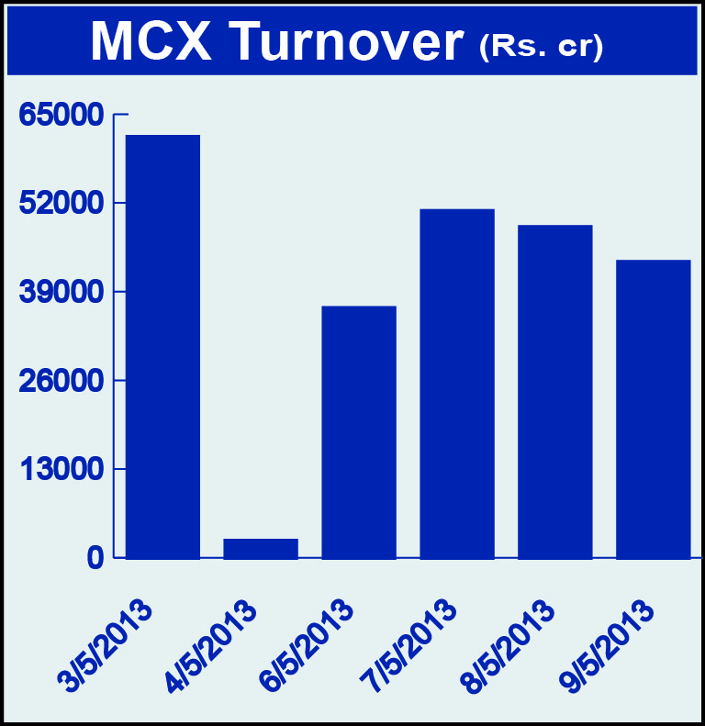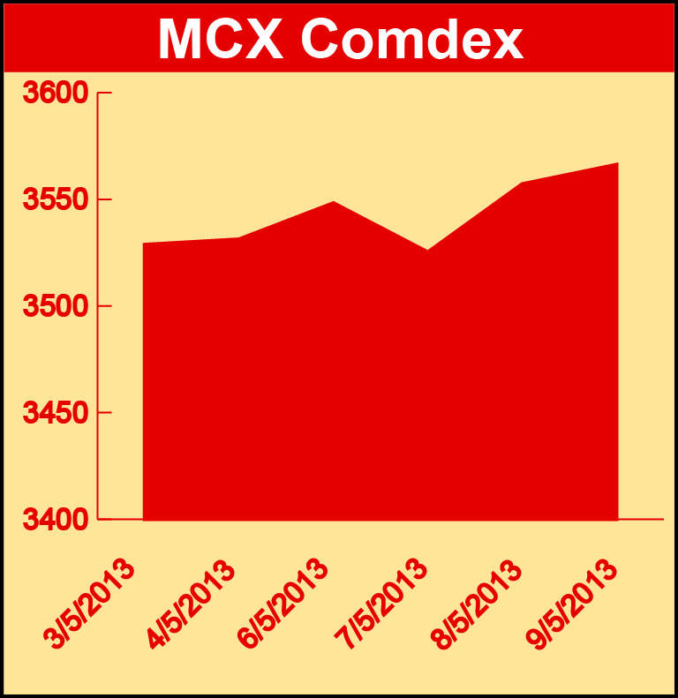

Bullion:
Gold June 13 contract was up by 0.94% to Rs 27166.00 per 10 grams, GoldM June 13 contract was up by 0.93% to Rs 27169.00 per 10 grams, Goldguinea July 13 contract was up by 0.97% to Rs 21936.00 per 8 grams, GoldPetal July 13 contract was up by 0.92% to Rs 2742.00 per grm and GoldPetalDel July 13 contract was up by 2.43% to Rs 2779.00 per grm. Silver July 13 contract was up by 1.19% to Rs 45165.00 per kg, SilverM June 13 contract was up by 1.15% to Rs 45182.00 per kg, SilverMIC June 13 contract was up by 2.84% to Rs 45545.00 per kg and Silver1000 June 13 contract was up by 2.84% to Rs 45545.00 per kg.

Metals
SteelRPR July 13 contract was up by 0.29% to Rs 28060.00 per MT, aluminium May 13 contract was up by 5.04% to Rs 102.20 per kg, alumini May 13 contract was up 5.04% to Rs 102.20 per kg, lead July 13 contract was up by 4.96% to Rs 111.20 per kg, lead mini May 13 contract was up by 4.58% to Rs 109.60 per kg, zinc July 13 contract was up by 3.35% to Rs 103.25 per kg, zinc mini May 13 contract was up by 3.27% to Rs 101.10 per kg, nickel May 13 contract was up by 5.08% to Rs 835.30 per kg, nickelm May 13 contract was up by 5.04% to Rs 835.10 per kg, copper June 13 contract was up by 8.18% to Rs 402.60 per kg and copperm June 13 contract was up by 8.20% to Rs 402.60 per kg.

Energy
Brcrude oil June 13 contract was up by 2.98% to Rs 5671.00 per barrel, Crude oil May 13 contract was up by 4.19% to Rs 5227.00 per barrel while Natural gas July 13 contract was down by 0.76% to Rs 222.10 per MMBTU.

AGRICULTURE:
Cardamom July 13 contract was up by 1.05% to Rs 802.10 per kg, cotton June 13 contract was up by 0.55% to Rs 18210.00 per bales, potato May 13 contract was up by 3.17% to Rs 1013.90 per 100 kgs, CPO July 13 contract was up by 1.86% to Rs 460.40 per 10 kgs while menthaoil June 13 contract was down by 5.03% to Rs 867.70 per kg and kapaskhali June 13 contract was down by 0.79% to Rs 1449.00 per 100 kgs.

For further information please contact:

 | Alok Gupta  AVP, Corporate Communication, MCX  Phone No.: +91 22 6731 8888  Mobile No.: +91 9930267906  Email: alok.gupta@mcxindia.com

