Weekly Market Report (March 01, 2013 – March 07, 2013)

MCX – COMDEX

Open: 3741.13 High: 3742.03 Low: 3701.16 Close: 3709.71 Previous close: 3741.40

MCX Comdex was down by 0.85% to 3709.71, MCX Metal was down by 0.89% to 4986.95 and MCX Energy was down by 1.25% to 3486.77.

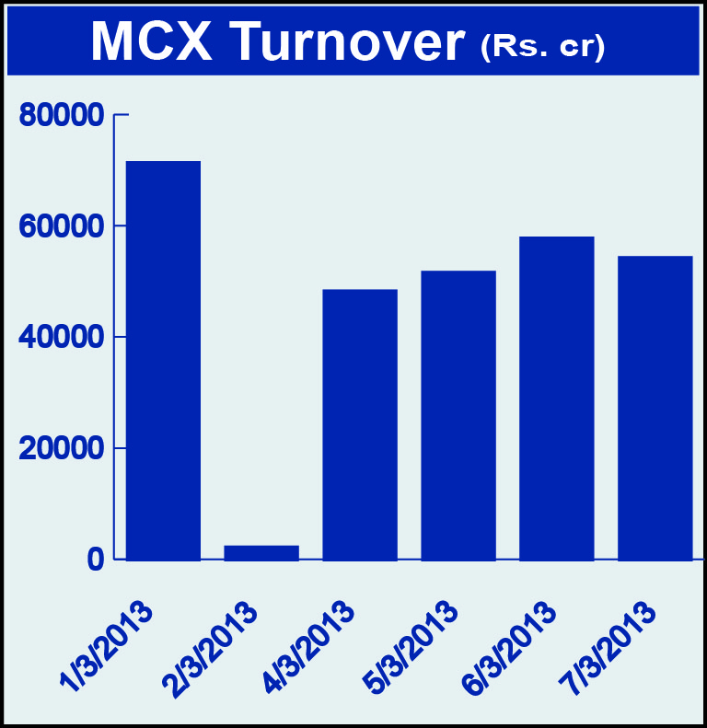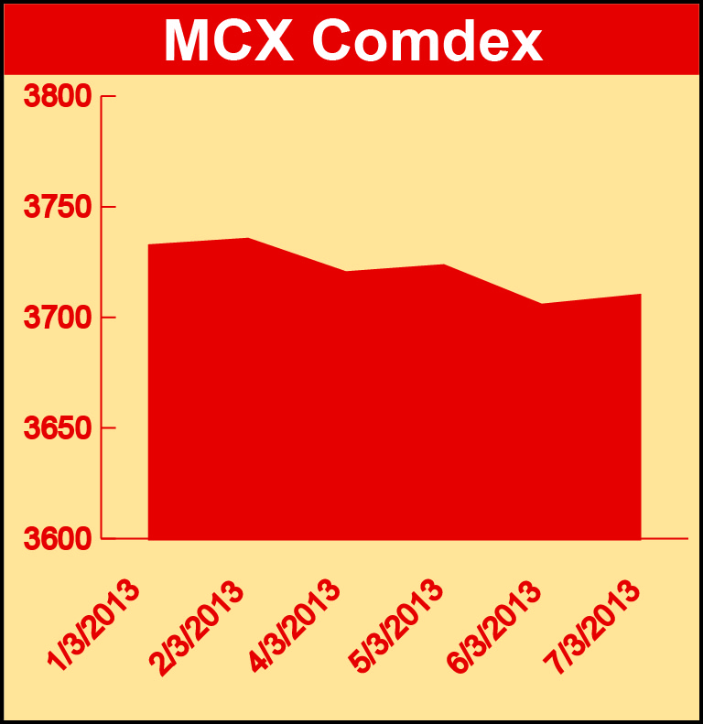g

Bullion:
Gold April 13 contract was down by 0.61% to Rs 29389.00 per 10 grams, GoldM May 13 contract was down by 0.66% to Rs 29699.00 per 10 grams, Goldguinea April 13 contract was down by 0.60% to Rs 23770.00 per 8 grams, GoldPetal March 13 contract was down by 0.54% to Rs 2937.00 per grm and GoldPetalDel May 13 contract was up by 1.07% to Rs 3030.00 per grm. Silver May 13 contract was up by 0.16% to Rs 54656.00 per kg, SilverM April 13 contract was up by 0.12% to Rs 54684.00 per kg, SilverMIC April 13 contract was up by 0.11% to Rs 54687.00 per kg and Silver1000 May 13 contract was down by 1.84% to Rs 55508.00 per kg.

Metals
Nickel May 13 contract was down 0.39% to Rs 923.00 per kg, nickelm March 13 contract was down by 0.27% to Rs 907.70 per kg, copper February 13 contract was down by 1.01% to Rs 427.20 per kg, copperm February 13 contract was down by 1.01% to Rs 427.20 per kg, lead May 13 contract was down by 3.85% to Rs 121.10 per kg, lead mini March 13 contract was down by 3.65% to Rs 120.20 per kg, aluminium March 13 contract was down by 1.84% to Rs 106.60 per kg, alumini March 13 contract was down 1.84% to Rs 106.60 per kg, zinc March 13 contract was down by 4.35% to Rs 107.80 per kg, zinc mini March 13 contract was down by 4.35% to Rs 107.80 per kg and steelRPR May 13 contract was down by 3.49% to Rs 30140.00 per MT.

Energy
Natural gas March 13 contract was up by 2.67% to Rs 196.20 per MMBTU while Crude oil March 13 contract was down by 1.89% to Rs 4980.00 per barrel and Brcrude oil March 13 contract was down by 1.92% to Rs 6032.00 per barrel.

AGRICULTURE:
CPO March 13 contract was up by 0.44% to Rs 457.50 per 10 kgs, potato March 13 contract was up by 1.03% to Rs 810.90 per 100 kgs, cotton May 13 contract was up by 0.26% to Rs 19180.00 per bales, menthaoil April 13 contract was up by 1.00% to Rs 1238.20 per kg while kapas March 13 contract was down by 4.09% to Rs 905.80 per 20 kgs, kapaskhali May 13 contract was down by 2.51% to Rs 1459.50 per 100 kg and cardamom March 13 contract was down by 7.12% to Rs 896.30 per kg.

For further information please contact:

 | Alok Gupta  AVP, Corporate Communication, MCX  Phone No.: +91 22 6731 8888  Mobile No.: +91 9930267906  Email: alok.gupta@mcxindia.com

