Weekly Market Report (January 31, 2014 – February 06, 2014)

MCX – COMDEX

Open: 3961.44 High: 3995.49 Low: 3938.83 Close: 3964.67 Previous close: 3961.44

MCX Comdex was up by 0.08% to 3964.67, MCX Metal was up by 0.65% to 4776.66 and MCX Energy was down by 0.82% to 4298.64.

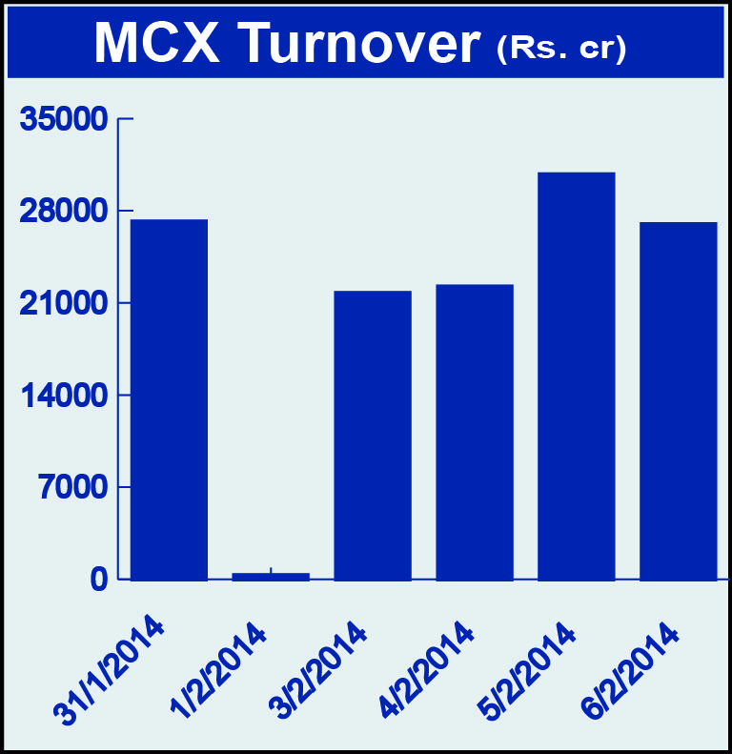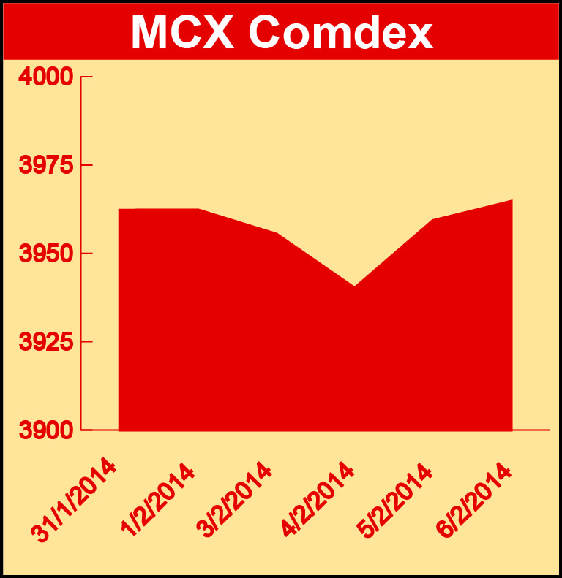

Bullion:
Gold April 14 contract was up by 0.33% to Rs 28650.00 per 10 grams, GoldM March 14 contract was up by 1.02% to Rs 29231.00 per 10 grams, Goldguinea February 14 contract was up by 0.77% to Rs 23745.00 per 8 grams, GoldPetal February 14 contract was up by 0.81% to Rs 2976.00 per grm and GoldPetalDel March 14 contract was down by 1.79% to Rs 3120.00 per grm. Silver March 14 contract was up by 2.76% to Rs 44413.00 per kg, SilverM April 14 contract was up by 2.77% to Rs 45428.00 per kg, SilverMIC February 14 contract was up by 2.75% to Rs 44448.00 per kg and Silver1000 February 14 contract was up by 2.00% to Rs 45999.00 per kg.

Metals
Nickelm February 14 contract was up by 0.25% to Rs 869.30 per kg, zinc February 14 contract was up by 0.48% to Rs 124.85 per kg, zinc mini February 14 contract was up by 0.52% to Rs 124.90 per kg while nickel April 14 contract was down by 1.07% to Rs 886.60 per kg, aluminium April 14 contract was down by 3.02% to Rs 107.75 per kg, alumini April 14 contract was down by 2.31% to Rs 107.90 per kg, lead April 14 contract was down by 2.35% to Rs 133.20 per kg, lead mini April 14 contract was down by 1.70% to Rs 132.85 per kg, copper April 14 contract was down by 0.90% to Rs 449.40 per kg and copperm April 14 contract was down by 0.92% to Rs 449.25 per kg.

Energy
Crude oil April 14 contract was down by 1.38% to Rs 6087.00 per barrel and Natural gas February 14 contract was down by 3.53% to Rs 309.00 per MMBTU.

AGRICULTURE:
Potato April 14 contract was up by 8.59% to Rs 1175.90 per 100 kgs, CPO February 14 contract was up 2.26% to Rs 544.10 per 10 kgs, cotton April 14 contract was up 1.65% to Rs 21560.00 per bales, kapas March 14 contract was up by 2.04% to Rs 957.60 per 20 kgs while cardamom February 14 contract was down by 7.85% to Rs 725.30 per kg, menthaoil February 14 contract was down by 3.78% to Rs 801.70 per kg and kapaskhali February 14 contract was down by 1.77% to Rs 1524.50 per 100 kgs.

For further information please contact:
 | Alok Gupta  AVP, Corporate Communication, MCX  Phone No.: +91 22 6731 8888  Mobile No.: +91 9930267906  Email: alok.gupta@mcxindia.com

