Weekly Market Report (September 27, 2013 – October 03, 2013)

MCX – COMDEX

Open: 4065.90 High: 4166.13 Low: 4037.88
Close: 4061.58 Previous close: 4064.78

MCX Comdex was down by 0.08% to 4061.58, MCX Metal was down by 0.38% to 4932.87 and MCX Energy was up by 0.82% to 4433.14.

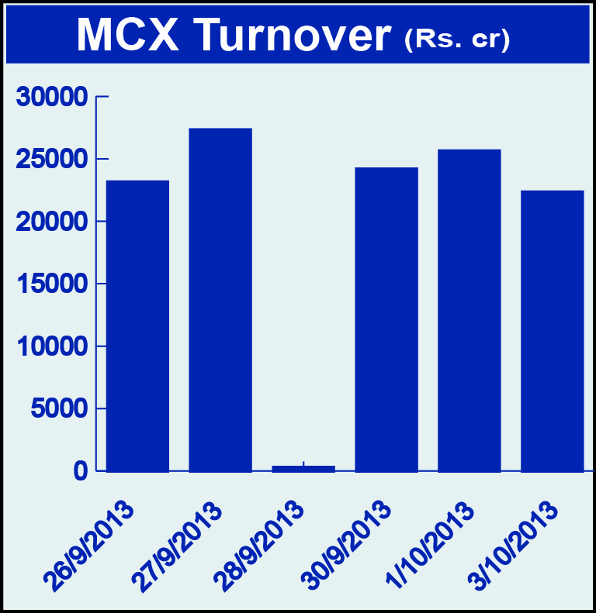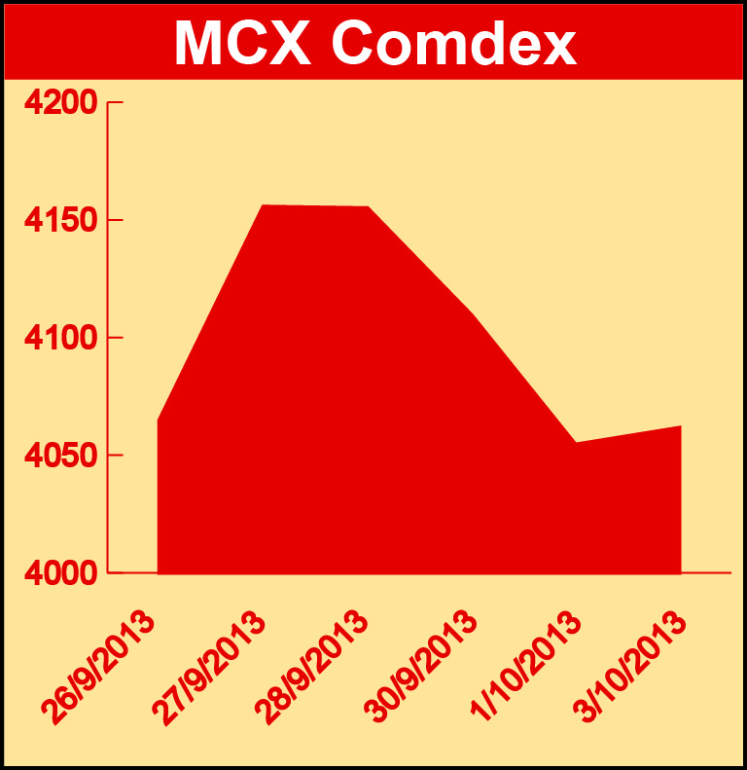

Bullion:
Gold October 13 contract was up by 1.14% to Rs 30204.00 per 10 grams, GoldM October 13 contract was up by 3.23% to Rs 31199.00 per 10 grams, Goldguinea October 13 contract was up by 1.23% to Rs 24144.00 per 8 grams, GoldPetal October 13 contract was up by 1.17% to Rs 3020.00 per grm and GoldPetalDel November 13 contract was down by 2.34% to Rs 3002.00 per grm. Silver December 13 contract was up by 0.03% to Rs 48653.00 per kg, SilverM November 13 contract was up by 0.06% to Rs 48686.00 per kg, SilverMIC November 13 contract was up by 0.07% to Rs 48690.00 per kg and Silver1000 October 13 contract was up by 4.50% to Rs 48179.00 per kg.

Metals:
Aluminium October 13 contract was up by 0.27% to Rs 111.95 per kg, alumini December 13 contract was up 0.39% to Rs 114.85 per kg while steelRPR October 13 contract was down by 0.89% to Rs 27860.00 per MT, nickel December 13 contract was down by 2.88% to Rs 861.10 per kg, nickelm December 13 contract was down by 2.39% to Rs 867.20 per kg, copper November 13 contract was down by 0.85% to Rs 454.40 per kg, copperm November 13 contract was down by 0.84% to Rs 454.45 per kg, lead October 13 contract was down by 1.77% to Rs 127.45 per kg, lead mini October 13 contract was down by 1.70% to Rs 127.45 per kg, zinc October 13 contract was down by 1.45% to Rs 115.30 per kg and zinc mini November 13 contract was down by 1.52% to Rs 116.55 per kg.

Energy:
Crude oil December 13 contract was up by 0.92% to Rs 6480.00 per barrel while Natural gas November 13 contract was down by 0.99% to Rs 231.10 per MMBTU and Brcrude oil November 13 contract was down by 0.58% to Rs 6900.00 per barrel.

Agriculture:
Cotton October 13 contract was up by 1.07% to Rs 21690.00 per bale, kapaskhali November 13 contract was up by 6.28% to Rs 1608.00 per 100 kgs, menthaoil December 13 contract was up by 0.56% to Rs 898.20 per kg while CPO December 13 contract was down by 2.85% to Rs 503.90 per 10 kgs, guarseed December 13 contract was down by 15.54% to Rs 4977.00 per 100 kgs and cardamom December 13 contract was down by 4.69% to Rs 705.90 per kg.

For further information please contact:

 | Alok Gupta  AVP, Corporate Communication, MCX  Phone No.: +91 22 6731 8888  Mobile No.: +91 9930267906  Email: alok.gupta@mcxindia.com

