Weekly Market Report (June 15, 2012 – June 21, 2012)

MCX – COMDEX

Open: 3650.01 High: 3710.23 Low: 3600.70 Close: 3604.44 Previous close: 3641.80

MCX Comdex was down 1.03% to 3604.44, MCX Metal was down by 1.26% to 4907.69 and MCX Energy was down by 2.81% to 3066.16.

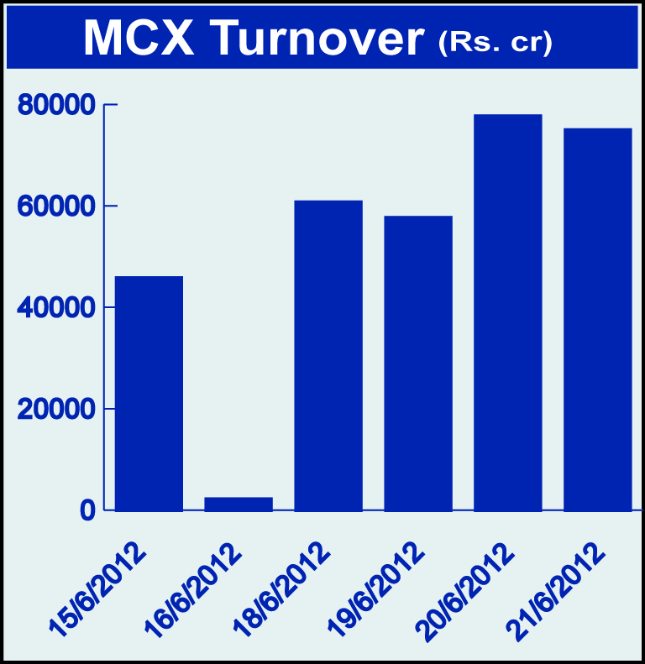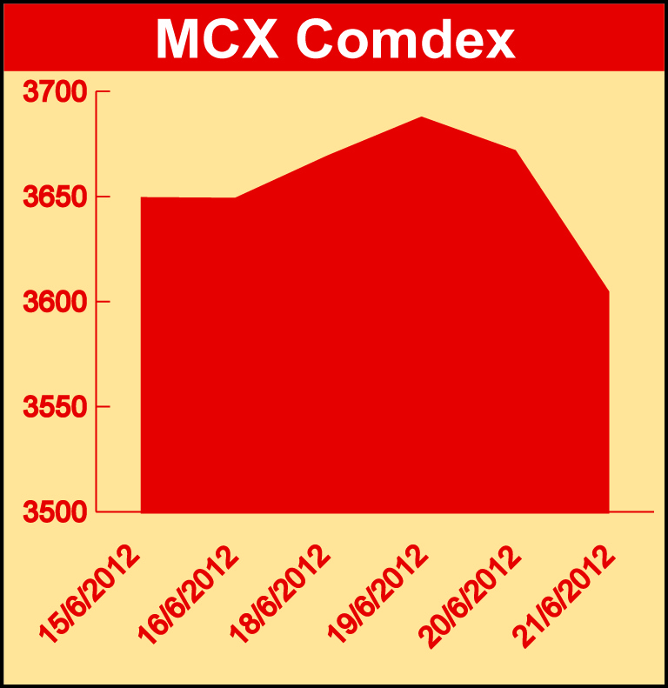

Bullion:
Gold August 12 contract was down by 0.90% to Rs 29843 per 10 grams, goldM August 12 contract was down by 0.86% to Rs 29858 per 10 grams, goldguinea August 12 contract was down by 0.62% to Rs 23975 per 8 grams GoldPetal August 12 contract was down by 0.60% to Rs 3000 per grm and GoldPetalDel August 12 contract was down by 3.33% to Rs 3016 per grm. Silver June 12 contract was down by 2.83% to Rs 52920 per kg, SilverM August 12 contract was down by 2.92% to Rs 54214 per kg and silverMIC August 12 contract was up by 2.90% to Rs 54219 per kg.

Metals
Copper June 12 contract was up by 0.45% to Rs 414.60 per kg, copperm June 12 contract was up by 0.46% to Rs 414.60 per kg, nickel August 12 contract was up by 0.44% to Rs 948.90 per kg, nickelm August 12 contract was up by 0.21% to Rs 948.40 per kg while Aluminium June 12 contract was down by 2.79% to Rs 104.70 per kg, alumini June 12 contract was down by 2.79% to Rs 104.70 per kg, lead June 12 contract was down by 2.58% to Rs 103.80 per kg and lead mini June 12 contract was down by 2.58% to Rs 103.80 per kg, zinc June 12 contract was down by 1.00% to Rs 103.85 per kg and zinc mini July 12 contract was down by 1.04% to Rs 104.40 per kg.

Energy
Natural gas June 12 contract was up by 7.71% to Rs 146.70 per MMBTU while Brcrude oil July 12 contract was down by 5.90% to Rs 5092.00 per barrel and Crude oil July 12 contract was down by 4.00% to Rs 4517.00 per barrel.

AGRICULTURE:
Potatotrwr August 12 contract was up by 8.32% to Rs 1114.50 per 100 kgs, potato August 12 contract was up by 6.19% to Rs 1281.90 per 100 kgs, cpo August 12 contract was up by 7.79% to Rs 568.60 per 10 kgs, cardamom July 12 contract was up by 4.28% to Rs 1288.40 per kg while Menthaoil June 12 contract was down by 7.03% to Rs 1295.70 per kg and cotton August 12 contract was down by 1.97% to Rs 16460.00 per bales.

For further information please contact:

 | Alok Gupta  AVP, Corporate Communication,  Phone No.: +91 22 6731 8888  Mobile No.: +91 9930267906  Email: alok.gupta@mcxindia.com

