Weekly Market Report (August 01, 2014 – August 07, 2014)

MCX – COMDEX

Open: 3906.82 High: 3933.89 Low: 3885.74 Close: 3922.71 Previous close: 3906.82

MCX Comdex was up by 0.41% to 3922.71; MCX Metal was up by 0.99% to 4896.29 and MCX Energy was down by 0.05% to 4154.93.

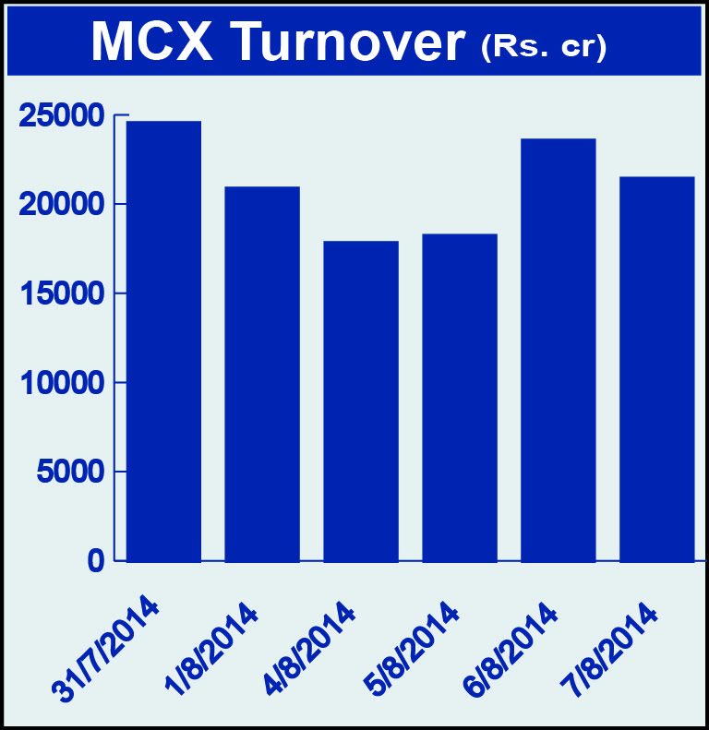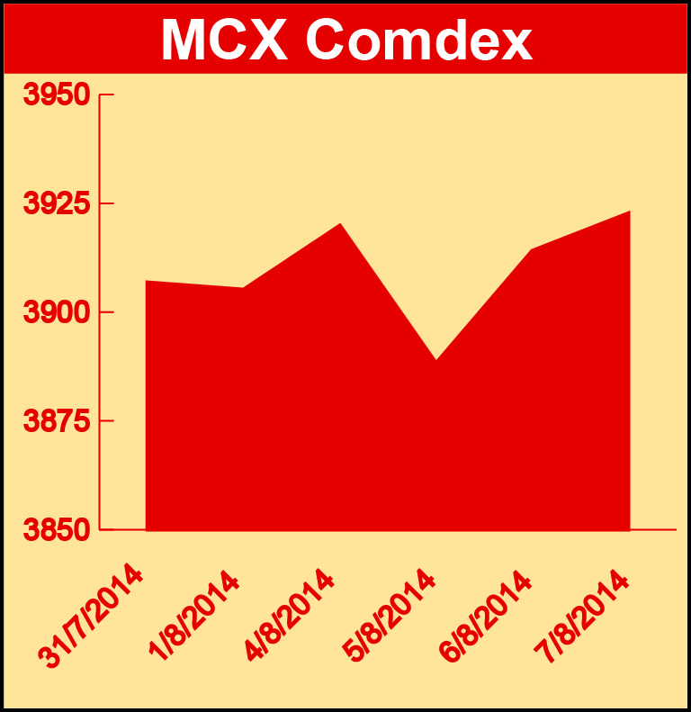

BULLION:

Gold October 14 contract was up by 3.03% to Rs 28770.00 per 10 grams, GoldM October 14 contract was up by 2.93% to Rs 28791.00 per 10 grams, Goldguinea August 14 contract was up by 1.85% to Rs 23095.00 per 8 grams, GoldPetal August 14 contract was up by 2.54% to Rs 2905.00 per grm and GoldPetalDel August 14 contract was up by 0.27% to Rs 2949.00 per grm. Silver September 14 contract was up by 1.32% to Rs 43814.00 per kg, SilverM August 14 contract was up by 1.32% to Rs 43839.00 per kg and SilverMIC August 14 contract was up by 1.31% to Rs 43842.00 per kg.

METALS:

Aluminium August 14 contract was up by 2.26% to Rs 124.20 per kg, alumini August 14 contract was up by 2.31% to Rs 124.25 per kg, lead August 14 contract was up by 2.92% to Rs 139.25 per kg, lead mini August 14 contract was up by 2.88% to Rs 139.25 per kg, nickel August 14 contract was up by 2.80% to Rs 1165.00 per kg, nickelm August 14 contract was up by 2.80% to Rs 1164.60 per kg while zinc August 14 contract was down by 0.83% to Rs 142.75 per kg, zinc mini August 14 contract was down by 0.83% to Rs 142.75 per kg, copper August 14 contract was down by 1.01% to Rs 431.70 per kg and copperm August 14 contract was down by 1.01% to Rs 431.70 per kg.

ENERGY:

Natural gas October 14 contract was up by 1.52% to Rs 247.20 per MMBTU while Crude oil August 14 contract was down by 0.32% to Rs 5987.00 per barrel.

AGRICULTURE:

Cotton October 14 contract was up by 3.97% to Rs 18090.00 per bale, cardamom October 14 contract was up by 5.64% to Rs 919.50 per kg while menthaoil October 14 contract was down by 0.93% to Rs 727.20per kg and CPO October 14 contract was down by 1.44% to Rs 499.90 per 10 kg.

For further information please contact:

 | Alok Gupta  AVP, Corporate Communication, MCX  Phone No.: +91 22 6731 8888  Mobile No.: +91 9930267906  Email: alok.gupta@mcxindia.com

