Weekly Market Report (August 28, 2014 – September 04, 2014)

MCX – COMDEX

Open: 3768.78 High: 3806.47 Low: 3727.54 Close: 3749.67 Previous close: 3768.78

MCX Comdex was down by 0.51% to 3749.67; MCX Metal was down by 0.73% to 4758.44 and MCX Energy was up by 0.37% to 3993.03.

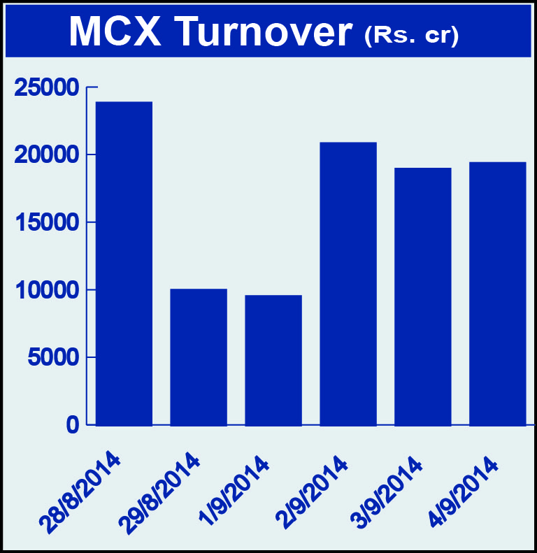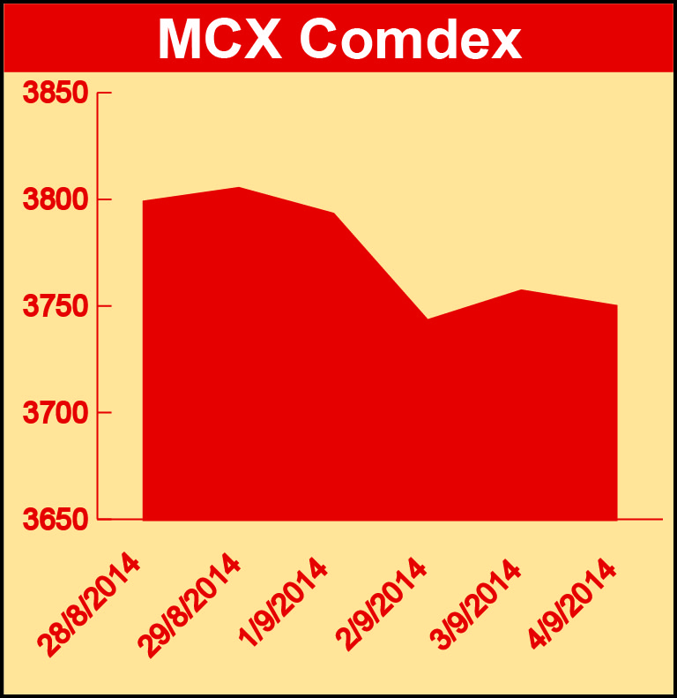

BULLION:

Gold October 14 contract was down by 1.15% to Rs 27461.00 per 10 grams, GoldM November 14 contract was down by 1.25% to Rs 27589.00 per 10 grams, Goldguinea November 14 contract was down 1.57% to Rs 22572.00 per 8 grams, GoldPetal October 14 contract was down by 1.64% to Rs 2813.00 per grm and GoldPetalDel September 14 contract was down by 1.06% to Rs 2886.00 per grm. Silver September 14 contract was down by 1.07% to Rs 41485.00 per kg, SilverM November 14 contract was down by 1.36% to Rs 42109.00 per kg and SilverMIC November 14 contract was down by 1.36% to Rs 42111.00 per kg.

METALS:

Aluminium October 14 contract was up by 1.23% to Rs 127.75 per kg, alumini October 14 contract was up by 1.31% to Rs 127.70 per kg, nickel November 14 contract was up by 3.29% to Rs 1179.80 per kg, nickelm November 14 contract was up by 3.33% to Rs 1179.90 per kg, zinc November 14 contract was up by 4.84% to Rs 146.15 per kg, zinc mini November 14 contract was up by 2.27% to Rs 146.30 per kg while lead mini September 14 contract was down by 1.46% to Rs 134.60 per kg, lead September 14 contract was down by 1.46% to Rs 134.60 per kg copper November 14 contract was down by 1.08% to Rs 427.15per kg and copperm November 14 contract was down by 1.09% to Rs 427.15 per kg.

ENERGY:

Crude oil September 14 contract was up by 1.23% to Rs 5745.00 per barrel while Natural gas October 14 contract was down by 4.61% to Rs 235.70 per MMBTU.

AGRICULTURE:

Cotton October 14 contract was down by 3.38% to Rs 17730.00 per bale, cardamom September 14 contract was down by 1.59% to Rs 932.90 per kg, menthaoil October14 contract was down by 3.17% to Rs 684.30 per kg and CPO September 14 contract was down by 2.79% to Rs 436.00 per 10 kg.

For further information please contact:

 | Alok Gupta  AVP, Corporate Communication, MCX  Phone No.: +91 22 6731 8888  Mobile No.: +91 9930267906  Email: alok.gupta@mcxindia.com

