Weekly Market Report (August 08, 2014 – August 13, 2014)

MCX – COMDEX

Open: 3922.71 High: 3954.02 Low: 3875.77 Close: 3882.90 Previous close: 3921.48

MCX Comdex was down by 0.98% to 3882.90; MCX Metal was down by 1.02% to 4834.02 and MCX Energy was down by 1.11% to 4119.89.

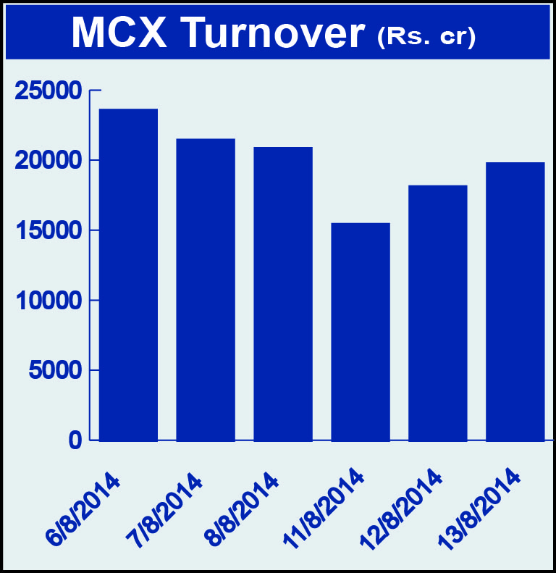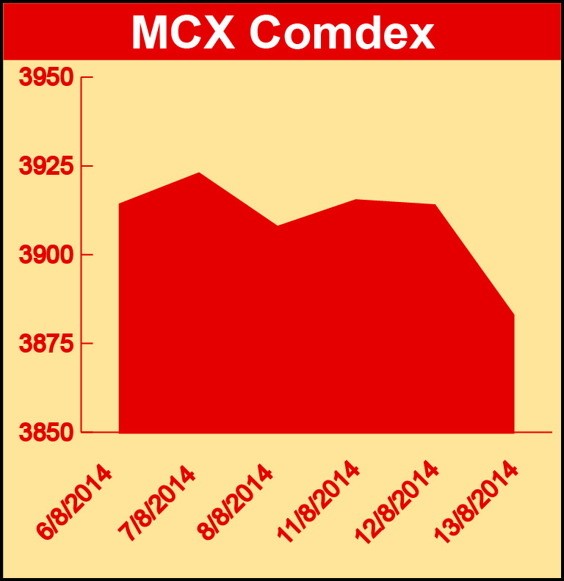

BULLION:

Gold October 14 contract was down by 0.29% to Rs 28688.00 per 10 grams, GoldM September 14 contract was down by 0.45% to Rs 28567.00 per 10 grams, Goldguinea October 14 contract was up 0.37% to Rs 23276.00 per 8 grams, GoldPetal August 14 contract was up by 1.31% to Rs 2943.00 per grm and GoldPetalDel August 14 contract was up by 1.70% to Rs 2999.00 per grm. Silver September 14 contract was down by 1.13% to Rs 43317.00 per kg, SilverM August 14 contract was down by 1.15% to Rs 43335.00 per kg, SilverMIC August 14 contract was down by 1.16% to Rs 43333.00 per kg and Silver1000 August 14 contract was down by 0.23% to Rs 43900.00 per kg.

METALS:

Aluminium August 14 contract was down by 0.60% to Rs 123.45 per kg, alumini August 14 contract was down by 0.64% to Rs 123.45 per kg, lead August 14 contract was down by 3.27% to Rs 134.70 per kg, lead mini August 14 contract was down by 3.30% to Rs 134.65 per kg, nickel October 14 contract was down by 2.24% to Rs 1149.60 per kg, nickelm October 14 contract was down by 2.02% to Rs 1147.30 per kg, zinc August 14 contract was down by 2.56% to Rs 139.10 per kg, zinc mini August 14 contract was down by 2.56% to Rs 139.10 per kg, copper August 14 contract was down by 2.61% to Rs 420.45 per kg and copperm August 14 contract was down by 2.59% to Rs 420.50 per kg.

ENERGY:

Natural gas August 14 contract was down by 1.38% to Rs 235.50 per MMBTU while Crude oil October 14 contract was down by 0.82% to Rs 5951.00 per barrel.

AGRICULTURE:

Cotton October 14 contract was up by 1.16% to Rs 18300.00 per bale, cardamom August 14 contract was up by 2.45% to Rs 973.20 per kg while menthaoil October 14 contract was down by 0.21% to Rs 725.70 per kg and CPO October 14 contract was down by 3.62% to Rs 481.80 per 10 kg.

For further information please contact:

 | Alok Gupta  AVP, Corporate Communication, MCX  Phone No.: +91 22 6731 8888  Mobile No.: +91 9930267906  Email: alok.gupta@mcxindia.com

