Weekly Market Report (March 07, 2014 – March 13, 2014)

MCX – COMDEX

Open: 4091.46 High: 4127.50 Low: 3999.54 Close: 4013.86 Previous close: 4091.46

MCX Comdex was down by 1.90% to 4013.86, MCX Metal was down by 1.94% to 4862.62 and MCX Energy was down by 1.85% to 4241.36.

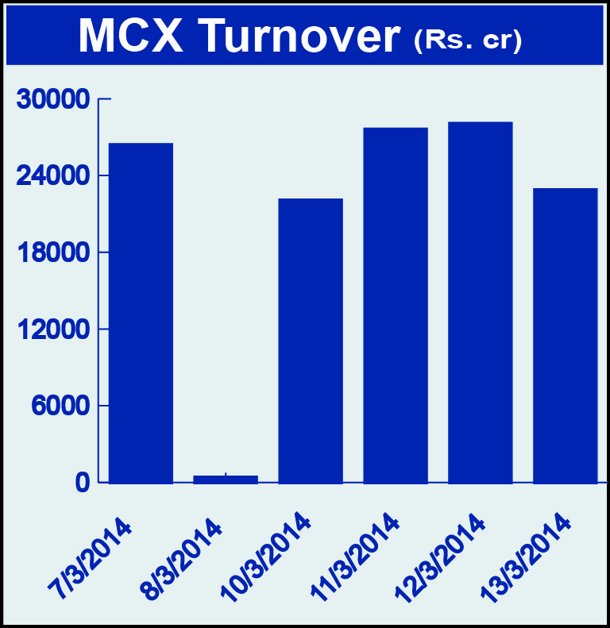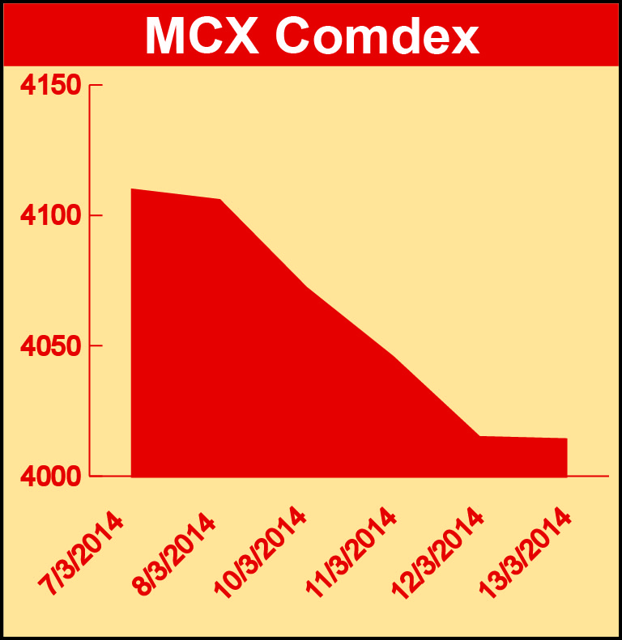

Bullion:
Gold April 14 contract was up by 1.13% to Rs 30549.00 per 10 grams, GoldM May 14 contract was up by 1.60% to Rs 30406.00 per 10 grams, Goldguinea March 14 contract was up by 1.22% to Rs 24962.00 per 8 grams, GoldPetal April 14 contract was up by 1.16% to Rs 3062.00 per grm and GoldPetalDel March 14 contract was down by 1.11% to Rs 2948.00 per grm. Silver May 14 contract was down by 0.97% to Rs 46734.00 per kg, SilverM April 14 contract was down by 0.96% to Rs 46770.00 per kg and SilverMIC April 14 contract was down by 0.96% to Rs 46771.00 per kg.

Metals
Nickelm April 14 contract was up by 2.47% to Rs 976.30 per kg, nickel March 14 contract was up by 2.40% to Rs 969.80 per kg while zinc March 14 contract was down by 5.86% to Rs 121.25 per kg, zinc mini March 14 14 contract was down by 5.86% to Rs 121.25 per kg, aluminium March 14 contract was down by 2.55% to Rs 104.95 per kg, alumini March 14 contract was down by 2.55% to Rs 104.95 per kg, lead May 14 contract was down by 5.86% to Rs 126.10 per kg, lead mini March 14 contract was down by 5.00% to Rs 123.45 per kg, copper April 14 contract was down by 8.47% to Rs 399.60 per kg and copperm April 14 contract was down by 8.47% to Rs 399.60 per kg.

Energy
BRCrudeoil March 14 contract was up by 2.72% to Rs 6711.00 per barrel while Crude oil March 14 contract was down by 1.59% to Rs 6021.00 per barrel and Natural gas March 14 contract was down by 4.85% to Rs 268.90 per MMBTU.

AGRICULTURE:
Menthaoil March 14 contract was up by 1.70% to Rs 836.00 per kg, potato April 14 contract was up by 2.25% to Rs 1201.60 per 100 kgs, cardamom March 14 contract was up by 8.40% to Rs 799.90 per kg, cotton May 14 contract was up by 0.52% to Rs 21170.00 per bales while CPO March 14 contract was down 2.78% to Rs 594.20 per 10 kgs, and kapas April 14 contract was down by 2.39% to Rs 875.00 per 20 kgs.

For further information please contact:
 | Alok Gupta  AVP, Corporate Communication, MCX  Phone No.: +91 22 6731 8888  Mobile No.: +91 9930267906  Email: alok.gupta@mcxindia.com

