Weekly Market Report (July 25, 2014 – July 31, 2014)

MCX – COMDEX

Open: 3933.66 High: 3942.47 Low: 3899.14 Close: 3906.82 Previous close: 3936.19

MCX Comdex was down by 0.75% to 3906.82; MCX Metal was up by 0.66% to 4848.47 and MCX Energy was down by 1.84% to 4157.09.

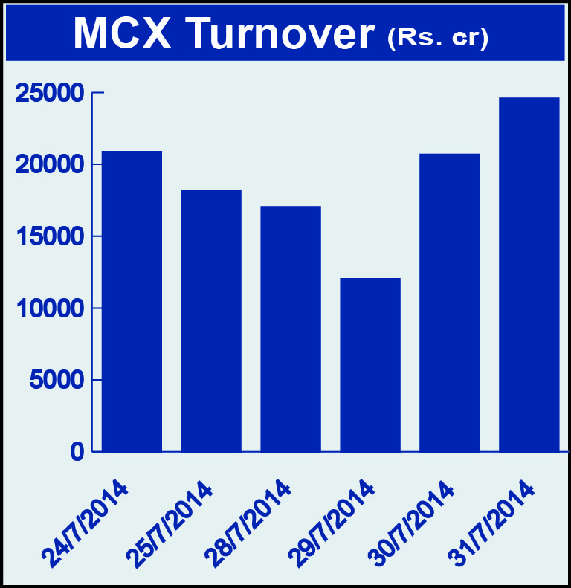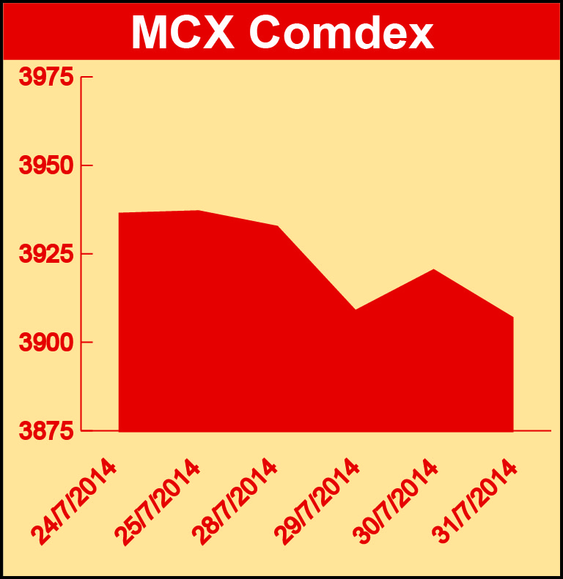

BULLION:

Gold August 14 contract was up by 0.69% to Rs 27818.00 per 10 grams, GoldM August 14 contract was up by 0.50% to Rs 27788.00 per 10 grams, Goldguinea September 14 contract was up by 0.54% to Rs 22862.00 per 8 grams, GoldPetal July 14 contract was down by 1.69% to Rs 2796.00 per grm and GoldPetalDel July 14 contract was down by 4.28% to Rs 2794.00 per grm. Silver September 14 contract was up by 1.40% to Rs 44399.00 per kg, SilverM August 14 contract was up by 1.40% to Rs 44426.00 per kg, SilverMIC August 14 contract was up by 1.40% to Rs 44424.00 per kg and Silver1000 August 14 contract was up by 0.89% to Rs 45000.00 per kg.

METALS:

Zinc July 14 contract was up by 0.66% to Rs 144.55 per kg, zinc mini July 14 contract was up by 0.66% to Rs 144.55 per kg, aluminium July 14 contract was up by 0.37% to Rs 121.45 per kg, alumini July 14 contract was up by 0.37% to Rs 121.45 per kg, lead September 14 contract was up by 1.04% to Rs 136.10 per kg, lead mini July 14 contract was up by 0.67% to Rs 134.75 per kg, copper August 14 contract was up 0.15% to Rs 436.10 per kg, copperm August 14 contract was up by 0.14% to Rs 436.10 per kg while nickel August 14 contract was down by 2.25% to Rs 1128.30 per kg and nickelm August 14 contract was down by 2.25% to Rs 1128.20 per kg.

ENERGY:

Natural gas September 14 contract was up by 2.17% to Rs 240.00 per MMBTU while Crude oil August 14 contract was down by 2.47% to Rs 6006.00 per barrel.

AGRICULTURE:

Cotton July 14 contract was up by 4.40% to Rs 18980.00 per bale, menthaoil July 14 contract was up by 9.14% to Rs 777.70 per kg while CPO August 14 contract was down by 1.11% to Rs 516.20 per 10 kg and cardamom September 14 contract was down by 1.90% to Rs 883.70 per kg.

For further information please contact:

 | Alok Gupta  AVP, Corporate Communication, MCX  Phone No.: +91 22 6731 8888  Mobile No.: +91 9930267906  Email: alok.gupta@mcxindia.com

