Weekly Market Report (July 04, 2014 – July 10, 2014)

MCX – COMDEX

Open: 3961.93 High: 4000.90 Low: 3926.86 Close: 3998.94 Previous close: 3961.93

MCX Comdex was up by 0.93% to 3998.94; MCX Metal was up by 2.38% to 4909.85 while MCX Energy was down by 0.98% to 4291.13.

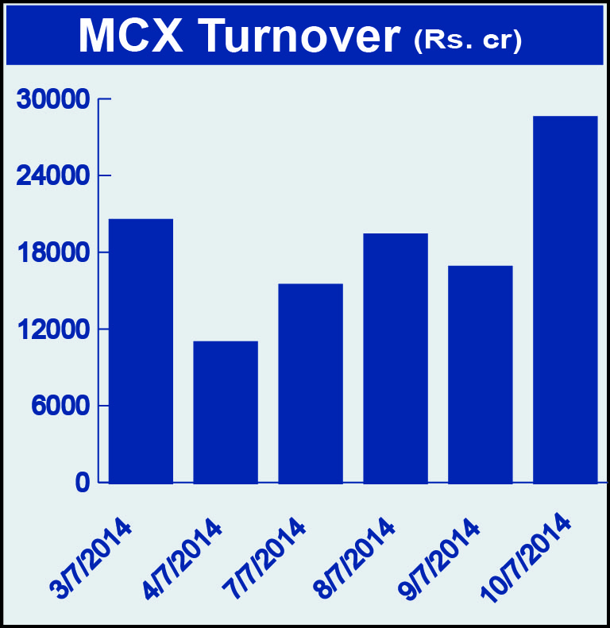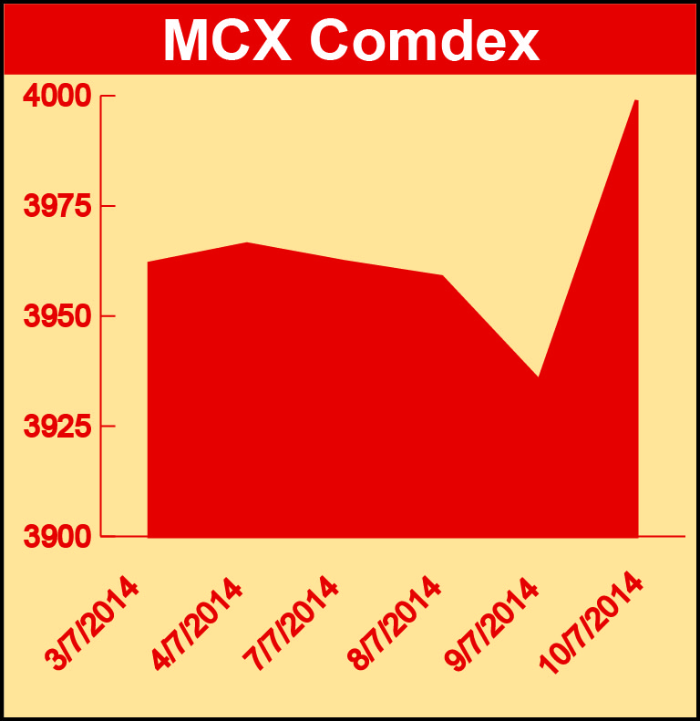

Bullion:

Gold August 14 contract was up by 3.76% to Rs 28496 per 10 grams, GoldM August 14 contract was up by 3.68% to Rs 28565 per 10 grams, Goldguinea July 14 contract was up by 2.74% to Rs 23019 per 8 grams, GoldPetal July 14 contract was up by 2.64% to Rs 2882 per grm and GoldPetalDel July 14 contract was up by 0.79% to Rs 2942 per grm. Silver September 14 contract was up by 3.11% to Rs 46242 per kg, SilverM August 14 contract was up by 3.11% to Rs 46270 per kg and silverMIC August 14 contract was up by 3.12% to Rs 46273 per kg.

Metals

Zinc July 14 contract was up by 2.17% to Rs 136.40 per kg, zinc mini July 14 contract was up by 2.13% to Rs 136.35 per kg, lead July 14 contract was up by 1.15% to Rs 131.65 per kg, lead mini July 14 contract was up by 1.15% to Rs 131.65 per kg, copper August 14 contract was up by 0.68% to Rs 437.55 per kg, copperm August 14 contract was up by 0.68% to Rs 437.55 per kg, aluminium July 14 contract was up by 0.44% to Rs 114.90 per kg, alumini July 14 contract was up 0.44% to Rs 114.90 per kg while Nickel September 14 contract was down by 2.35% to Rs 1166.50 per kg and nickelm September 14 contract was down by 2.22% to Rs 1166.20 per kg.

Energy

Natural gas July 14 contract was down by 4.78% to Rs 249.10 per MMBTU and Crude oil September 14 contract was down by 0.79% to Rs 6142.00 per barrel.

AGRICULTURE:

Potato August 14 contract was up by 12.20% to Rs 1500.40 per 10 kg, menthaoil July 14 contract was up by 4.45% to Rs 733.00 per kg, cardamom July 14 contract was up by 3.64% to Rs 994.50 per kg, CPO July 14 contract was up by 1.57% to Rs 535.30 per 10 kg while Cotton July 14 contract was down by 1.59% to Rs 19240.00 per bale.

For further information please contact:

 | Alok Gupta  AVP, Corporate Communication, MCX  Phone No.: +91 22 6731 8888  Mobile No.: +91 9930267906  Email: alok.gupta@mcxindia.com

