Weekly Market Report (February 07, 2014 – February 13, 2014)

MCX – COMDEX

Open: 3963.79 High: 4037.35 Low: 3963.79 Close: 4034.71 Previous close: 3964.67

MCX Comdex was up by 1.77% to 4034.71, MCX Metal was up by 1.18% to 4833.24 and MCX Energy was up by 2.75% to 4416.94.

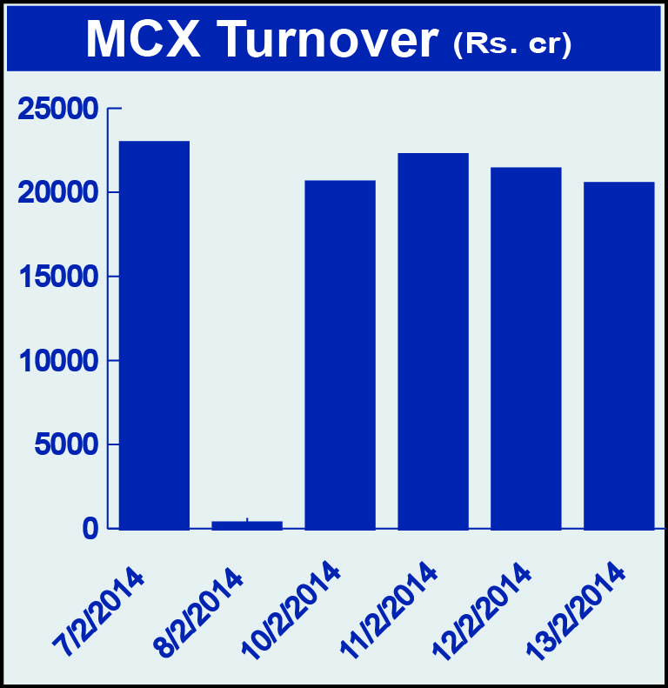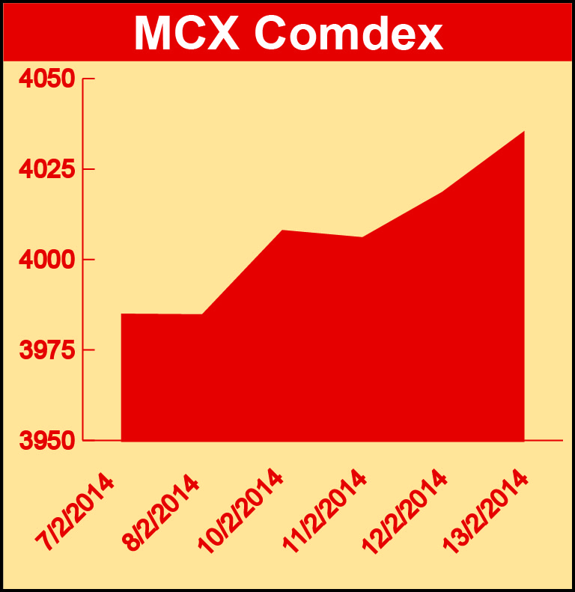

Bullion:
Gold April 14 contract was up 1.86% to Rs 29184.00 per 10 grams, GoldM March 14 contract was up by 1.69% to Rs 29726.00 per 10 grams, Goldguinea March 14 contract was up by 1.44% to Rs 23744.00 per 8 grams, GoldPetal February 14 contract was up by 1.34% to Rs 3016.00 per grm and GoldPetalDel February 14 contract was down by 0.55% to Rs 3101.00 per grm. Silver March 14 contract was up by 1.15% to Rs 44922.00 per kg, SilverM February 14 contract was up by 1.13% to Rs 44945.00 per kg, SilverMIC February 14 contract was up by 1.12% to Rs 44945.00 per kg and Silver1000 February 14 contract was down by 3.08% to Rs 44581.00 per kg.

Metals
Nickelm April 14 contract was up by 1.55% to Rs 895.60 per kg, zinc April 14 contract was up by 1.19% to Rs 127.20 per kg, zinc mini April 14 contract was up by 1.48% to Rs 127.10 per kg, nickel April 14 contract was up by 1.79% to Rs 902.50 per kg, aluminium April 14 contract was up by 1.28% to Rs 106.45 per kg, alumini April 14 contract was up by 1.28% to Rs 106.45 per kg, lead April 14 contract was up by 0.23% to Rs 133.50 per kg, lead mini April 14 contract was up by 0.30% to Rs 133.25 per kg, copper February 14 contract was up by 0.46% to Rs 446.30 per kg and copperm February 14 contract was up by 0.45% to Rs 446.25 per kg.

Energy
Crude oil February 14 contract was up by 2.93% to Rs 6253.00 per barrel and Natural gas February 14 contract was up by 3.14% to Rs 318.70 per MMBTU.

AGRICULTURE:
Kapaskhali February 14 contract was up by 1.57% to Rs 1548.50 per 100 kgs, CPO April 14 contract was up 1.92% to Rs 557.70 per 10 kgs while cotton March 14 contract was down by 1.45% to Rs 21000.00 per bales, kapas April 14 contract was down by 3.66% to Rs 971.10 per 20 kgs, guarseed February 14 contract was down by 3.005 to Rs 4753.00 per 100 kgs, potato April 14 contract was down by 1.34% to Rs 1160.10 per 100 kgs, cardamom February 14 contract was down by 4.34% to Rs 693.80 per kg and menthaoil April 14 contract was down by 3.56% to Rs 788.80 per kg.

For further information please contact:
 | Alok Gupta  AVP, Corporate Communication, MCX  Phone No.: +91 22 6731 8888  Mobile No.: +91 9930267906  Email: alok.gupta@mcxindia.com

