Weekly Market Report (December 20, 2013 – December 26, 2013)

MCX – COMDEX

Open: 4009.36 High: 4038.49 Low: 3989.84 Close: 4031.39 Previous close: 4009.36

MCX Comdex was up by 0.55% to 4031.39, MCX Metal was up by 1.57% to 4863.37 while MCX Energy was down by 0.21% to 4375.22.

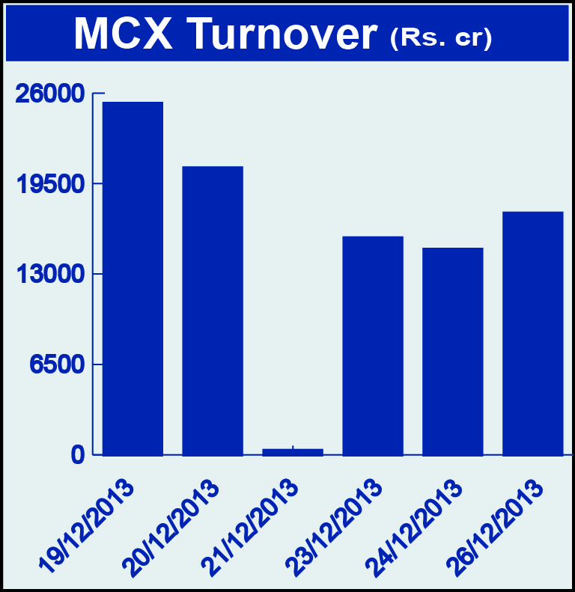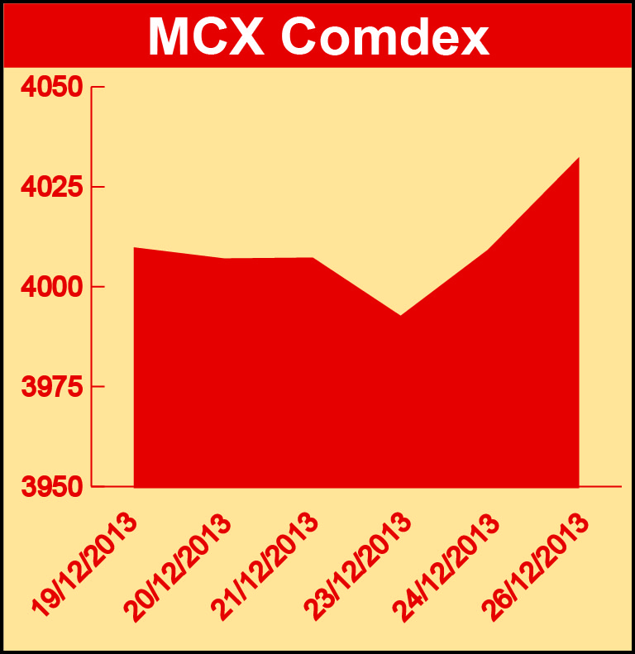

Bullion:
Gold February 14 contract was up by 0.75% to Rs 28576 per 10 grams, goldM February 14 contract was up by 0.53% to Rs 28693 per 10 grams while Goldguinea December 13 contract was down by 2.87% to Rs 23282 per 8 grams, goldPetal December 13 contract was down by 2.02% to Rs 2955 per grm and goldPetalDel December 13 contract was down by 0.82% to Rs 3018 per grm. Silver March 14 contract was up by 2.07% to Rs 44776 per kg, SilverM February 14 contract was up by 2.05% to Rs 44800 per kg, silverMIC February 14 contract was up by 2.06% to Rs 44800 per kg and silver1000 December 13 contract was up by 2.88% to Rs 44617 per kg.

Metals
Zinc December 13 contract was up by 5.53% to Rs 130.80 per kg, zinc mini December 13 contract was up by 5.57% to Rs 130.80 per kg, lead December 13 contract was up by 3.56% to Rs 139.70 per kg, lead mini February 14 contract was up by 3.58% to Rs 141.75 per kg, copper February 14 contract was up by 2.09% to Rs 470.00 per kg, copperm February 14 contract was up by 2.09% to Rs 469.95 per kg while Aluminium February 14 contract was down by 2.10% to Rs 109.75 per kg, alumini December 13 contract was down 1.98% to Rs 106.50 per kg, nickel December 13 contract was down by 0.90% to Rs 879.30 per kg, nickelm December 13 contract was down by 0.89% to Rs 879.30 per kg and SteelRPR January 14 contract was down by 1.06% to Rs 28110.00 per MT.

Energy
Crude oil January 14 contract was down by 0.64% to Rs 6199.00 per barrel, Brcrude oil January 14 contract was down by 0.56% to Rs 6898.00 per barrel and Natural gas December 13 contract was down by 0.29% to Rs 275.40 per MMBTU.

AGRICULTURE:
Kapaskhali January 14 contract was up by 0.87% to Rs 1443.50 per 100 kgs, while Cardamom February 14 contract was down by 1.78% to Rs 710.50 per kg, menthaoil February 14 contract was down by 1.46% to Rs 842.90 per kg, cotton December 13 contract was down by 1.40% to Rs 19010.00 per bale and cpo December 13 contract was down by 1.13% to Rs 543.50 per 10 kgs.

For further information please contact:

 | Alok Gupta  AVP, Corporate Communication, MCX  Phone No.: +91 22 6731 8888  Mobile No.: +91 9930267906  Email: alok.gupta@mcxindia.com

