Weekly Market Report (December 13, 2013 – December 19, 2013)

MCX – COMDEX

Open: 4005.50 High: 4012.87 Low: 3964.04 Close: 4009.36 Previous close: 4005.50

MCX Comdex was up by 0.10% to 4009.36, MCX Energy was up by 1.80% to 4384.25 and MCX Metal was down by 1.22% to 4788.04.

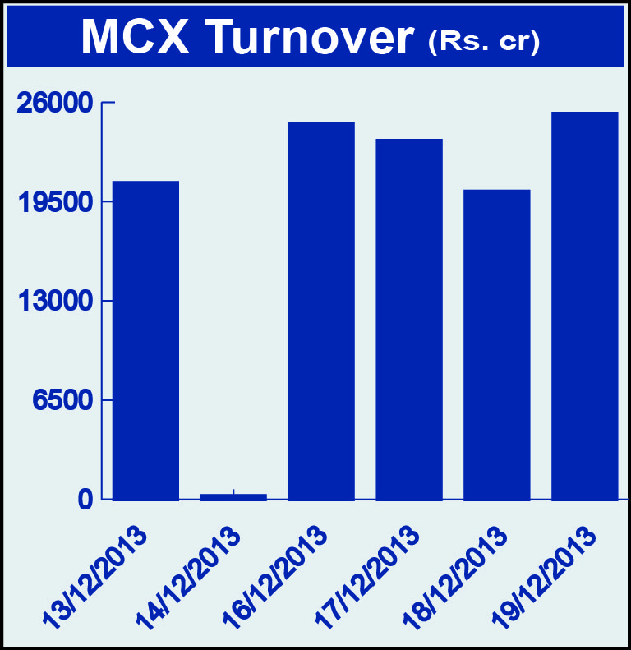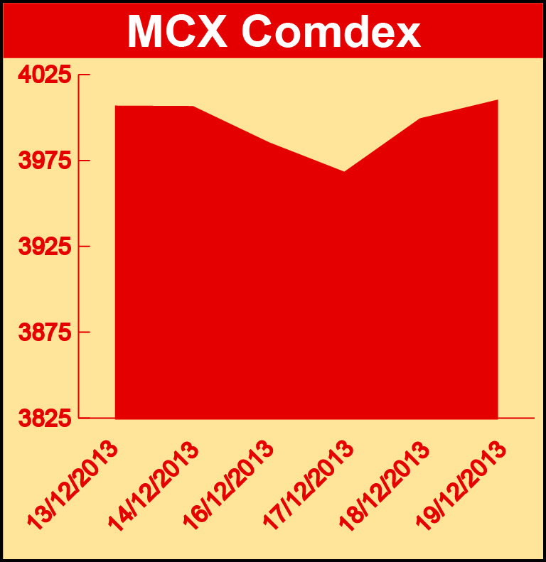

Bullion:
Gold February 14 contract was down by 2.95% to Rs 28362.00 per 10 grams, GoldM February 14 contract was down by 2.38% to Rs 28543.00 per 10 grams, Goldguinea February 14 contract was down by 1.47% to Rs 22980.00 per 8 grams, GoldPetal February 14 contract was down 1.51% to Rs 2872.00 per grm and GoldPetalDel January 14 contract was down by 1.07% to Rs 2971.00 per grm. Silver March 14 contract was down by 1.35% to Rs 43869.00 per kg, SilverM February 14 contract was down by 1.35% to Rs 43898.00 per kg and SilverMIC February 14 contract was down by 1.35% to Rs 43897.00 per kg.

Metals
Nickel December 13 contract was up by 1.66% to Rs 887.20 per kg, nickelm December 13 contract was up by 1.66% to Rs 887.20 per kg, copper February 14 contract was up by 0.11% to Rs 460.40 per kg, copperm February 14 contract was up by 0.10% to Rs 460.35 per kg, zinc mini February 14 contract was up by 1.83% to Rs 125.00 per kg, lead January 14 contract was up by 2.40% to Rs 136.40 per kg, zinc December 13 contract was up by 1.72% to Rs 123.95 per kg, lead mini January 14 contract was up by 2.36% to Rs 136.35 per kg while aluminium December 13 contract was down by 1.14% to Rs 108.65 per kg and alumini December 13 contract was down 1.14% to Rs 108.65 per kg.

Energy
Natural gas February 14 contract was up by 3.33% to Rs 279.60 per MMBTU, Crude oil February 14 contract was up by 1.78% to Rs 6275.00 per barrel and Brcrude oil January 14 contract was up by 0.61% to Rs 6937.00 per barrel.

Agriculture:
Potato March 14 contract was up by 3.97% to Rs 955.80 per 100 kgs, kapas March 14 contract was up by 5.51% to Rs 930.20 per 20 kgs, cotton December 13 contract was up 2.55% to Rs 19280.00 per bale, kapaskhali January 14 contract was up by 0.67% to Rs 1431.00 per 100 kgs, menthaoil December 13 contract was up by 0.41% to Rs 832.50 per kg while guarseed December 13 contract was down by 10.02% to Rs 4230.00 per 100 kgs, CPO December 13 contract was down by 1.75% to Rs 556.00 per 10 kgs and cardamom January 14 contract was down by 2.90% to Rs 692.90 per kg.

For further information please contact:

 | Alok Gupta  AVP, Corporate Communication, MCX  Phone No.: +91 22 6731 8888  Mobile No.: +91 9930267906  Email: alok.gupta@mcxindia.com

