Weekly Market Report (April 17, 2014 – April 23, 2014)

MCX – COMDEX

Open: 3992.30 High: 4027.32 Low: 3982.62 Close: 4024.51 Previous close: 3988.25

MCX Comdex was up by 0.91% to 4024.51; MCX Energy was up by 0.91% to 4420.60 while MCX Metal was up by 1.25% to 4760.41.

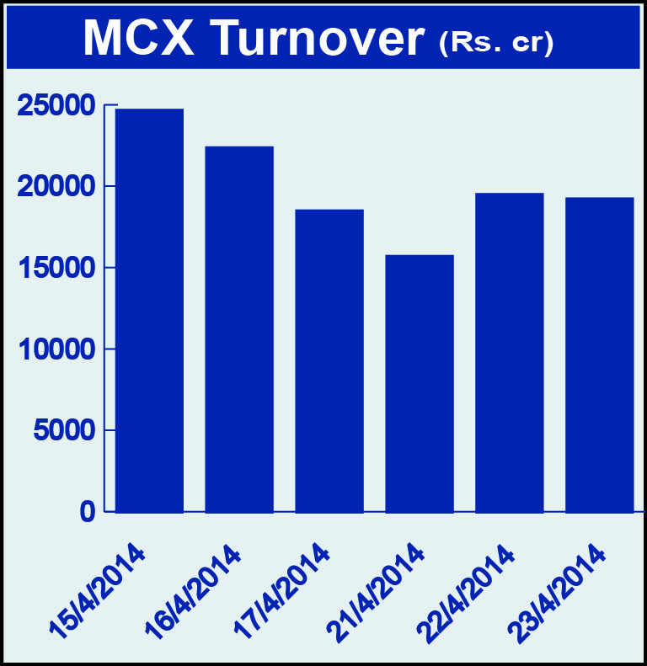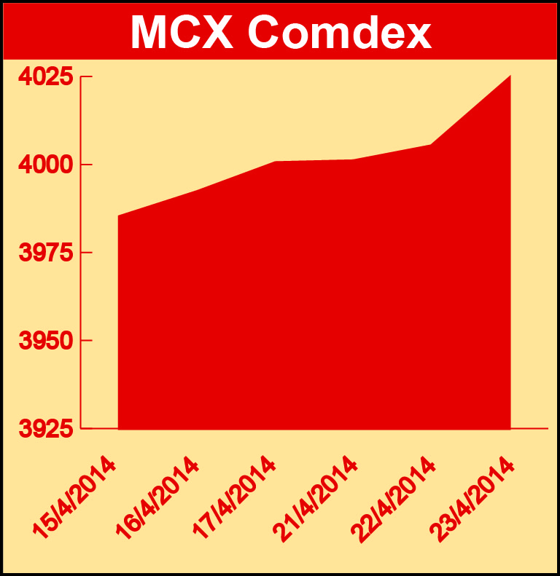

Bullion:
Gold June 14 contract was up by 0.70% to Rs 28790.00 per 10 grams, GoldM May 14 contract was up by 1.58% to Rs 29752.00 per 10 grams, Goldguinea April 14 contract was down by 1.15% to Rs 23718.00 per 8 grams, GoldPetal April 14 contract was down by 1.59% to Rs 3037.00 per grm and GoldPetalDel June 14 contract was down by 2.50% to Rs 2813.00 per grm. Silver May 14 contract was up by 0.16% to Rs 42482.00 per kg, SilverM April 14 contract was up by 0.12% to Rs 42498.00 per kg, SilverMIC April 14 contract was up by 0.12% to Rs 42497.00 per kg and Silver1000 April 14 contract was up by 4.075 to Rs 43400.00 per kg.

Metals
Copper April 14 contract was up by 2.20% to Rs 413.60 per kg, copperm April 14 contract was up by 2.20% to Rs 413.55 per kg, nickel May 14 contract was up by 4.32% to Rs 1132.70 per kg, nickelm April 14 contract was up by 4.31% to Rs 1125.60 per kg, zinc June 14 contract was up by 1.94% to Rs 128.70 per kg, zinc mini June 14 contract was up by 2.15% to Rs 128.45 per kg, aluminium June 14 contract was up by 1.72% to Rs 115.25 per kg, alumini May 14 contract was up by 1.11% to Rs 113.95 per kg, lead June 14 contract was up by 2.62% to Rs 133.40 per kg and lead mini June 14 contract was up by 2.82% to Rs 133.15 per kg.

Energy
Crude oil June 14 contract was up by 0.18% to Rs 6251.00 per barrel and Natural gas April 14 contract was up by 6.09% to Rs 291.10 per MMBTU.

AGRICULTURE:
Cotton June 14 contract was up by 3.35% to Rs 21290.00 per bales, cardamom May 14 contract was up by 7.16% to Rs 980.20 per kg while menthaoil April 14 contract was down by 2.02% to Rs 833.30 per kg, CPO April 14 contract was down 1.20% to Rs 566.50 per 10 kgs, kapas April 14 contract was down by 4.01% to Rs 734.90 per 20 kgs and potato May 14 contract was down by 0.52% to Rs 1426.40 per 100 kgs.

For further information please contact:
 | Alok Gupta  AVP, Corporate Communication, MCX  Phone No.: +91 22 6731 8888  Mobile No.: +91 9930267906  Email: alok.gupta@mcxindia.com

