Weekly Market Report (February 24, 2012 –March 01, 2012)

MCX – COMDEX
Open: 3934.69 High: 4003.69 Low: 3924.40 Close: 3940.50 Previous close: 3925.05

MCX Comdex was up by 0.39% to 3940.50, MCX Energy was up by 0.57% to 3522.58 and MCX Metal was down by 0.52% to 4983.63.

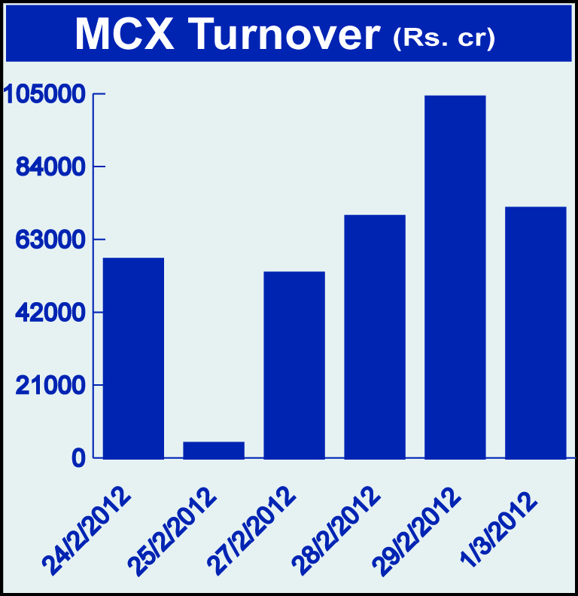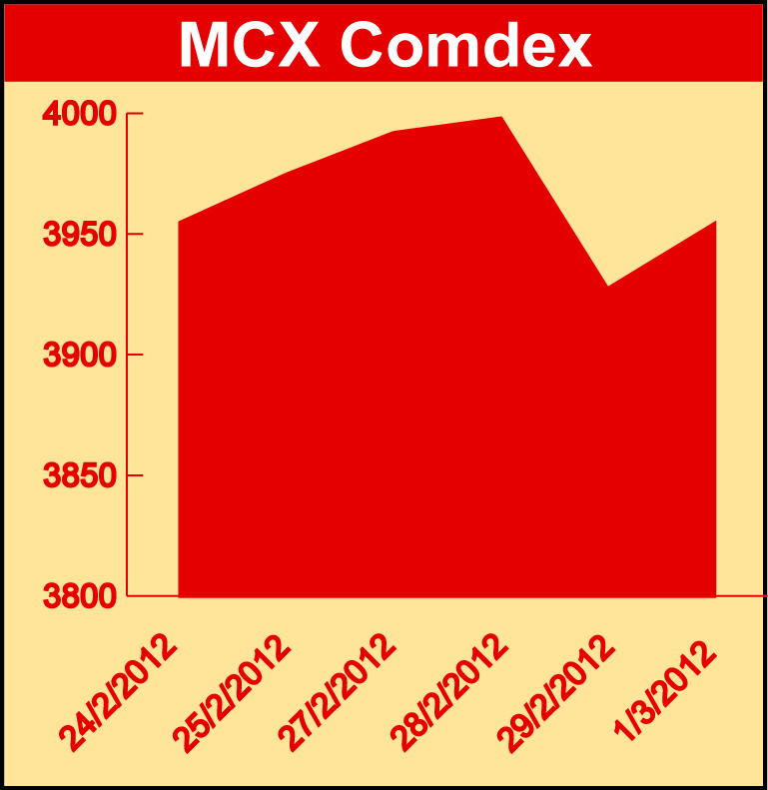

Bullion:
Gold April 12 contract was down by 3.60% to Rs 27872.00 per 10 grams, goldM April 12 contract was down by 3.54% to Rs 27896.00 per 10 grams, goldguinea March 12 contract was down by 3.38% to Rs 22290.00 per 8 grams GoldPetal March 12 contract was down by 3.39% to Rs 2790.00 per grm and GoldPetalDel April 12 contract was down by 1.96% to Rs 2898.00 per grm. Silver March 12 contract was down by 1.82% to Rs 57612.00 per kg, SilverM April 12 contract was down by 1.49% to Rs 59412.00 per kg and silverMIC April 12 contract was down by 1.46% to Rs 59426.00 per kg.

Metals
Copper April 12 contract was up by 1.92% to Rs 426.95 per kg, copperm April 12 contract was up by 1.89% to Rs 426.95 per kg, alumini April 12 contract was up 2.50% to Rs 115.00 per kg, aluminium March 12 contract was up by 2.47% to Rs 113.95 per kg, lead mini May 12 contract was up by 1.24% to Rs 109.90 per kg, lead April 12 contract was up by 1.16% to Rs 108.65 per kg, zinc March 12 contract was up by 2.46% to Rs 103.95 per kg, zinc mini March 12 contract was up by 2.46% to Rs 103.95per kg while nickelm March 12 contract was down by 1.21% to Rs 981.20 per kg and nickel March 12 contract was down by 1.17% to Rs 981.20 per kg.

Energy
BRcrudeoil May 12 contract was up by 0.68% to Rs 5890.00 per barrel, crude oil March 12 contract was up by 0.61% to Rs 5312.00 per barrel while natural gas March 12 contract was down by 6.24% to Rs 127.80 per MMBTU.

Agriculture:
Cardamom May 12 contract was up by 12.03% to Rs 1083.40 per kg, potato May 12 contract was up by 13.37% to Rs 965.50 per 100 kgs, potatoTRWR May 12 contract was up by 12.35% to Rs 808.00 per 100 kgs, menthaoil April 12 contract was up by 19.50% to Rs 2041.10 per kg, cotton May 12 contract was up by 1.63% to Rs 18070.00 per bales, sugar April 12 contract was up by 0.73% to Rs 2906.00 per 100 kgs while CPO May 12 contract was down by 1.21% to Rs 555.90 per 10 kgs and kapas March 12 contract was down by 2.27% to Rs 840.90 per 20 kgs.

For further information please contact:

 | Alok Gupta  AVP, Corporate Communication,  Phone No.: +91 22 6731 8888  Mobile No.: +91 9930267906  Email: alok.gupta@mcxindia.com

Disclaimer:
Multi Commodity Exchange of India Limited is proposing, subject to market conditions and other considerations, a public offer of equity shares by way of an offer for sale and has filed a Draft Red Herring Prospectus ("DRHP") with the SEBI. The DRHP is available on the websites of SEBI at www.sebi.gov.in and the book running lead managers at www.edelcap.com, http://www.online.citibank.co.in/rhtm/citigroupglobalscreen1.htm and www.morganstanley.com/indiaofferdocuments. Investors should note that investment in equity shares involves a high degree of risk and for details in relation to risk factors, please see the section titled "Risk Factors" in the DRHP.

This advertisement may not be published or distributed in the U.S., Canada or Japan and is not an offer or solicitation of an offer for sale of securities in the U.S. These securities have not been and will not be registered under the U.S. Securities Act of 1933, as amended, and may not be offered or sold in the U.S. absent registration or an exemption from registration under such act.

