Weekly Market Report (August 10, 2012 – August 16, 2012)

MCX – COMDEX

Open: 3784.87 High: 3795.45 Low: 3746.92 Close: 3795.03 Previous close: 3785.27

MCX Comdex was up by 0.26% to 3795.03, MCX Energy was up by 1.04% to 3568.95 while MCX Metal was down by 0.20% to 4905.98.

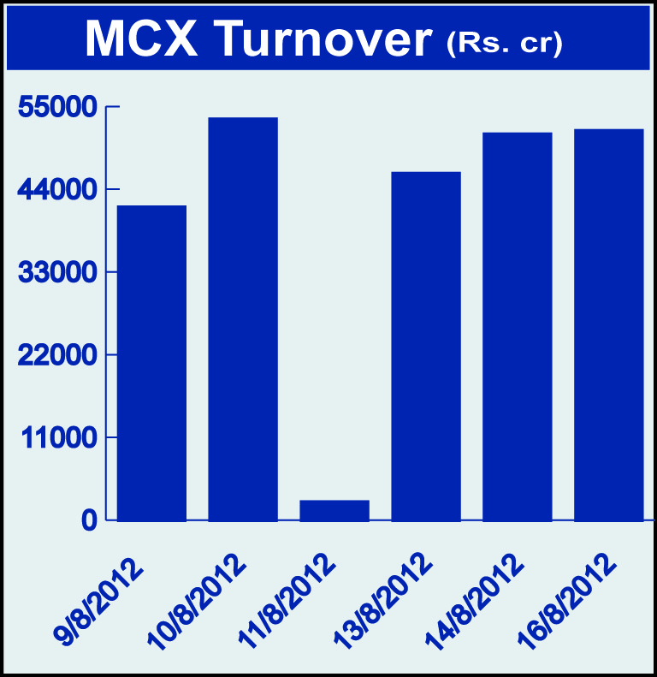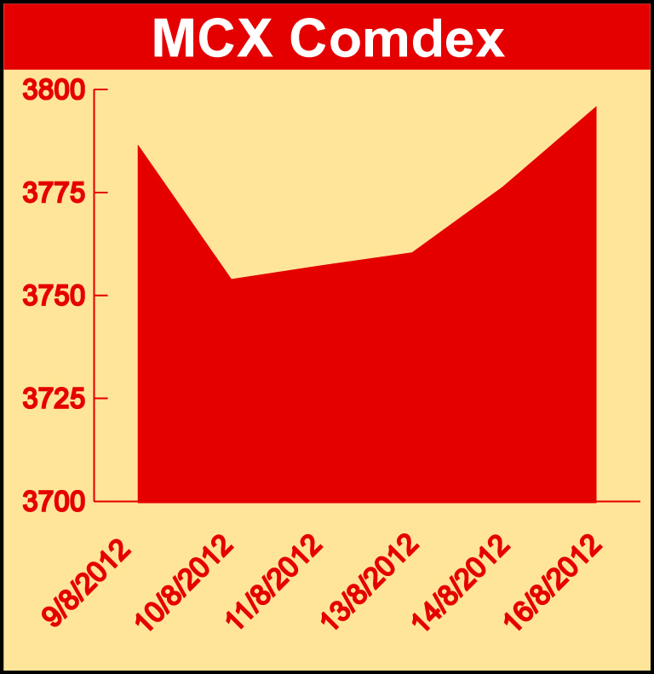

Bullion:
Gold October 12 contract was up by 0.46% to Rs 30104 per 10 grams, goldM September 12 contract was up by 0.55% to Rs 29970 per 10 grams, goldguinea August 12 contract was up by 0.77% to Rs 24044 per 8 grams, goldPetal August 12 contract was up by 0.60% to Rs 3005 per grm while GoldPetalDel October 12 contract was down by 0.44% to Rs 3166 per grm. Silver September 12 contract was up by 0.44% to Rs 53750 per kg, SilverM August 12 contract was up by 0.44% to Rs 53769 per kg and silverMIC August 12 contract was up by 0.44% to Rs 53769 per kg.

Metals
Nickel August 12 contract was up by 0.48% to Rs 867.00 per kg, nickelm August 12 contract was up by 0.47% to Rs 867.30 per kg while Zinc August 12 contract was down by 2.88% to Rs 99.65 per kg, zinc mini August 12 contract was down by 2.83% to Rs 99.70 per kg, lead August 12 contract was down by 2.65% to Rs 103.00 per kg, lead mini August 12 contract was down by 2.65% to Rs 103.00 per kg, aluminium October 12 contract was down by 2.15% to Rs 104.65 per kg, alumini August 12 contract was down 2.07% to Rs 101.70 per kg, copper August 12 contract was down by 0.66% to Rs 414.95 per kg and copperm August 12 contract was down by 0.65% to Rs 415.00 per kg.

Energy
Brcrude oil September 12 contract was up by 3.64% to Rs 6404.00 per barrel, crude oil August 12 contract was up by 2.36% to Rs 5296.00 per barrel while Natural gas August 12 contract was down by 8.78% to Rs 153.80 per MMBTU.

AGRICULTURE:
Maize September 12 contract was up by 2.00% to Rs 1451.00 per kg, cardamom September 12 contract was up by 1.74% to Rs 1212.60 per kg, cpo October 12 contract was up by 1.46% to Rs 554.20 per 10 kgs while PotatoTRWR September 12 contract was down by 6.32% to Rs 1016.20 per 100 kgs, potato September 12 contract was down by 5.08% to Rs 1235.10 per 100 kgs, menthaoil September 12 contract was down by 3.77% to Rs 1360.10 per kg and cotton August 12 contract was down by 0.88% to Rs 17990.00 per bale.

For further information please contact:

 | Alok Gupta  AVP, Corporate Communication, MCX  Phone No.: +91 22 6731 8888  Mobile No.: +91 9930267906  Email: alok.gupta@mcxindia.com

