Weekly Market Report (May 10, 2013 – May 16, 2013)

MCX – COMDEX

Open: 3564.64 High: 3587.25 Low: 3482.07 Close: 3522.08 Previous close: 3566.25

MCX Comdex was down by 1.24% to 3522.08, MCX Metal was down by 2.87% to 4380.15 and MCX Energy was down by 0.36% to 3652.40.

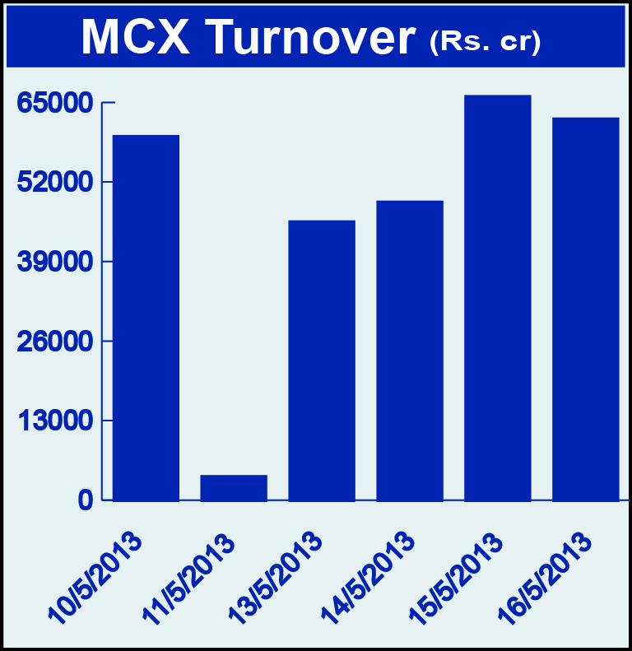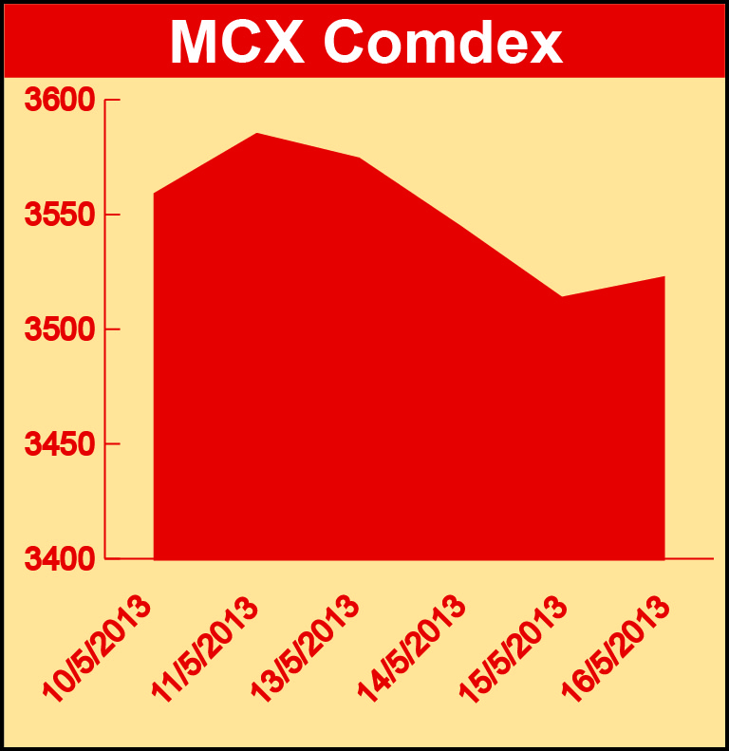

Bullion:
Gold June 13 contract was down by 3.81% to Rs 26131.00 per 10 grams, GoldM July 13 contract was down by 3.76% to Rs 26205.00 per 10 grams, Goldguinea July 13 contract was down by 4.07% to Rs 21043.00 per 8 grams, GoldPetal July 13 contract was down by 4.27% to Rs 2625.00 per grm and GoldPetalDel July 13 contract was down by 4.61% to Rs 2651.00 per grm. Silver July 13 contract was down by 4.21% to Rs 43262.00 per kg, SilverM June 13 contract was down by 4.17% to Rs 43298.00 per kg, SilverMIC June 13 contract was down by 4.16% to Rs 43300.00 per kg and Silver1000 June 13 contract was down by 4.36% to Rs 43561.00 per kg.

Metals
SteelRPR June 13 contract was up by 0.75% to Rs 28240.00 per MT while aluminium July 13 contract was down 1.88% to Rs 101.95 per kg, alumini July 13 contract was down 2.11% to Rs 102.05 per kg, lead July 13 contract was down by 1.08% to Rs 110.00 per kg, lead mini July 13 contract was down by 0.72% to Rs 110.15 per kg, zinc June 13 contract was down by 1.71% to Rs 100.40 per kg, zinc mini June 13 contract was down by 1.71% to Rs 100.40 per kg, nickel May 13 contract was down by 2.43% to Rs 815.00 per kg, nickelm June 13 contract was down by 2.42% to Rs 821.70 per kg, copper June 13 contract was down by 0.52% to Rs 400.50 per kg and copperm June 13 contract was down by 0.52% to Rs 400.50 per kg.

Energy
Brcrude oil June 13 contract was up by 0.76% to Rs 5714.00 per barrel while Crude oil May 13 contract was down by 0.34% to Rs 5209.00 per barrel and Natural gas July 13 contract was down by 0.72% to Rs 220.50 per MMBTU.

AGRICULTURE:
Kapaskhali July 13 contract was up by 3.74% to Rs 1552.00 per 100 kgs, menthaoil June 13 contract was up by 4.13% to Rs 903.50 per kg, CPO July 13 contract was up by 2.48% to Rs 471.80 per 10 kgs while cardamom June 13 contract was down by 7.54% to Rs 732.00 per kg, potato July 13 contract was down by 7.43% to Rs 858.50 per 100 kgs and cotton May 13 contract was down by 0.17% to Rs 17940.00 per bales.

For further information please contact:

 | Alok Gupta  AVP, Corporate Communication, MCX  Phone No.: +91 22 6731 8888  Mobile No.: +91 9930267906  Email: alok.gupta@mcxindia.com

