Weekly Market Report (June 28, 2013 – July 04, 2013)

MCX – COMDEX

Open: 3663.18 High: 3796.73 Low: 3636.92 Close: 3781.01 Previous close: 3668.76

MCX Comdex was up by 3.06% to 3781.01, MCX Metal was up by 3.18% to 4442.33 and MCX Energy was up by 3.87% to 4180.10.

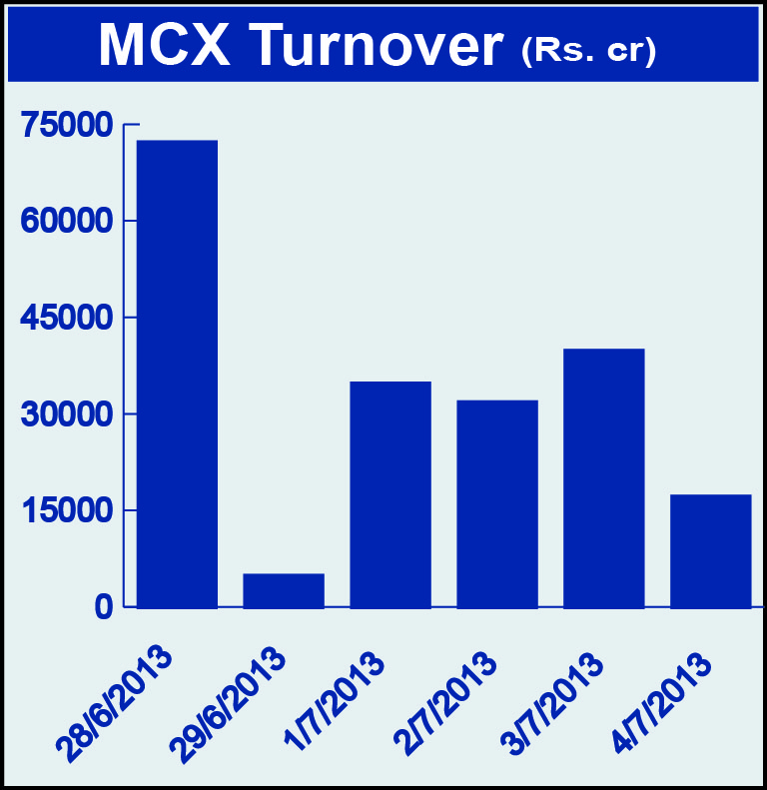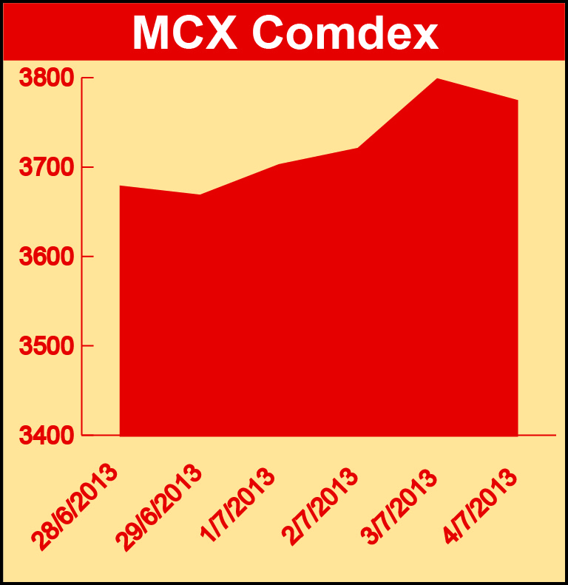

Bullion:
Gold August 13 contract was up by 3.18% to Rs 26181.00 per 10 grams, GoldM July 13 contract was up by 3.15% to Rs 26242.00 per 10 grams, Goldguinea August 13 contract was up by 2.62% to Rs 21012.00 per 8 grams, GoldPetal July 13 contract was up by 2.70% to Rs 2621.00 per grm and GoldPetalDel July 13 contract was up by 2.47% to Rs 2698.00 per grm. Silver September 13 contract was up by 4.95% to Rs 41058.00 per kg, SilverM August 13 contract was up by 4.89% to Rs 41091.00 per kg, SilverMIC August 13 contract was up by 4.86% to Rs 41093.00 per kg and Silver1000 August 13 contract was up by 4.03% to Rs 41479.00 per kg.

Metals:
Zinc September 13 contract was up by 1.64% to Rs 114.70 per kg, zinc mini August 13 contract was up by 1.43% to Rs 113.10 per kg, nickel September 13 contract was up by 0.26% to Rs 852.20 per kg, nickelm August 13 contract was up by 0.18% to Rs 842.10 per kg, lead August 13 contract was up by 1.78% to Rs 125.80 per kg, lead mini August 13 contract was up by 1.86% to Rs 125.75 per kg, aluminium September 13 contract was up by 2.60% to Rs 110.35 per kg, alumini August 13 contract was up by 1.92% to Rs 108.90 per kg, copper August 13 contract was up by 3.02% to Rs 421.20 per kg, copperm August 13 contract was up by 3.03% to Rs 421.25 per kg while steelRPR July 13 contract was down by 1.29% to Rs 27500.00 per MT.

Energy:
Crude oil July 13 contract was up by 4.02% to Rs 6080.00 per barrel, BRcrude oil July 13 contract was up by 1.99% to Rs 6345.00 per barrel and Natural gas September 13 contract was up by 2.79% to Rs 224.40 per MMBTU.

AGRICULTURE:
CPO July 13 contract was up by 0.48% to Rs 505.10 per 10 kgs, cotton July 13 contract was up by 0.05% to Rs 19770.00 per bale, guarseed July 13 contract was up by 2.11% to Rs 7164.0 per 100 kgs, guargum July 13 contract was up by 0.92% to Rs 20383.00 per 100 kgs while kapaskhali July 13 contract was down by 1.17% to Rs 1643.50 per 100 kgs, cardamom July 13 contract was down by 7.23% to Rs 713.90 per kg, potato July 13 contract was down by 4.25% to Rs 804.30 per 100 kgs and menthaoil August 13 contract was down by 3.26% to Rs 971.20 per kg.

For further information please contact:

 | Alok Gupta  AVP, Corporate Communication, MCX  Phone No.: +91 22 6731 8888  Mobile No.: +91 9930267906  Email: alok.gupta@mcxindia.com

