Weekly Market Report (January 03, 2014 – January 09, 2014)

MCX – COMDEX

Open: 4007.58 High: 4007.58 Low: 3867.93 Close: 3870.46 Previous close: 4007.58

MCX Comdex was down by 3.42% to 3870.46, MCX Metal was down by 2.26% to 4791.11 and MCX Energy was down by 5.22% to 4035.23.

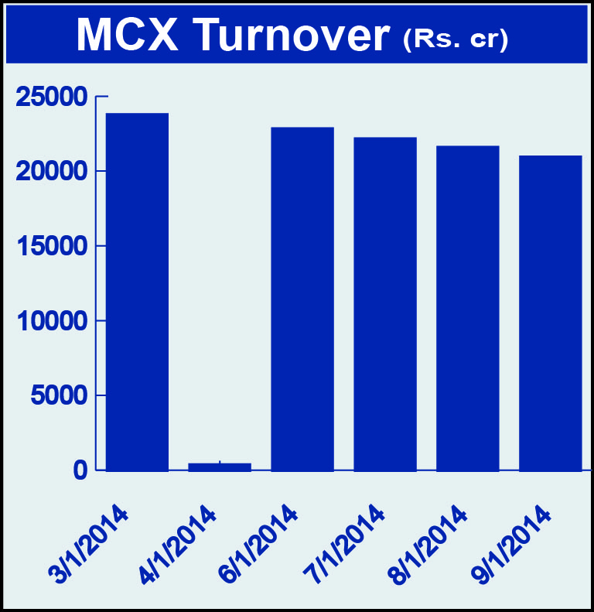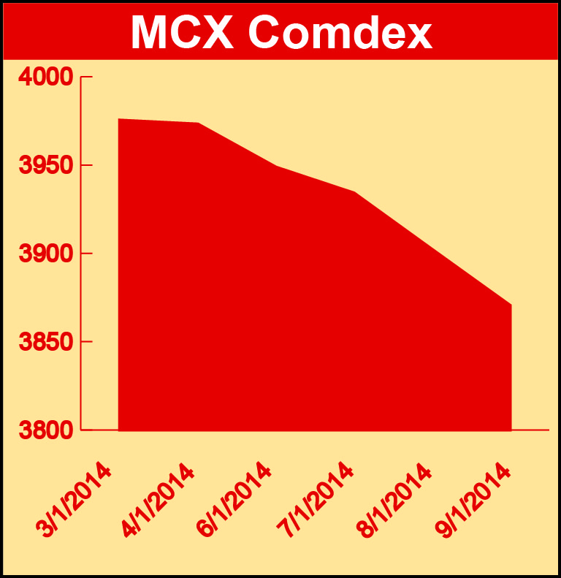

Bullion:
Gold February 14 contract was down by 0.37% to Rs 28862.00 per 10 grams, GoldM February 14 contract was down by 0.37% to Rs 28997.00 per 10 grams, Goldguinea February 14 contract was up by 0.48% to Rs 23218.00 per 8 grams, GoldPetal March 14 contract was up by 0.21% to Rs 2892.00 per grm and GoldPetalDel March 14 contract was up by 1.58% to Rs 2951.00 per grm. Silver March 14 contract was up by 2.70% to Rs 44124.00 per kg, SilverM February 14 contract was up by 2.72% to Rs 44143.00 per kg, SilverMIC February 14 contract was up by 2.74% to Rs 44137.00 per kg and Silver1000 January 14 contract was down by 3.14% to Rs 44093.00 per kg.

Metals
SteelRPR January 14 contract was up by 0.51% to Rs 29350.00 per MT while aluminium January 14 contract was down by 3.78% to Rs 107.00 per kg, alumini January 14 contract was down 3.78% to Rs 107.00 per kg, zinc January 14 contract was down by 3.74% to Rs 124.80 per kg, zinc mini January 14 contract was down by 3.74% to Rs 124.80 per kg, lead January 14 contract was down by 5.94% to Rs 129.80 per kg, lead mini March 14 contract was down by 6.19% to Rs 131.90 per kg, copper February 14 contract was down 2.99% to Rs 455.65 per kg, copperm February 14 contract was down by 3.00% to Rs 455.65 per kg, nickel January 14 contract was down by 4.91% to Rs 832.20 per kg and nickelm January 14 contract was down by 4.90% to Rs 832.30 per kg.

Energy
Crude oil January 14 contract was down by 5.17% to Rs 5705.00 per barrel, Brcrude oil January 14 contract was down by 2.98% to Rs 6649.00 per barrel and Natural gas January 14 contract was down by 6.20% to Rs 252.80 per MMBTU.

AGRICULTURE:
Kapaskhali January 14 contract was up by 2.72% to Rs 1510.00 per 100 kgs, kapas March 14 contract was up by 1.39% to Rs 963.90 per 20 kgs, cotton January 14 contract was up 1.92% to Rs 20140.00 per bales, cardamom January 14 contract was up by 4.68% to Rs 722.20 per kg while menthaoil February 14 contract was down by 1.84% to Rs 842.00 per kg, CPO January 14 contract was down by 1.87% to Rs 541.60 per 10 kgs and potato March 14 contract was down by 3.13% to Rs 940.10 per 100 kgs.

For further information please contact:
 | Alok Gupta  AVP, Corporate Communication, MCX  Phone No.: +91 22 6731 8888  Mobile No.: +91 9930267906  Email: alok.gupta@mcxindia.com

