Weekly Market Report (December 28, 2012 – January 03, 2013)

MCX – COMDEX

Open: 3800.24 High: 3861.31 Low: 3785.36 Close: 3833.27 Previous close: 3795.29

MCX Comdex was up by 1.00% to 3833.27, MCX Energy was up by 0.88% to 3499.85 while MCX Metal was down 0.75% to 5482.71.

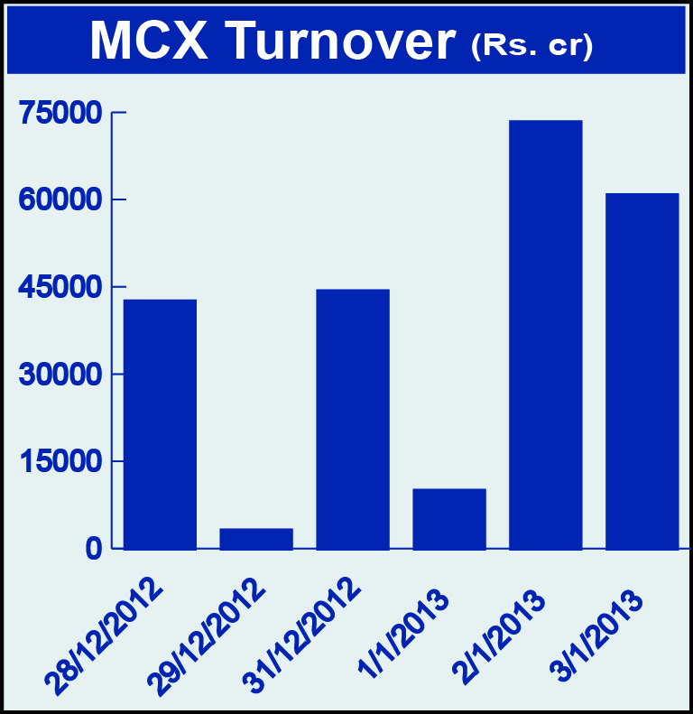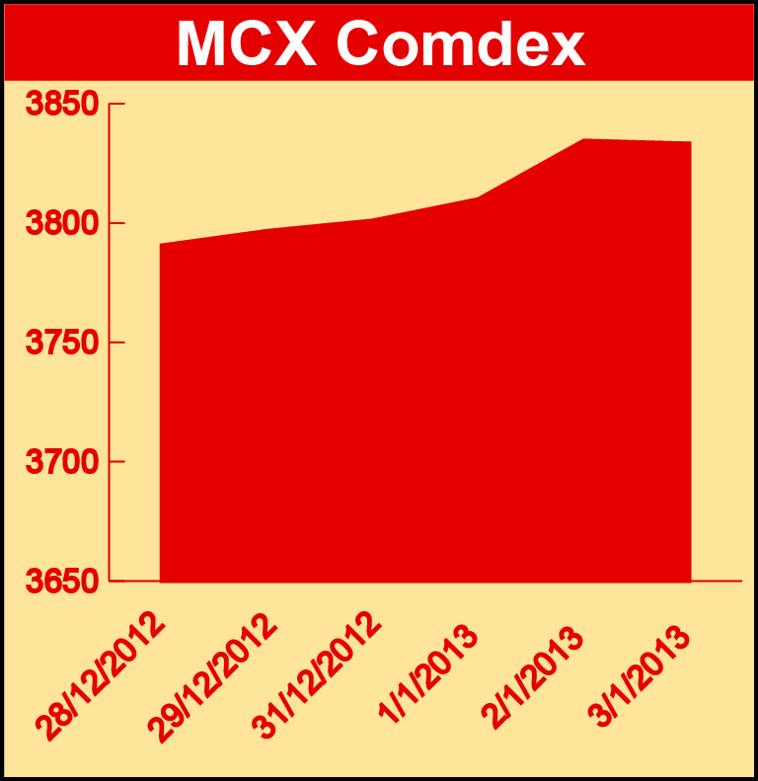

Bullion:
Gold February 13 contract was up by 0.40% to Rs 30945.00 per 10 grams, GoldM March 13 contract was up by 0.60% to Rs 31258.00 per 10 grams, Goldguinea February 13 contract was up by 0.47% to Rs 25023.00 per 8 grams, GoldPetal February 13 contract was up by 0.45% to Rs 3128.00 per grm and GoldPetalDel January 13 contract was up by 0.87% to Rs 3138.00 per grm. Silver March 13 contract was up by 0.82% to Rs 58651.00 per kg, SilverM February 13 contract was up by 0.81% to Rs 58677.00 per kg, SilverMIC February 13 contract was up by 0.82% to Rs 58685.00 per kg and Silver1000 February 13 contract was up by 1.90% to Rs 58593.00 per kg.

Metals
SteelRPR February 13 contract was up by 1.91% to Rs 32610.00 per MT, lead February 13 contract was up by 1.64% to Rs 129.95 per kg, lead mini March 13 contract was up by 1.88% to Rs 130.10 per kg, aluminium March 13 contract was up by 0.96% to Rs 116.15 per kg, alumini March 13 contract was up 0.74% to Rs 116.00 per kg, copper February 13 contract was up by 1.95% to Rs 449.40 per kg, copperm February 13 contract was up by 1.95% to Rs 449.40 per kg, nickel March 13 contract was up 0.41% to Rs 969.30 per kg, nickelm March 13 contract was up by 0.47% to Rs 969.60 per kg while zinc January 13 contract was down by 1.31% to Rs 112.85 per kg and zinc mini January 13 contract was down by 1.31% to Rs 112.85 per kg.

Energy
Crude oil January 13 contract was up by 1.76% to Rs 5080.00 per barrel, Brcrude oil January 13 contract was up by 0.38% to Rs 6113.00 per barrel while Natural gas February 13 contract was down by 6.30% to Rs 178.60 per MMBTU.

AGRICULTURE:
CPO February 13 contract was up by 3.32% to Rs 454.10 per 10 kgs, potato March 13 contract was up by 1.14% to Rs 724.10 per 100 kgs, almond January 13 contract was up by 7.00% to Rs 497.00 per kg while cardamom February 13 contract was down by 2.46% to Rs 1058.60 per kg, menthaoil January 13 contract was down by 2.62% to Rs 1426.30 per kg, kapaskhali March 13 contract was down by 0.41% to Rs 1446.50 per 100 kgs, kapas March 13 contract was down by 3.37% to Rs 958.40 per 20 kgs and cotton March 13 contract was down by 0.99% to Rs 17000.00 per bales.

For further information please contact:

 | Alok Gupta  AVP, Corporate Communication, MCX  Phone No.: +91 22 6731 8888  Mobile No.: +91 9930267906  Email: alok.gupta@mcxindia.com

