Weekly Market Report (December 07, 2012 – December 13, 2012)

MCX – COMDEX

Open: 3757.20 High: 3793.76 Low: 3739.45 Close: 3744.41 Previous close: 3756.72

MCX Comdex was down by 0.33% to 3744.41, MCX Energy was down by 0.69% to 3299.33 and MCX Metal was up by 0.27% to 5340.05.

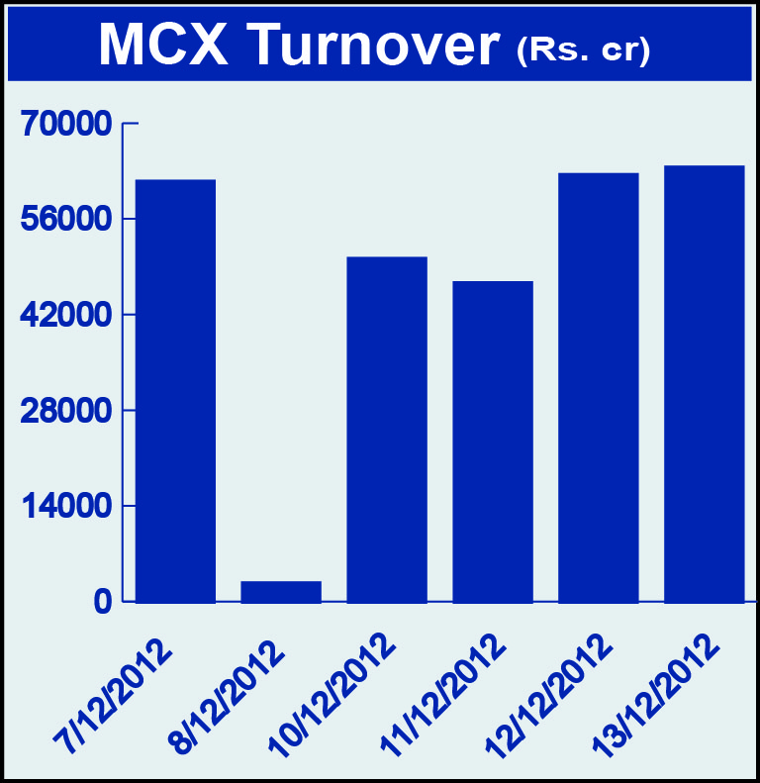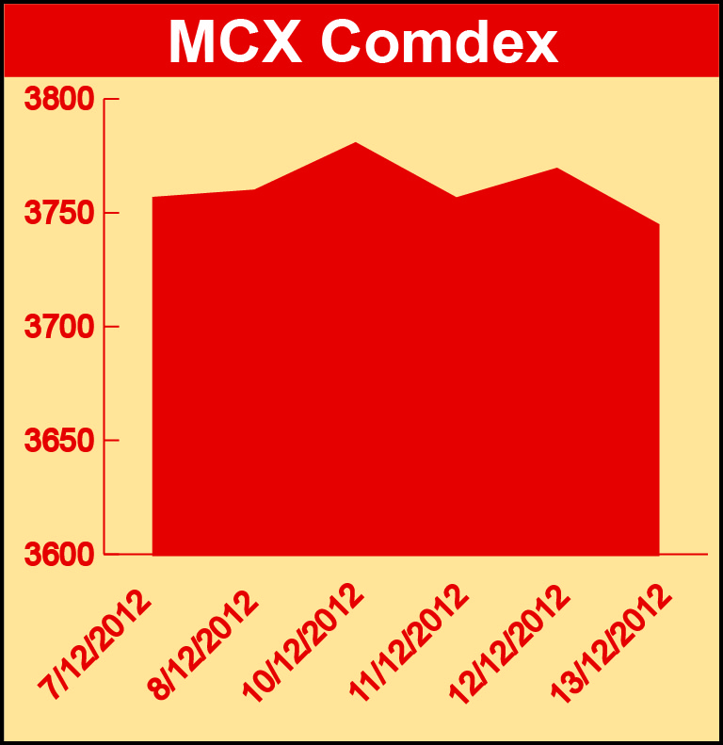

Bullion:
Gold February 13 contract was up by 0.01% to Rs 31227.00 per 10 grams, GoldM January 13 contract was down by 0.10% to Rs 30997.00 per 10 grams, Goldguinea January 13 contract was down by 0.22% to Rs 25011.00 per 8 grams, GoldPetal January 13 contract was down by 2.85% to Rs 3126.00 per grm and GoldPetalDel February 13 contract was up by 0.50% to Rs 3204.00 per grm. Silver March 13 contract was down by 1.49% to Rs 61508.00 per kg, SilverM February 13 contract was down by 1.48% to Rs 61535.00 per kg, SilverMIC February 13 contract was down by 1.48% to Rs 61534.00 per kg and Silver1000 December 12 contract was down by 1.99% to 60048.00 per kg.

Metals
Copper February 13 contract was up by 0.74% to Rs 444.15 per kg, copperm February 13 contract was up by 0.73% to Rs 444.10 per kg, aluminium December 12 contract was up by 1.69% to Rs 114.55 per kg, alumini December 12 contract was up 1.69% to Rs 114.55 per kg, nickel December 12 contract was up 2.95% to Rs 962.90 per kg, nickelm December 12 contract was up by 2.94% to Rs 962.90 per kg, zinc December 12 contract was up by 2.01% to Rs 111.50 per kg, zinc mini December 12 contract was up by 2.12% to Rs 112.95 per kg, lead December 12 contract was up by 3.46% to Rs 124.20 per kg, lead mini December 12 contract was up by 3.46% to Rs 124.20 per kg while steelRPR February 13 contract was down by 1.07% to Rs 30510.00 per MT.

Energy
Crude oil December 12 contract was up by 0.62% to Rs 4716.00 per barrel MMBTU, Brcrude oil December 12 contract was up by 0.88% to Rs 5873.00 per barrel while Natural gas December 12 contract was down by 10.44% to Rs 181.10 per MMBTU.

AGRICULTURE:
Kapaskhali December 12 contract was up by 3.67% to Rs 1426.00per 100 kgs, menthaoil February 13 contract was up by 1.94% to Rs 1474.90 per kg, cotton February 13 contract was up by 3.27% to Rs 17050.00 per bales, kapas March 13 contract was up by 4.96% to Rs 1010.90, potato March 13 contract was up by 0.83% to Rs 725.70per 100 kgs while CPO February 13 contract was down by 2.77% to Rs 413.70 per 10 kgs, almond January 13 contract was down by 0.11% to Rs 456.00 per kg and cardamom December 12 contract was down by 8.79% to Rs 888.60 per kg.

For further information please contact:

 | Alok Gupta  AVP, Corporate Communication, MCX  Phone No.: +91 22 6731 8888  Mobile No.: +91 9930267906  Email: alok.gupta@mcxindia.com

