Weekly Market Report (September 05, 2014 – September 11, 2014)

MCX – COMDEX

Open: 3749.67 High: 3749.96 Low: 3666.05 Close: 3681.21 Previous close: 3739.60

MCX Comdex was down by 1.56% to 3681.21; MCX Metal was down by 2.05% to 4653.24 and MCX Energy was down by 1.75% to 3915.12.

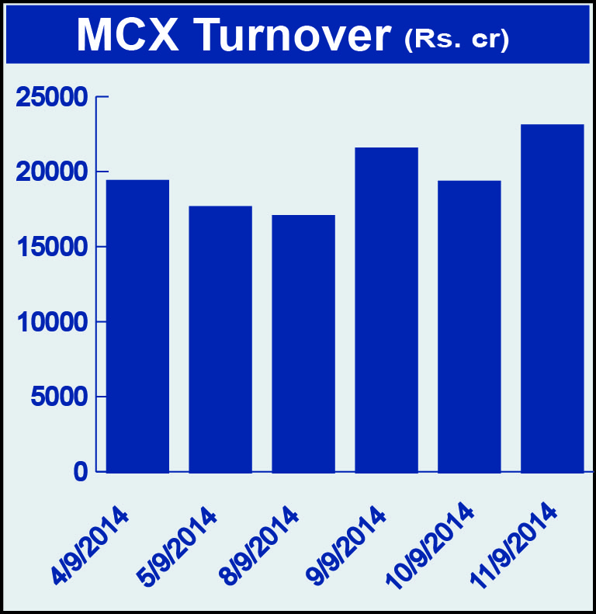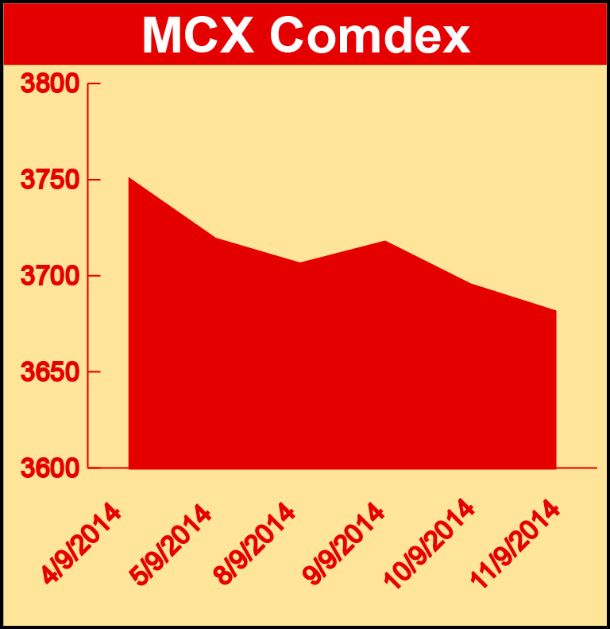

BULLION:
Gold October 14 contract was down by 1.73% to Rs 26986.00 per 10 grams, GoldM October 14 contract was down by 1.74% to Rs 26996.00 per 10 grams, Goldguinea September 14 contract was down 1.28% to Rs 22060.00 per 8 grams, GoldPetal October 14 contract was down by 1.88% to Rs 2760.00 per grm and GoldPetalDel September 14 contract was up by 1.84% to Rs 2939.00 per grm. Silver December 14 contract was down by 1.92% to Rs 41270.00 per kg, SilverM November 14 contract was down by 1.91% to Rs 41305.00 per kg and SilverMIC November 14 contract was down by 1.93% to Rs 41299.00 per kg.

METALS:
Aluminium September 14 contract was down by 3.04% to Rs 122.90 per kg, alumini September 14 contract was down by 3.08% to Rs 122.85 per kg, nickel September 14 contract was down by 4.66% to Rs 1117.60 per kg, nickelm September 14 contract was down by 4.67% to Rs 1117.50 per kg, zinc September 14 contract was down by 4.92% to Rs 138.30 per kg, zinc mini September 14 contract was down by 4.92% to Rs 138.30 per kg, lead mini September 14 contract was down by 4.20% to Rs 128.95 per kg, lead September 14 contract was down by 4.20% to Rs 128.95 per kg, copper November 14 contract was down by 1.37% to Rs 421.30 per kg and copperm November 14 contract was down by 1.37% to Rs 421.30 per kg.

ENERGY:
Natural gas October 14 contract was up by 1.06% to Rs 238.20 per MMBTU while Crude oil October 14 contract was down by 2.33% to Rs 5605.00 per barrel and BRCrudeoil October 14 contract was up by 4.31% to Rs 6063.00 per barrel.

AGRICULTURE:
Cotton October 14 contract was up by 1.47% to Rs 17990.00 per bale, cardamom November 14 contract was up by 2.64% to Rs 941.60 per kg, menthaoil November 14 contract was up by 1.80% to Rs 707.90 per kg and CPO November 14 contract was up by 1.24% to Rs 431.30 per 10 kg.

For further information please contact:

 | Alok Gupta  AVP, Corporate Communication, MCX  Phone No.: +91 22 6731 8888  Mobile No.: +91 9930267906  Email: alok.gupta@mcxindia.com

