Weekly Market Report (October 25, 2012 – November 01, 2012)

MCX – COMDEX

Open: 3655.62 High: 3697.07 Low: 3633.42 Close: 3690.46 Previous close: 3639.92

MCX Comdex was up by 1.39% to 3690.46, MCX Energy was up by 1.86% to 3324.33 and MCX Metal was up by 0.64% to 5146.15.

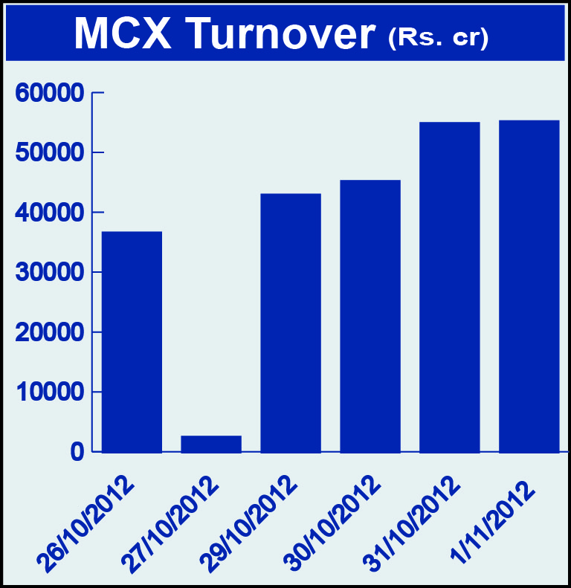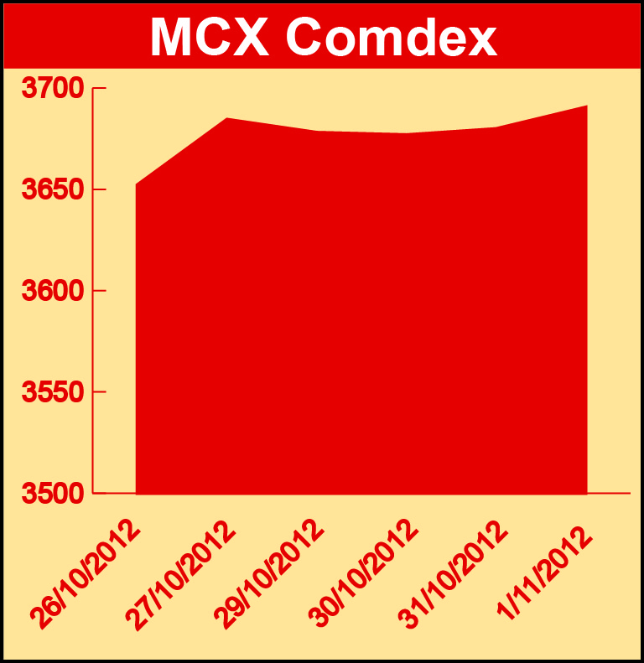

Bullion:
Gold December 12 contract was up by 0.35% to Rs 30952 per 10 grams, goldM January 13 contract was up by 0.41% to Rs 31162 per 10 grams, goldguinea December 12 contract was up by 0.38% to Rs 25055 per 8 grams, goldPetal December 12 contract was up by 0.26% to Rs 3146 per grm and goldPetalDel November 12 contract was up by 0.41% to Rs 3152 per grm. Silver December 12 contract was up by 1.18% to Rs 59695 per kg, SilverM November 12 contract was up by 1.18% to Rs 59715 per kg, silverMIC November 12 contract was up by 1.18% to Rs 59719 per kg and silver1000 November 12 contract was up by 1.11% to Rs 59706 per kg.

Metals
Lead December 12 contract was up by 4.93% to Rs 115.00 per kg, lead mini January 13 contract was up by 4.78% to Rs 115.05 per kg, zinc January 13 contract was up by 1.27% to Rs 103.70 per kg, zinc mini December 12 contract was up by 0.94% to Rs 102.50 per kg while Nickel November 12 contract was down by 1.10% to Rs 882.60 per kg, nickelm November 12 contract was down by 1.11% to Rs 882.70 per kg, copper November 12 contract was down by 0.96% to Rs 423.30 per kg, copperm November 12 contract was down by 0.97% to Rs 423.30 per kg, aluminium November 12 contract was down by 0.57% to Rs 104.40 per kg and alumini December 12 contract was down 0.80% to Rs 105.45 per kg.

Energy
Crude oil January 13 contract was up by 1.12% to Rs 4801.00 per barrel while Natural gas November 12 contract was down by 3.68% to Rs 198.70 per MMBTU and Brcrude oil December 12 contract was down by 0.39% to Rs 5815.00 per barrel.

AGRICULTURE:
Menthaoil January 13 contract was up by 5.07% to Rs 1221.60 per kg, cpo January 13 contract was up by 2.15% to Rs 451.80 per 10 kgs, kapaskhali December 12 contract was up by 0.84% to Rs 1443.50 per 100 kgs, steelRPR December 12 contract was up by 0.35% to Rs 31270.20 per MT while Cardamom November 12 contract was down by 4.35% to Rs 800.00 per kg and cotton November 12 contract was down by 2.37% to Rs 16100.00 per bale.

For further information please contact:

 | Alok Gupta  AVP, Corporate Communication, MCX  Phone No.: +91 22 6731 8888  Mobile No.: +91 9930267906  Email: alok.gupta@mcxindia.com

