Weekly Market Report (June 17, 2011 – June 23, 2011)

MCX – COMDEX

Open: 3362.62 High: 3385.50 Low: 3305.62 Close: 3319.16 Previous close: 3365.99

MCX Comdex was down by 1.39% to 3319.16, MCX Energy was down by 3.84% to 2928.09 and MCX Metal was down by 0.43% to 4421.67.

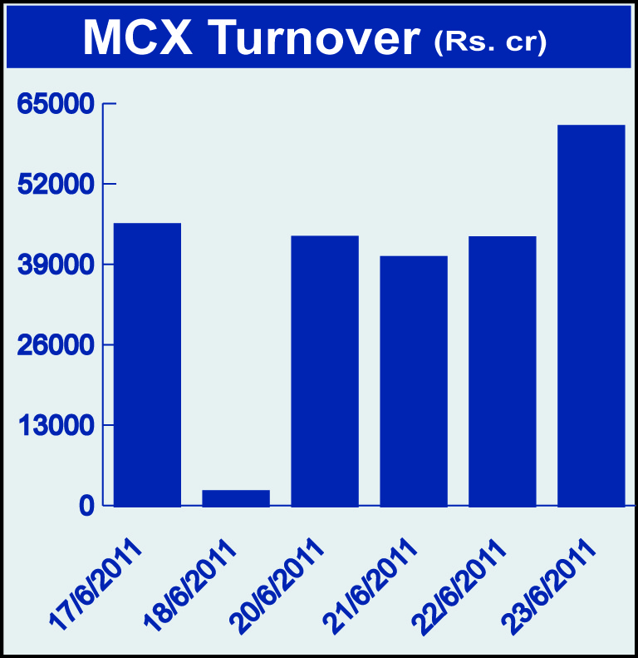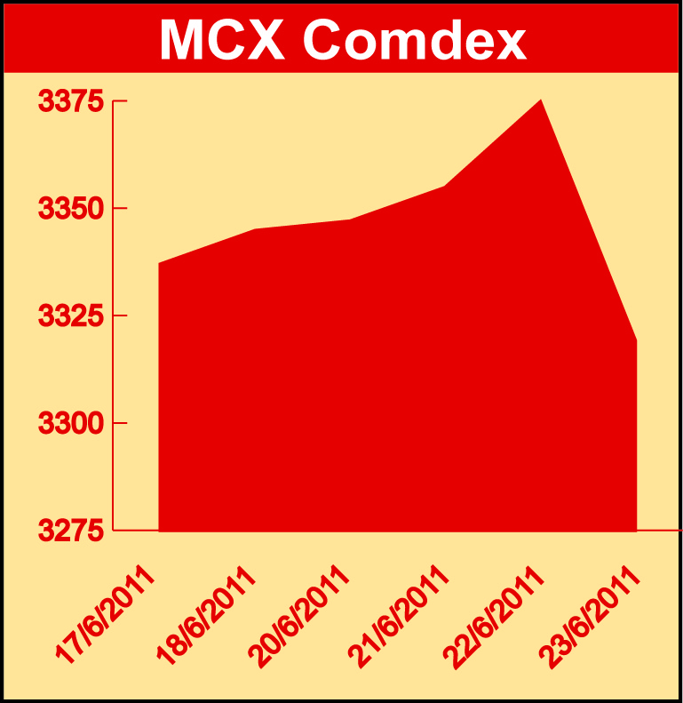

Bullion:
Gold August 11 contract was down 0.37% to Rs 22411.00 per 10 grams, GoldM July 11 contract was down by 0.39% to Rs 22259.00 per 10 grams, Goldguinea June 11 contract was down by 0.45% to Rs 17843.00 per 8 grams and GoldPetal June 11 contract was down by 0.27% to Rs 2243.00 per grm. Silver July 11 contract was down by 1.15% to Rs 52721.00 per kg, SilverM June 11 contract was down by 1.15% to Rs 52742.00 per kg and SilverMIC June 11 contract was down by 1.16% to Rs 52747.00 per kg.

Metals
Lead August 11 contract was up by 2.44% to Rs 115.50 per kg, lead mini August 11 contract was up by 2.08% to Rs 115.30 per kg, zinc August 11 contract was up by 1.44% to Rs 102.35 per kg, zinc mini June 11 contract was up 1.01% to Rs 100.25 per kg, nickel June 11 contract was up by 1.22% to Rs 991.60 per kg while copper June 11 contract was down by 1.58% to Rs 402.00 per kg, aluminium June 11 contract was down by 1.88% to Rs 112.10 per kg and alumini June 11 contract was down 1.88% to Rs 112.10 per kg.

Energy
Crude oil July 11 contract was down 3.90% to Rs 4141.00 per barrel and natural gas August 11 contract was down by 5.54% to Rs 194.40 per MMBTU.

AGRICULTURE:
Cardamom July 11 contract was up by 6.47% to Rs 872.70 per kg, potatoTRWR August 11 contract was up by 5.70% to Rs 415.50 per 100 kgs, sugar July 11 contract was up 3.53% to Rs 2612.00 per 100 kgs, menthaoil June 11 contract was up by 1.04% to Rs 848.40 per kg, potato August 11 contract was up by 3.70% to Rs 451.00 per 100 kgs while CPO July 11 contract was down by 1.46% to Rs 484.80 per 10 kgs and refsoyoil August 11 contract was down by 1.69% to Rs 638.25 per 10 kgs.

For further information please contact:

 | Alok Gupta  Sr. Manager, Corporate Communication, MCX  Phone No.: +91 22 6731 8888  Mobile No.: +91 9930267906  Email: alok.gupta@mcxindia.com

Disclaimer:
Multi Commodity Exchange of India Limited is proposing, subject to market conditions and other considerations, a public offer of equity shares by way of an offer for sale and has filed a Draft Red Herring Prospectus ("DRHP") with the SEBI. The DRHP is available on the websites of SEBI at www.sebi.gov.in and the book running lead managers at www.edelcap.com, http://www.online.citibank.co.in/rhtm/citigroupglobalscreen1.htm and www.morganstanley.com/indiaofferdocuments. Investors should note that investment in equity shares involves a high degree of risk and for details in relation to risk factors, please see the section titled "Risk Factors" in the DRHP.

This advertisement may not be published or distributed in the U.S., Canada or Japan and is not an offer or solicitation of an offer for sale of securities in the U.S. These securities have not been and will not be registered under the U.S. Securities Act of 1933, as amended, and may not be offered or sold in the U.S. absent registration or an exemption from registration under such act.

