Weekly Market Report (July 20, 2012 – July 26, 2012)

MCX – COMDEX

Open: 3763.55 High: 3765.11 Low: 3713.63 Close: 3750.19 Previous close: 3763.90

MCX Comdex was down by 0.36% to 3750.19, MCX Metal was up by 0.57% to 4918.23 and MCX Energy was down by 1.40% to 3420.53.

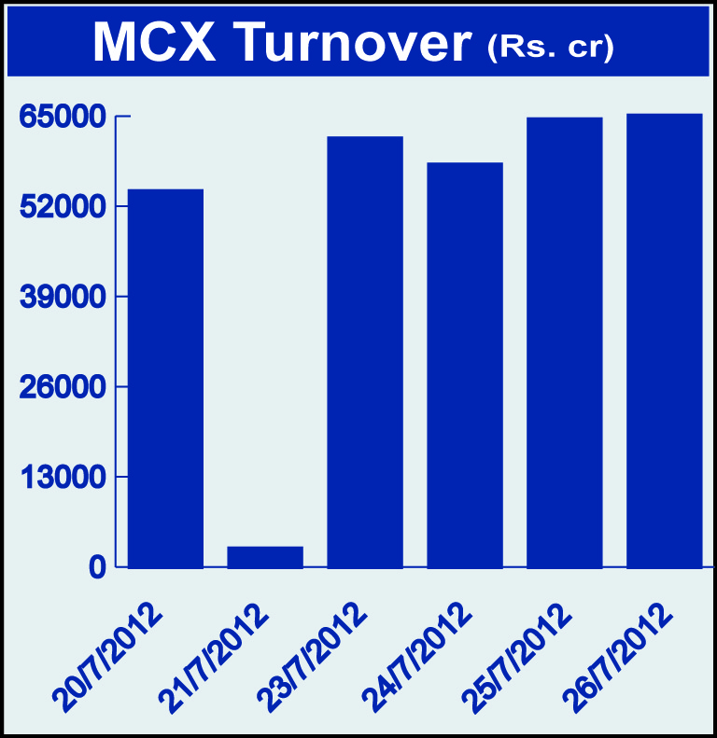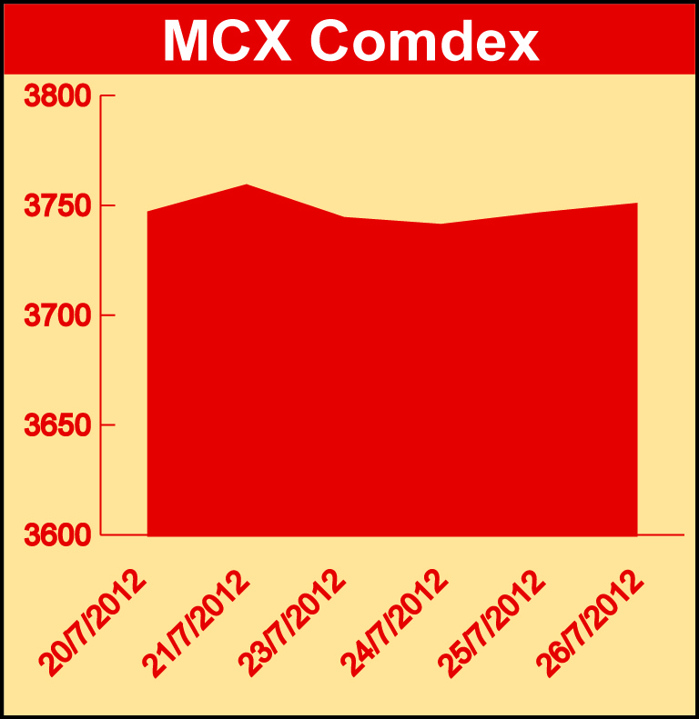

Bullion:
Gold August 12 contract was down by 2.18% to Rs 29793.00 per 10 grams, GoldM August 12 contract was down by 2.06% to Rs 29774.00 per 10 grams, Goldguinea August 12 contract was down by 1.80% to Rs 24001.00 per 8 grams GoldPetal September 12 contract was down by 1.92% to Rs 3022.00 per grm and GoldPetalDel August 12 contract was up by 1.06% to Rs 3137.00 per grm. Silver September 12 contract was down by 1.04% to Rs 53217.00 per kg, SilverM August 12 contract was down by 1.03% to Rs 53247.00 per kg and SilverMIC August 12 contract was down by 1.02% to Rs 53248.00 per kg.

Metals
Copper August 12 contract was down by 2.87% to Rs 418.60 per kg, copperm August 12 contract was down by 2.84% to Rs 418.65 per kg, aluminium July 12 contract was down by 2.64% to Rs 103.25 per kg, alumini July 12 contract was down by 2.59% to Rs 103.25 per kg, lead July 12 contract was down by 1.70% to Rs 104.20 per kg, lead mini July 12 contract was down by 1.60% to Rs 104.25 per kg, zinc July 12 contract was down 2.84% to Rs 101.05 per kg, zinc mini July 12 contract was down by 2.79% to Rs 101.05 per kg, nickel July 12 contract was down by 1.10% to Rs 883.00 per kg and nickelm July 12 contract was down by 1.09% to Rs 883.20 per kg.

Energy
Natural gas July 12 contract was up by 4.24% to Rs 172.00 per MMBTU while Brcrude oil September 12 contract was down by 1.97% to Rs 5816.00 per barrel and Crude oil September 12 contract was down by 2.59% to Rs 5035.00 per barrel.

AGRICULTURE:
Cardamom August 12 contract was up by 6.18% to Rs 1416.00 per kg, potato August 12 contract was up by 0.78% to Rs 1331.80 per 100 kgs, maize September 12 contract was up by 5.11% to Rs 1409.00 per 100 kgs while CPO September 12 contract was down by 1.99% to Rs 565.00 per 10 kgs, cotton July 12 contract was down by 2.63% to Rs 17800.00 per bales, menthaoil September 12 contract was down by 1.65% to Rs 1368.90 per kg and potatoTRWR August 12 contract was down by 3.33% to Rs 1003.80 per 100 kgs.

For further information please contact:

 | Alok Gupta  AVP, Corporate Communication,  Phone No.: +91 22 6731 8888  Mobile No.: +91 9930267906  Email: alok.gupta@mcxindia.com

