Weekly Market Report (July 06, 2012 – July 12, 2012)

MCX – COMDEX

Open: 3667.67 High: 3671.22 Low: 3641.09 Close: 3668.34 Previous close: 3668.36

MCX Comdex was down by 0.02 points to 3668.34, MCX Metal was down by 0.02% to 4874.24 and MCX Energy was up by 0.46% to 3279.07.

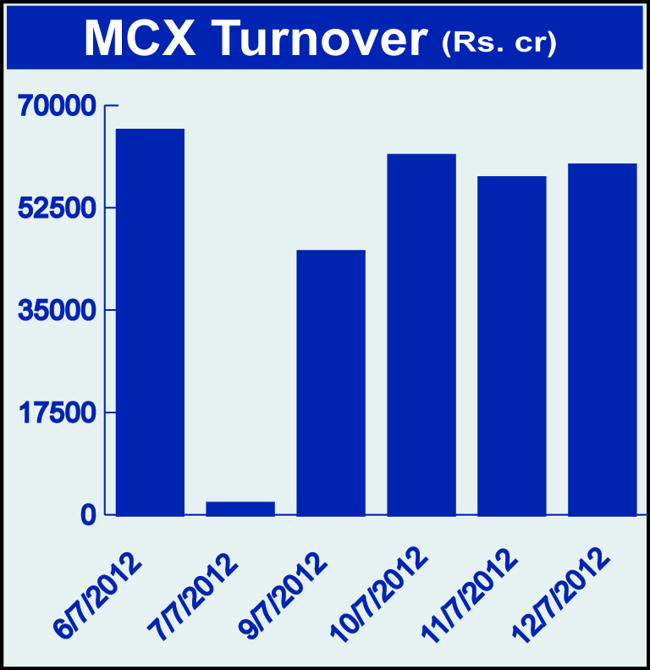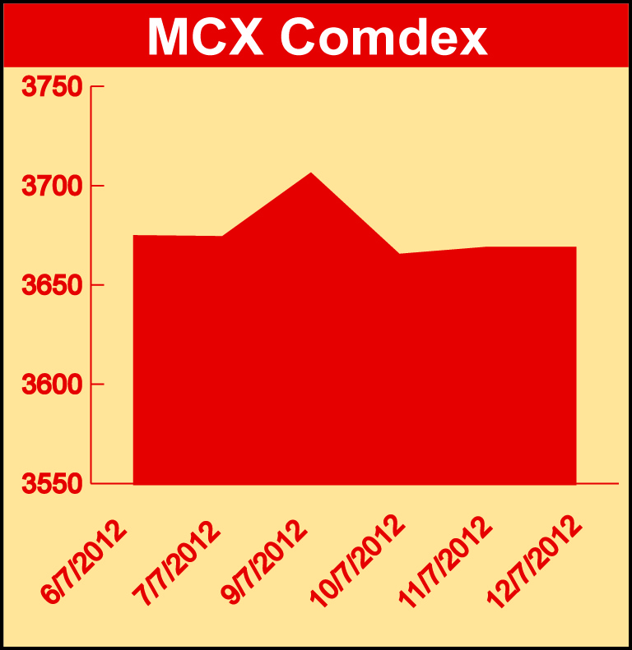

Bullion:
Gold August 12 contract was down by 1.76% to Rs 29222.00 per 10 grams, GoldM August 12 contract was down by 1.74% to Rs 29240.00 per 10 grams, Goldguinea July 12 contract was down by 1.56% to Rs 23442.00 per 8 grams GoldPetal July 12 contract was down by 1.44% to Rs 2943.00 per grm and GoldPetalDel July 12 contract was down by 2.17% to Rs 3150.00 per grm. Silver September 12 contract was down by 1.22% to Rs 53017.00 per kg, SilverM August 12 contract was down by 1.20% to Rs 53020.00 per kg and SilverMIC August 12 contract was down by 1.20% to Rs 53054.00 per kg.

Metals
Copper August 12 contract was down by 1.32% to Rs 422.90 per kg, copperm August 12 contract was down by 1.32% to Rs 422.90 per kg, aluminium July 12 contract was down by 2.16% to Rs 104.25 per kg, alumini July 12 contract was down by 2.11 % to Rs 104.30 per kg, lead July 12 contract was down by 0.72% to Rs 103.85 per kg, lead mini July 12 contract was down by 0.72% to Rs 103.85 per kg, zinc September 12 contract was down 0.48% to Rs 104.25 per kg, zinc mini July 12 contract was down by 0.24% to Rs 103.25 per kg, nickel July 12 contract was down by 4.29% to Rs 890.30 per kg and nickelm July 12 contract was down by 4.29% to Rs 890.40 per kg.

Energy
Natural gas September 12 contract was down by 1.73% to Rs 164.30 per MMBTU, Brcrude oil August 12 contract was down by 0.41% to Rs 5567.00 per barrel and Crude oil July 12 contract was down by 0.91% to Rs 4780.00 per barrel.

AGRICULTURE:
Cardamom July 12 contract was up by 10.18% to Rs 1484.60 per kg, cotton July 12 contract was up by 3.21% to Rs 17340.00 per bales, potato September 12 contract was up by 3.71% to Rs 1446.90 per 100 kgs, menthaoil August 12 contract was up by 3.02% to Rs 1284.10 per kg while potatoTRWR July 12 contract was down by 8.67% to Rs 980.20 per 100 kgs and CPO August 12 contract was down by 2.79% to Rs 560.90 per 10 kgs.

For further information please contact:

 | Alok Gupta  AVP, Corporate Communication,  Phone No.: +91 22 6731 8888  Mobile No.: +91 9930267906  Email: alok.gupta@mcxindia.com

