Weekly Market Report (January 27, 2012 – February 02, 2012)

MCX – COMDEX

Open: 3807.43 High: 3838.04 Low: 3726.20 Close: 3736.12 Previous close: 3800.91

MCX Comdex was down by 1.70% to 3736.12, MCX Energy was down by 5.04% to 3173.04 and MCX Metal was down by 0.16% to 4937.30.

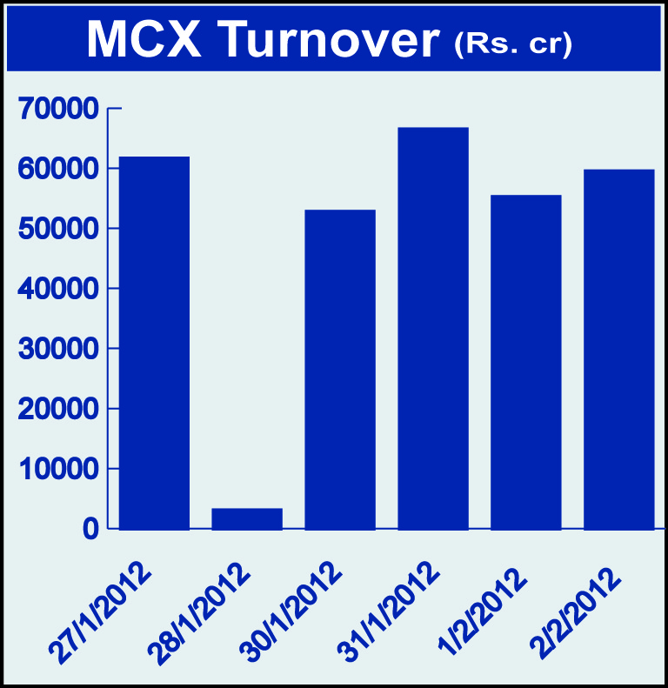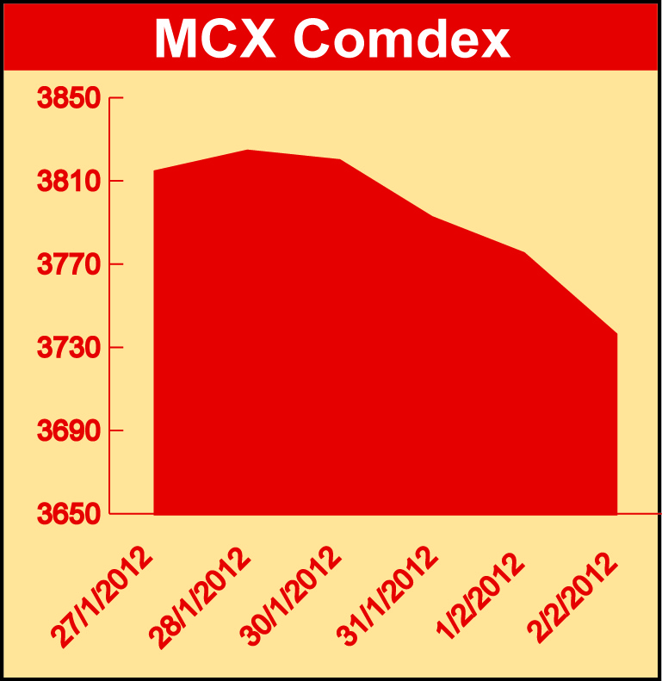

Bullion:
Gold February 12 contract was up by 2.05% to Rs 28155.00 per 10 grams, goldM February 12 contract was up by 1.96% to Rs 28139.00 per 10 grams, goldguinea March 12 contract was up by 1.77% to Rs 22814.00 per 8 grams GoldPetal March 12 contract was up by 1.82% to Rs 2858.00 per grm and GoldPetalDel March 12 contract was up by 4.72% to Rs 2930.00 per grm. Silver March 12 contract was up by 1.08% to Rs 57023.00 per kg, SilverM April 12 contract was up by 1.36% to Rs 58398.00 per kg and silverMIC April 12 contract was up by 1.36% to Rs 58392.00 per kg.

Metals
Nickel February 12 contract was down by 2.33% to Rs 1026.70 per kg, alumini March 12 contract was down 3.75% to Rs 109.10 per kg, zinc February 12 contract was down by 5.57% to Rs 102.55 per kg and zinc mini February 12 contract was down by 5.57% to Rs 102.55 per kg, lead mini February 12 contract was up by 6.66% to Rs 105.85 per kg and lead February 12 contract was up by 6.66% to Rs 105.85 per kg, aluminium February 12 contract was down by 3.70% to Rs 108.00 per kg, nickelm March 12 contract was down by 2.32% to Rs 1033.00 per kg, copper February 12 contract was down by 2.71% to Rs 411.70 per kg and copperm February 12 contract was down by 2.72% to Rs 411.70 per kg.

Energy
Natural gas February 12 contract was down by 9.73% to Rs 124.30 per MMBTU, crude oil February 12 contract was down by 5.31% to Rs 4727.00 per barrel and BRcrudeoil February 12 contract was down by 0.85% to Rs 5483.00 per barrel.

Agriculture:
Cardamom April 12 contract was up by 4.99% to Rs 757.50 per kg, sugar April 12 contract was up by 1.97% to Rs 2947.00 per 100 kgs, potato April 12 contract was up by 0.23% to Rs 726.00 per 100 kgs, menthaoil March 12 contract was up by 3.70% to Rs 1601.10 per kg while CPO April 12 contract was down by 3.43% to Rs 517.50 per 10 kgs, potatoTRWR April 2012 contract was down by 0.50% to Rs 575.40 per 100 kgs, kapas April 12 contract was down by 7.83% to Rs 864.00 per 20 kgs and cotton March 12 contract was down by 3.22% to Rs 17730.00 per bales.

For further information please contact:

 | Alok Gupta  AVP, Corporate Communication,  Phone No.: +91 22 6731 8888  Mobile No.: +91 9930267906  Email: alok.gupta@mcxindia.com

Disclaimer:
Multi Commodity Exchange of India Limited is proposing, subject to market conditions and other considerations, a public offer of equity shares by way of an offer for sale and has filed a Draft Red Herring Prospectus ("DRHP") with the SEBI. The DRHP is available on the websites of SEBI at www.sebi.gov.in and the book running lead managers at www.edelcap.com, http://www.online.citibank.co.in/rhtm/citigroupglobalscreen1.htm and www.morganstanley.com/indiaofferdocuments. Investors should note that investment in equity shares involves a high degree of risk and for details in relation to risk factors, please see the section titled "Risk Factors" in the DRHP.

This advertisement may not be published or distributed in the U.S., Canada or Japan and is not an offer or solicitation of an offer for sale of securities in the U.S. These securities have not been and will not be registered under the U.S. Securities Act of 1933, as amended, and may not be offered or sold in the U.S. absent registration or an exemption from registration under such act.

