Weekly Market Report (January 06, 2012 – January 12, 2012)

MCX – COMDEX

Open: 3855.19 High: 3855.19 Low: 3805.08 Close: 3819.97 Previous close: 3854.87

MCX Comdex was down 0.91% to 3819.97, MCX Energy was down by 4.25% to 3505.57 and MCX Metal was down by 0.82% to 4798.22.

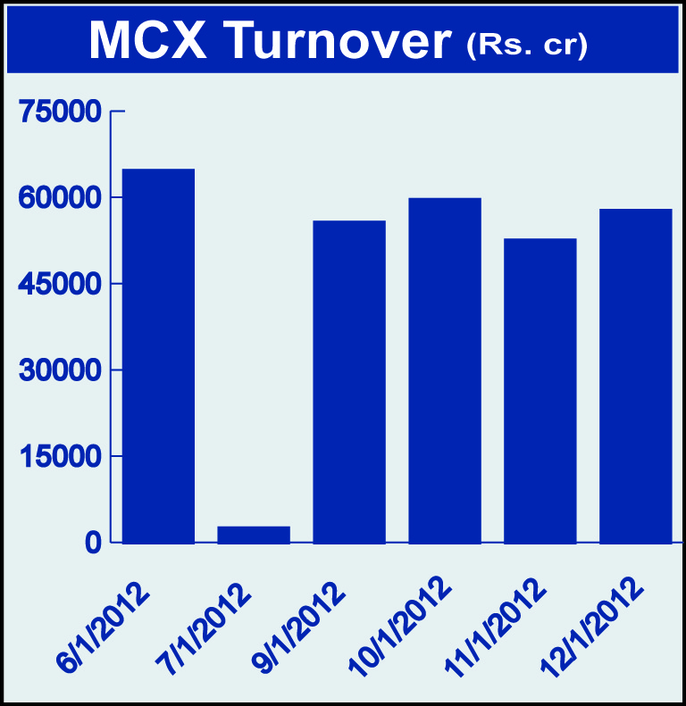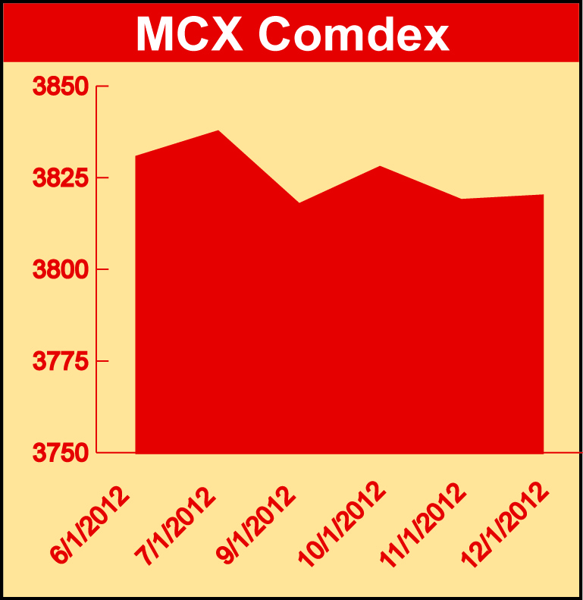

Bullion:
Gold February 12 contract was down by 0.56% to Rs 27665.00 per 10 grams, goldM February 12 contract was down by 0.54% to Rs 27681.00 per 10 grams, goldguinea January 12 contract was down by 0.45% to Rs 22122.00 per 8 grams GoldPetal January 12 contract was down by 0.43% to Rs 2775.00 per grm and GoldPetalDel February 12 contract was down by 2.62% to Rs 2716.00 per grm. Silver March 12 contract was up by 0.06% to Rs 52770.00 per kg, SilverM February 12 contract was up by 0.06% to Rs 52803.00 per kg and silverMIC February 12 contract was up by 0.06% to Rs 52811.00 per kg.

Metals
Nickel January 12 contract was up by 2.59% to Rs 1015.90 per kg, nickelm March 12 contract was up by 2.82% to Rs 1028.20 per kg, copper February 12 contract was up by 3.58% to Rs 416.80 per kg, copperm February 12 contract was up by 3.57% to Rs 416.75 per kg, aluminium March 12 contract was up by 3.61% to Rs 113.50 per kg, alumini March 12 contract was up 2.96% to Rs 113.10 per kg, zinc January 12 contract was up by 3.80% to Rs 101.10 per kg and zinc mini January 12 contract was up by 3.80% to Rs 101.10 per kg while lead mini January 12 contract was down by 1.32% to Rs 104.65 per kg and lead March 12 contract was down by 2.20% to Rs 106.45 per kg.

Energy
Crude oil January 12 contract was down by 3.36% to Rs 5260.00 per barrel and Natural gas January 12 contract was down by 12.27% to Rs 138.70 per MMBTU.

Agriculture:
Menthaoil January 12 contract was up by 6.93% to Rs 1447.60 per kg, cotton March 12 contract was up by 3.76% to Rs 18510.00 per bales, potato March 12 contract was up by 8.66% to Rs 716.50 per 100 kgs, potatoTRWR March 2012 contract was up by 8.90% to Rs 584.90 per 100 kgs, kapas March 12 contract was 7.49% to Rs 914.50 per 20 kgs, guarseed January 12 contract was up by 14.67% to Rs 8490.00 per 100 kgs while sugar March 12 contract was down by 0.38% to Rs 2899.00 per 100 kgs, CPO February 12 contract was down by 1.37% to Rs 539.70 per 10 kgs and cardamom January 12 contract was down by 3.69% to Rs 581.50 per kg.

For further information please contact:

 | Alok Gupta  AVP, Corporate Communication,  Phone No.: +91 22 6731 8888  Mobile No.: +91 9930267906  Email: alok.gupta@mcxindia.com

Disclaimer:
Multi Commodity Exchange of India Limited is proposing, subject to market conditions and other considerations, a public offer of equity shares by way of an offer for sale and has filed a Draft Red Herring Prospectus ("DRHP") with the SEBI. The DRHP is available on the websites of SEBI at www.sebi.gov.in and the book running lead managers at www.edelcap.com, http://www.online.citibank.co.in/rhtm/citigroupglobalscreen1.htm and www.morganstanley.com/indiaofferdocuments. Investors should note that investment in equity shares involves a high degree of risk and for details in relation to risk factors, please see the section titled "Risk Factors" in the DRHP.

This advertisement may not be published or distributed in the U.S., Canada or Japan and is not an offer or solicitation of an offer for sale of securities in the U.S. These securities have not been and will not be registered under the U.S. Securities Act of 1933, as amended, and may not be offered or sold in the U.S. absent registration or an exemption from registration under such act.

