Weekly Market Report (February 17, 2012 – February 23, 2012)

MCX – COMDEX

Open: 3809.05 High: 3929.84 Low: 3804.84 Close: 3925.05 Previous close: 3808.95

MCX Comdex was up by 3.05% to 3925.05, MCX Energy was up by 3.67% to 3502.60 and MCX Metal was up by 2.99% to 5009.93.

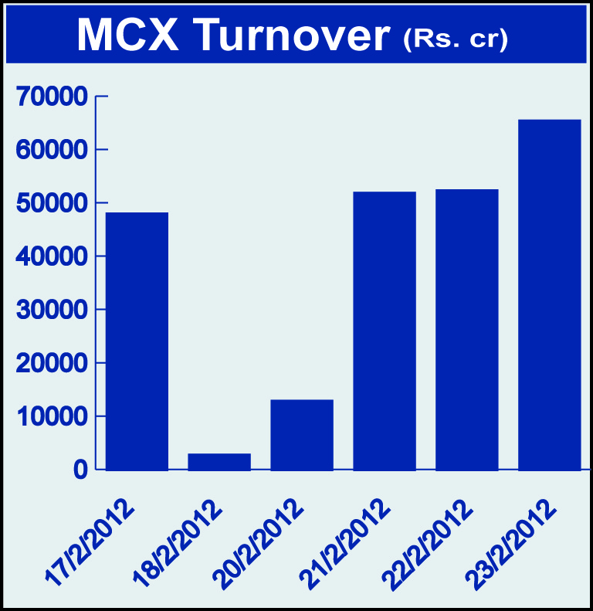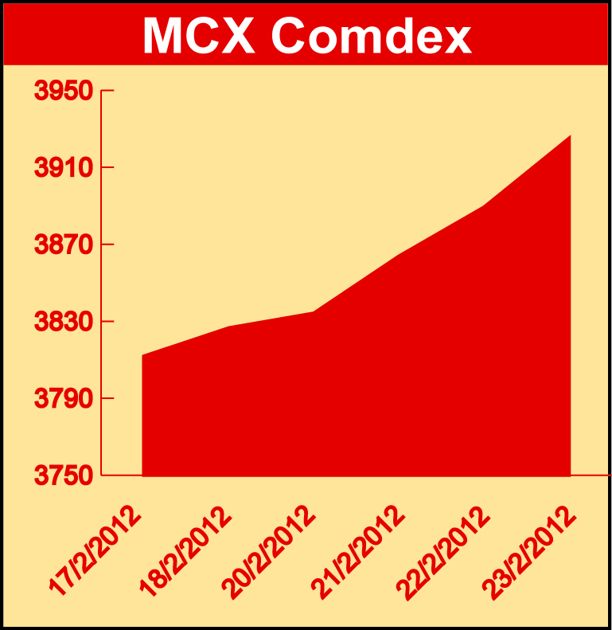

Bullion:
Gold April 12 contract was up by 0.52% to Rs 28357.00 per 10 grams, goldM March 12 contract was up by 0.56% to Rs 28172.00 per 10 grams, goldguinea April 12 contract was up by 0.72% to Rs 22852.00 per 8 grams GoldPetal March 12 contract was up by 0.59% to Rs 2841.00 per grm and GoldPetalDel March 12 contract was up by 2.49% to Rs 2857.00 per grm. Silver March 12 contract was up by 4.38% to Rs 58677.00 per kg, SilverM April 12 contract was up by 4.55% to Rs 60310.00 per kg, silverMIC April 12 contract was up by 4.54% to Rs 60308.00 per kg and platinum March 12 contract was up by 3.96% to Rs 2663.00 per grm.

Metals
Alumini February 12 contract was up 3.68% to Rs 110.00 per kg, aluminium February 12 contract was up by 3.63% to Rs 109.95 per kg, lead mini February 12 contract was up by 5.06% to Rs 104.95 per kg, lead February 12 contract was up by 5.11% to Rs 104.95 per kg, zinc April 12 contract was up by 2.65% to Rs 102.65 per kg, zinc mini April 12 contract was up by 1.99% to Rs 102.60 per kg while nickelm April 12 contract was down by 0.88% to Rs 1001.90 per kg, nickel April 12 contract was down by 0.86% to Rs 1001.80 per kg, copper April 12 contract was down by 0.57% to Rs 418.90 per kg and copperm April 12 contract was down by 0.53% to Rs 419.05 per kg.

Energy
BRcrudeoil April 12 contract was up by 2.02% to Rs 6040.00 per barrel, crude oil March 12 contract was up by 3.45% to Rs 5280.00 per barrel and natural gas February 12 contract was up by 0.95% to Rs 128.00 per MMBTU.

Agriculture:
Cardamom April 12 contract was up by 10.43% to Rs 927.50 per kg, CPO April 12 contract was up by 3.48% to Rs 558.30 per 10 kgs, potato April 12 contract was up by 5.74% to Rs 799.20 per 100 kgs, potatoTRWR April 12 contract was up by 5.43% to Rs 669.50 per 100 kgs, menthaoil April 12 contract was up by 5.99% to Rs 1708.10 per kg, kapas March 12 contract was up by 0.33% to Rs 860.40 per 20 kgs while cotton March 12 contract was down by 3.44% to Rs 17120.00 per bales, maize March 12 contract was down by 0.55% to Rs 1170.00 per 100 kgs and sugar March 12 contract was down by 0.98% to Rs 2840.00 per 100 kgs.

For further information please contact:

 | Alok Gupta  AVP, Corporate Communication,  Phone No.: +91 22 6731 8888  Mobile No.: +91 9930267906  Email: alok.gupta@mcxindia.com

Disclaimer:
Multi Commodity Exchange of India Limited is proposing, subject to market conditions and other considerations, a public offer of equity shares by way of an offer for sale and has filed a Draft Red Herring Prospectus ("DRHP") with the SEBI. The DRHP is available on the websites of SEBI at www.sebi.gov.in and the book running lead managers at www.edelcap.com, http://www.online.citibank.co.in/rhtm/citigroupglobalscreen1.htm and www.morganstanley.com/indiaofferdocuments. Investors should note that investment in equity shares involves a high degree of risk and for details in relation to risk factors, please see the section titled "Risk Factors" in the DRHP.

This advertisement may not be published or distributed in the U.S., Canada or Japan and is not an offer or solicitation of an offer for sale of securities in the U.S. These securities have not been and will not be registered under the U.S. Securities Act of 1933, as amended, and may not be offered or sold in the U.S. absent registration or an exemption from registration under such act.

