Weekly Market Report (December 30, 2011 – January 05, 2012)

MCX – COMDEX

Open: 3766.15 High: 3885.16 Low: 3766.15 Close: 3854.87 Previous close: 3765.92

MCX Comdex was up 2.36% to 3854.87, MCX Energy was up by 2.02% to 3588.64 and MCX Metal was down by 2.75% to 4759.31.

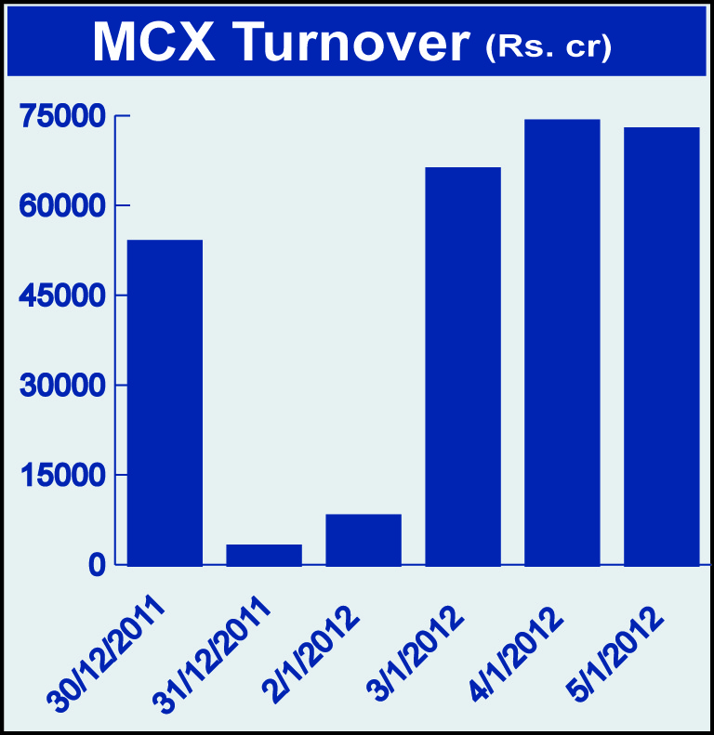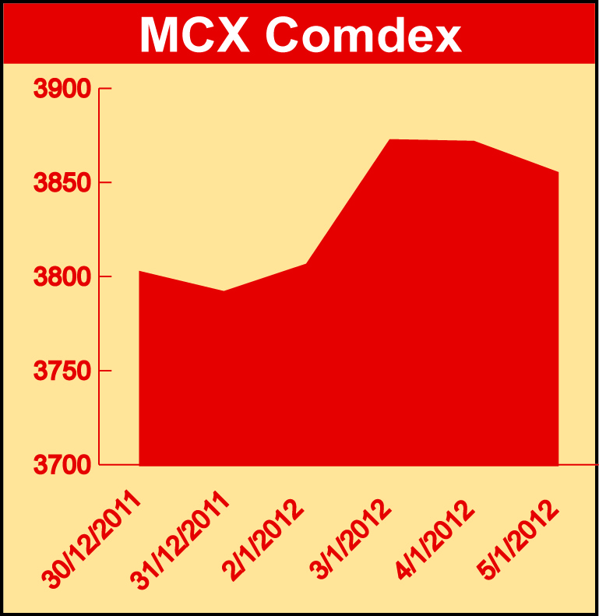

Bullion:
Gold February 12 contract was up by 3.67% to Rs 27821.00 per 10 grams, goldM March 12 contract was up by 3.70% to Rs 28000.00 per 10 grams, goldguinea January 12 contract was up by 3.52% to Rs 22222.00 per 8 grams GoldPetal January 12 contract was up by 3.53% to Rs 2787.00 per grm and GoldPetalDel January 12 contract was up by 3.33% to Rs 2792.00 per grm. Silver March 12 contract was up by 5.02% to Rs 52740.00 per kg, SilverM February 12 contract was up by 5.04% to Rs 52773.00 per kg and silverMIC February 12 contract was up by 5.03% to Rs 52777.00 per kg.

Metals
Lead March 12 contract was up by 1.82% to Rs 108.85 per kg, nickel March 12 contract was up by 2.29% to Rs 1004.90 per kg, copper February 12 contract was up by 0.59% to Rs 402.40 per kg, copperm February 12 contract was up by 0.61% to Rs 402.40 per kg, aluminium March 12 contract was up by 1.15% to Rs 109.55 per kg, alumini March 12 contract was up 1.57% to Rs 109.85 per kg while lead mini January 12 contract was down by 0.38% to Rs 106.05 per kg zinc January 12 contract was down by 0.76% to Rs 97.40 per kg and zinc mini January 12 contract was down by 0.81% to Rs 97.40 per kg.

Energy
Crude oil February 12 contract was up by 2.71% to Rs 5462.00 per barrel while Natural gas January 12 contract was down by 3.36% to Rs 158.10 per MMBTU.

Agriculture:
CPO February 12 contract was up by 0.33% to Rs 547.20 per 10 kgs, menthaoil January 12 contract was up by 3.09% to Rs 1353.80 per kg, cardamom March 12 contract was up by 1.32% to Rs 653.30 per kg, cotton January 12 contract was up by 2.58% to Rs 17520.00 per bales, potato March 12 contract was up by 2.41% to Rs 659.40 per 100 kgs, potatoTRWR March 2012 contract was up by 1.82% to Rs 537.10 per 100 kgs, kapas March 12 contract was up 2.00% to Rs 850.80 per 20 kgs while sugar January 12 contract was down by 2.58% to Rs 2832.00 per 100 kgs.

For further information please contact:

 | Alok Gupta  AVP, Corporate Communication,  Phone No.: +91 22 6731 8888  Mobile No.: +91 9930267906  Email: alok.gupta@mcxindia.com

Disclaimer:
Multi Commodity Exchange of India Limited is proposing, subject to market conditions and other considerations, a public offer of equity shares by way of an offer for sale and has filed a Draft Red Herring Prospectus ("DRHP") with the SEBI. The DRHP is available on the websites of SEBI at www.sebi.gov.in and the book running lead managers at www.edelcap.com, http://www.online.citibank.co.in/rhtm/citigroupglobalscreen1.htm and www.morganstanley.com/indiaofferdocuments. Investors should note that investment in equity shares involves a high degree of risk and for details in relation to risk factors, please see the section titled "Risk Factors" in the DRHP.

This advertisement may not be published or distributed in the U.S., Canada or Japan and is not an offer or solicitation of an offer for sale of securities in the U.S. These securities have not been and will not be registered under the U.S. Securities Act of 1933, as amended, and may not be offered or sold in the U.S. absent registration or an exemption from registration under such act.

