Weekly Market Report (December 23, 2011 – December 29, 2011)

MCX – COMDEX

Open: 3790.25 High: 3844.18 Low: 3765.92 Close: 3765.92 Previous close: 3789.16

MCX Comdex was down 0.61% to 3765.92, MCX Energy was up by 0.65% to 3588.64 and MCX Metal was down by 2.37% to 4631.88.

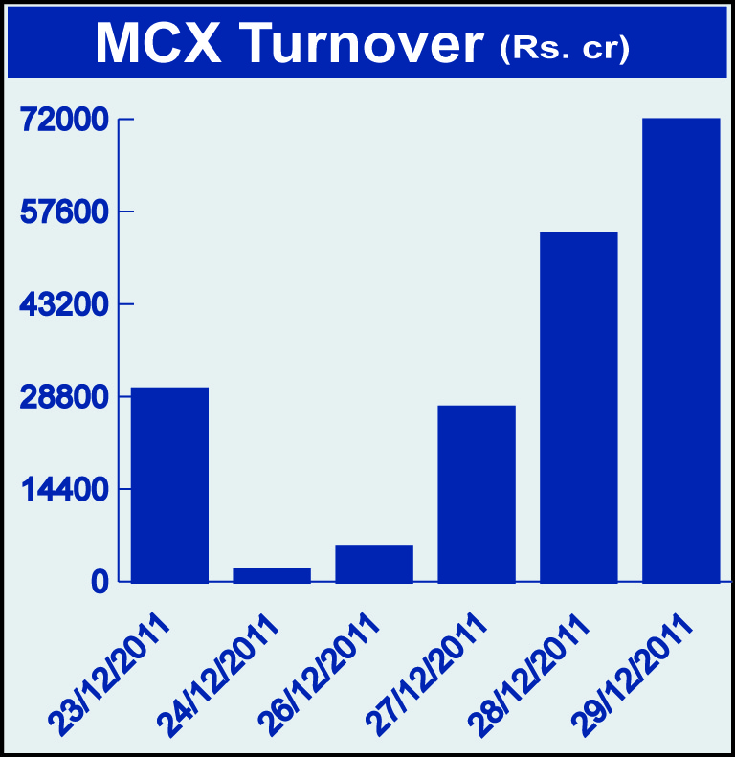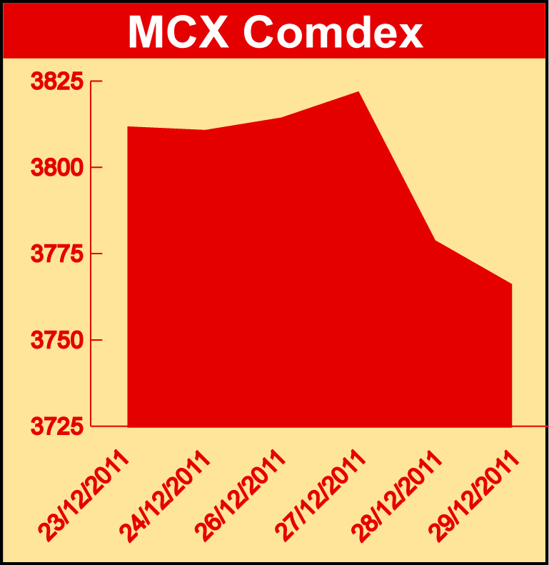

Bullion:
Gold February 12 contract was down by 3.11% to Rs 26836.00 per 10 grams, goldM January 12 contract was down by 3.22% to Rs 26666.00 per 10 grams, goldguinea December 11 contract was down by 3.65% to Rs 21206.00 per 8 grams GoldPetal December 11 contract was down by 3.33% to Rs 2668.00 per grm and GoldPetalDel January 12 contract was down by 2.81% to Rs 2702.00 per grm. Silver March 12 contract was down by 5.06% to Rs 50218.00 per kg, SilverM February 12 contract was down by 5.07% to Rs 50240.00 per kg and silverMIC February 12 contract was down by 5.07% to Rs 50248.00 per kg.

Metals
Lead December 11 contract was up by 0.72% to Rs 105.60 per kg, lead mini December 11 contract was up by 0.72% to Rs 105.60 per kg while nickel December 11 contract was down by 1.72% to Rs 969.30 per kg, copper February 12 contract was down by 0.15% to Rs 400.05 per kg, copperm February 12 contract was down by 0.17% to Rs 399.95 per kg zinc February 12 contract was down by 1.30% to Rs 98.75 per kg, zinc mini January 12 contract was down by 0.96% to Rs 98.20 per kg, aluminium December 11 contract was down by

0.38% to Rs 105.10 per kg and alumini December 11 contract was down 0.38% to Rs 105.10 per kg.

Energy
Crude oil January 12 contract was up by 0.68% to Rs 5304.00 per barrel while Natural gas January 12 contract was down by 3.82% to Rs 163.60 per MMBTU.

Agriculture:
Guarseed January 12 contract was up by 8.11% to Rs 7155.00 per 100 kgs, CPO December 11 contract was up by 4.96% to Rs 541.60 per 10 kgs, menthaoil February 12 contract was up by 0.74% to Rs 1311.50 per kg, cardamom February 12 contract was up by 2.25% to Rs 627.10613.30 per kg, cotton January 12 contract was up by 5.56% to Rs 17080.00 per bales, sugar January 12 contract was up by 0.97% to Rs 2907.00 per 100 kgs, potato March 12 contract was up by 2.45% to Rs 643.90 per 100 kgs, potatoTRWR March 2012 contract was up by 1.52% to Rs 527.50 per 100 kgs and kapas March 12 contract was up 10.23% to Rs 834.10 per 20 kgs.

For further information please contact:

 | Alok Gupta  AVP, Corporate Communication,  Phone No.: +91 22 6731 8888  Mobile No.: +91 9930267906  Email: alok.gupta@mcxindia.com

Disclaimer:
Multi Commodity Exchange of India Limited is proposing, subject to market conditions and other considerations, a public offer of equity shares by way of an offer for sale and has filed a Draft Red Herring Prospectus ("DRHP") with the SEBI. The DRHP is available on the websites of SEBI at www.sebi.gov.in and the book running lead managers at www.edelcap.com, http://www.online.citibank.co.in/rhtm/citigroupglobalscreen1.htm and www.morganstanley.com/indiaofferdocuments. Investors should note that investment in equity shares involves a high degree of risk and for details in relation to risk factors, please see the section titled "Risk Factors" in the DRHP.

This advertisement may not be published or distributed in the U.S., Canada or Japan and is not an offer or solicitation of an offer for sale of securities in the U.S. These securities have not been and will not be registered under the U.S. Securities Act of 1933, as amended, and may not be offered or sold in the U.S. absent registration or an exemption from registration under such act.

