Weekly Market Report (December 09, 2011 – December 15, 2011)

MCX – COMDEX

Open: 3833.98 High: 3891.47 Low: 3698.73 Close: 3716.03 Previous close: 3835.42

MCX Comdex was down by 3.11% to 3716.03, MCX Energy was down by 2.83% to 3448.37 and MCX Metal was down by 4.23% to 4729.27.

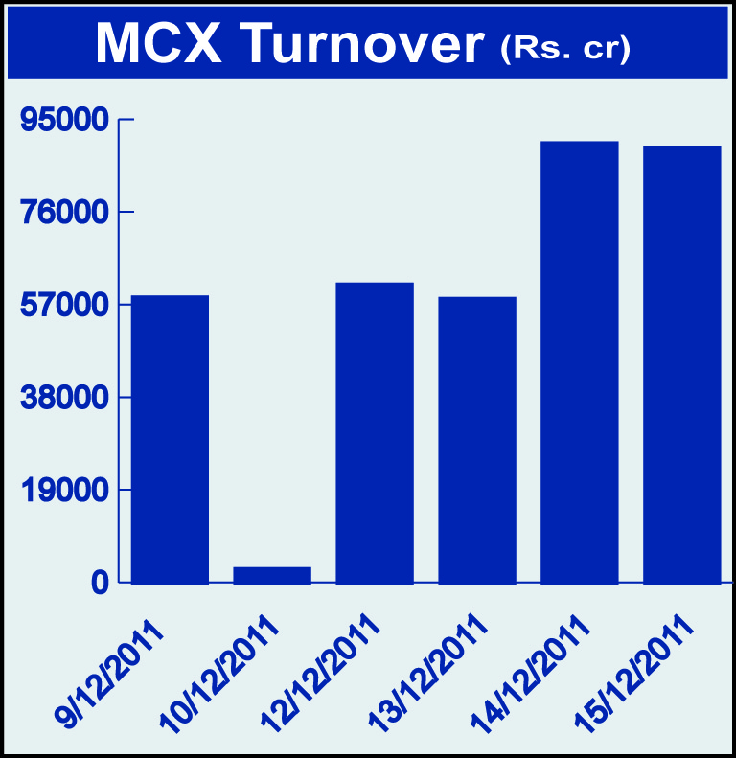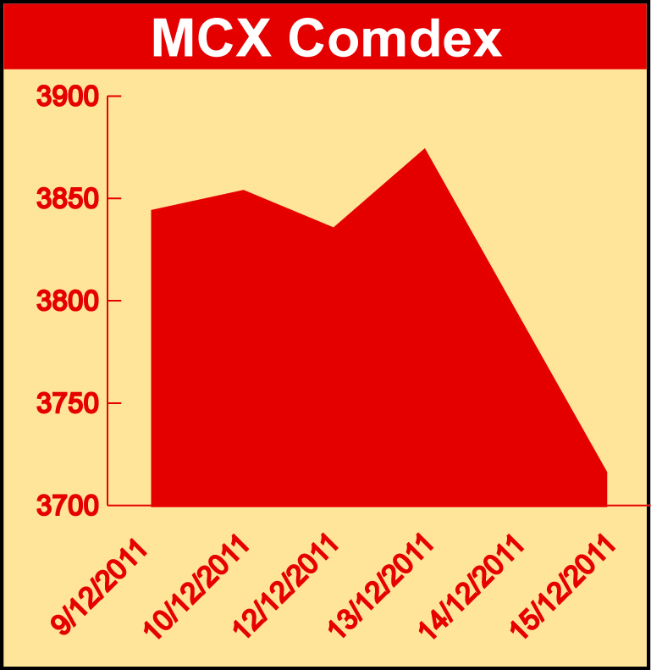

Bullion:
Gold February 12 contract was down by 5.38% to Rs 27531.00 per 10 grams, GoldM February 12 contract was down by 5.37% to Rs 27539.00 per 10 grams, Goldguinea December 11 contract was down by 5.34% to Rs 21894.00 per 8 grams, GoldPetal December 11 contract was down by 5.33% to Rs 2751.00 per grm and GoldPetalDel December 11 contract was down by 6.01% to Rs 2722.00 per grm. Silver March 12 contract was down by 4.68% to Rs 53604.00 per kg, SilverM February 12 contract was down by 4.71% to Rs 53612.00 per kg, SilverMIC February 12 contract was down by 4.73% to Rs 53614.00 per kg and Platinum December 11 contract was down by 6.82% to Rs 2500.50 per grm.

Metals
Nickel December 11 contract was up by 1.27% to Rs 962.40 per kg while lead February 12 contract was down by 3.60% to Rs 107.20 per kg, lead mini February 12 contract was down by 3.11% to Rs 107.40 per kg, copper February 12 contract was down by 3.83% to Rs 390.70 per kg, aluminium December 11 contract was down by 1.62% to Rs 106.15 per kg, alumini December 11 contract was down 1.67% to Rs 106.10 per kg, zinc February 12 contract was down by 4.70% to Rs 101.45 per kg and zinc mini December 11 contract was down by 3.72% to Rs 99.70 per kg.

Energy
Crude oil December contract was down by 2.31% to Rs 5036.00 per barrel and Natural gas December 11 contract was down by 7.40% to Rs 168.90 per MMBTU.

AGRICULTURE:
Sugar December 11 contract was up by 1.10% to Rs 2951.00 per 100 kgs, menthaoil February 12 contract was up by 0.83% to Rs 1290.70 per kg while CPO January 12 contract was down by 0.89% to Rs 513.70 per 10 kgs, cardamom December 11 contract was down by 10.32% to Rs 533.80 per kg, cotton January 12 contract was down by 2.49% to Rs 16460.00 per bales, kapas March 12 contract was down by 0.645 to Rs 712.50 per 20 kgs, potato March 12 contract was down by 0.78% to Rs 623.10 per 100 kgs and potatoTRWR March 12 contract was down by 0.02% to Rs 524.70 per 100 kgs.

For further information please contact:

 | Alok Gupta  AVP, Corporate Communication,  Phone No.: +91 22 6731 8888  Mobile No.: +91 9930267906  Email: alok.gupta@mcxindia.com

Disclaimer:
Multi Commodity Exchange of India Limited is proposing, subject to market conditions and other considerations, a public offer of equity shares by way of an offer for sale and has filed a Draft Red Herring Prospectus ("DRHP") with the SEBI. The DRHP is available on the websites of SEBI at www.sebi.gov.in and the book running lead managers at www.edelcap.com, http://www.online.citibank.co.in/rhtm/citigroupglobalscreen1.htm and www.morganstanley.com/indiaofferdocuments. Investors should note that investment in equity shares involves a high degree of risk and for details in relation to risk factors, please see the section titled "Risk Factors" in the DRHP.

This advertisement may not be published or distributed in the U.S., Canada or Japan and is not an offer or solicitation of an offer for sale of securities in the U.S. These securities have not been and will not be registered under the U.S. Securities Act of 1933, as amended, and may not be offered or sold in the U.S. absent registration or an exemption from registration under such act.

