Weekly Market Report (March 16, 2012 –March 22, 2012)

MCX – COMDEX
Open: 3937.47 High: 3968.28 Low: 3913.77 Close: 3920.56 Previous close: 3932.59

MCX Comdex was down by 0.31% to 3920.56, MCX Energy was up by 1.15% to 3427.98 and MCX Metal was down by 1.18% to 4895.68.

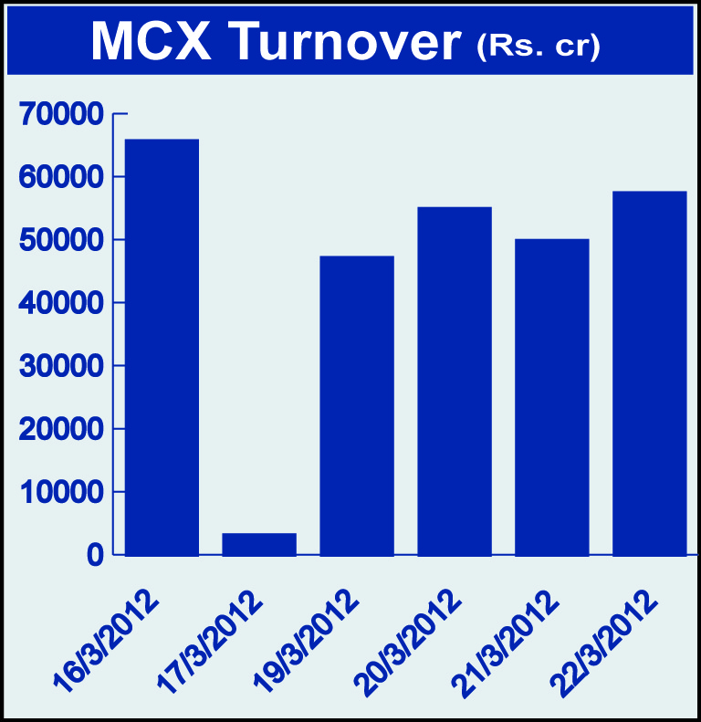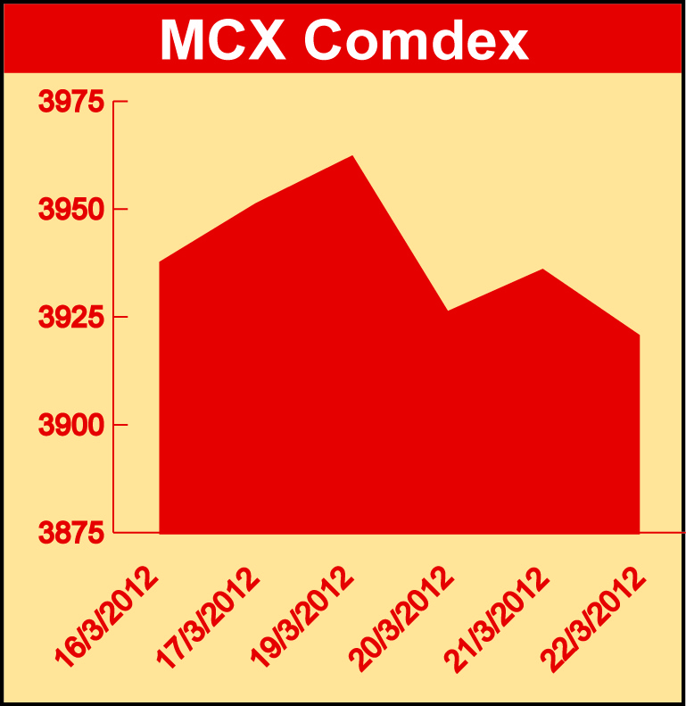

Bullion:
Gold April 12 contract was up by 0.75% to Rs 27913.00 per 10 grams, goldM May 12 contract was up by 0.68% to Rs 28140.00 per 10 grams, goldguinea May 12 contract was up by 0.72% to Rs 22682.00 per 8 grams GoldPetal May 12 contract was up by 0.57% to Rs 2839.00 per grm and GoldPetalDel April 12 contract was up by 0.66% to Rs 2888.00 per grm. Silver May 12 contract was down by 2.89% to Rs 56302.00 per kg, SilverM April 12 contract was down by 2.88% to Rs 56326.00 per kg and silverMIC April 12 contract was down by 2.87% to Rs 56333.00 per kg.

Metals
Copper April 12 contract was down by 1.08% to Rs 429.90 per kg, copperm April 12 contract was down by 1.07% to Rs 429.90 per kg, alumini March 12 contract was down 1.39% to Rs 110.20 per kg, aluminium March 12 contract was down by 1.43% to Rs 110.20 per kg, lead mini March 12 contract was down by 4.13% to Rs 102.25 per kg, lead March 12 contract was down by 4.17% to Rs 102.20 per kg, zinc March 12 contract was down by 2.63% to Rs 101.90 per kg, zinc mini March 12 contract was down by 2.63% to Rs 101.90 per kg, nickelm March 12 contract was down by 2.92% to Rs 946.40 per kg and nickel March 12 contract was down by 2.91% to Rs 946.40 per kg.

Energy
Natural gas March 12 contract was up by 2.25% to Rs 118.10 per MMBTU, BRcrudeoil April 12 contract was up by 1.52% to Rs 6330.00 per barrel and crude oil April 12 contract was up by 1.21% to Rs 5418.00 per barrel.

Agriculture:
Cardamom May 12 contract was up by 7.77% to Rs 1287.90 per kg while potato May 12 contract was down by 8.39% to Rs 1133.70 per 100 kgs, potatoTRWR May 12 contract was down by 3.88% to Rs 988.90 per 100 kgs, CPO May 12 contract was down by 1.41% to Rs 574.90 per 10 kgs, menthaoil March 12 contract was down by 5.63% to Rs 2090.30 per kg, cotton March 12 contract was down by 0.60% to Rs 16630.00 per bales, sugar May 12 contract was down by 1.50% to Rs 2820.00 per 100 kgs and kapas April 12 contract was down by 1.63% to Rs 828.60 per 20 kgs.

For further information please contact:

 | Alok Gupta  AVP, Corporate Communication,  Phone No.: +91 22 6731 8888  Mobile No.: +91 9930267906  Email: alok.gupta@mcxindia.com

