Weekly Market Report (October 21, 2011 – October 27, 2011)

MCX – COMDEX

Open: 3416.60 High: 3670.56 Low: 3416.60 Close: 3667.13 Previous close: 3415.79

MCX Comdex was up by 7.36% to 3667.13, MCX Metal was up by 9.80% to 4852.05 and MCX Energy was up by 6.59% to 3215.63.

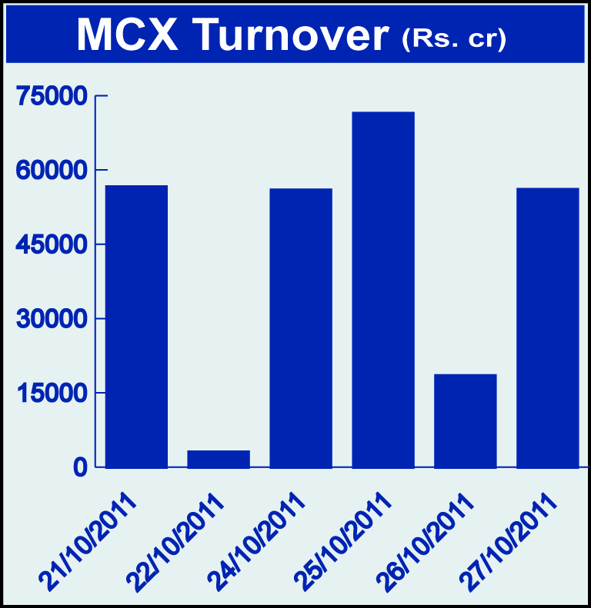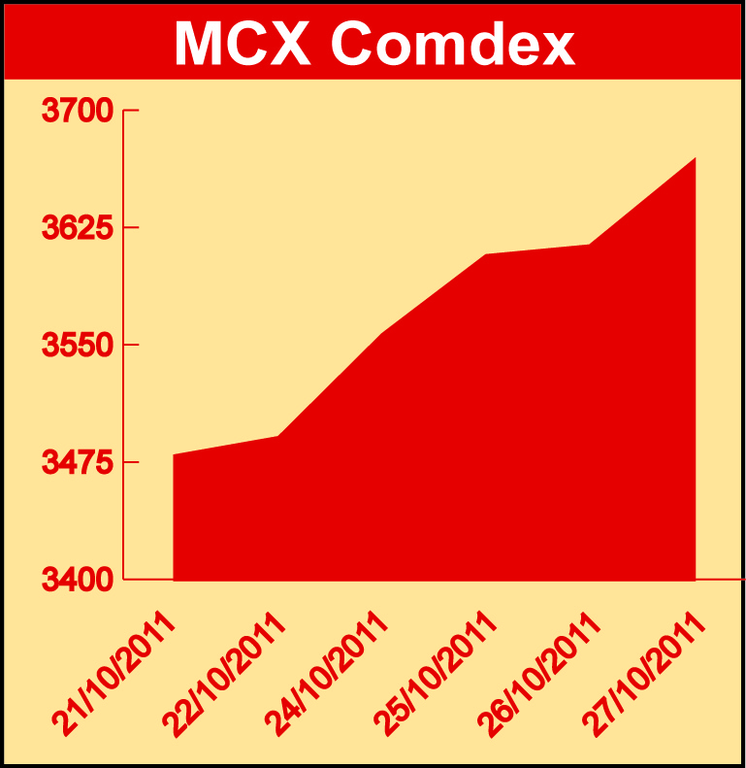

Bullion:
Gold December 11 contract was up by 5.70% to Rs 27848.00 per 10 grams, GoldM December 11 contract was up 5.65% to Rs 27849.00 per 10 grams, Goldguinea November 11 contract was up by 5.26% to Rs 22258.00 per 8 grams and GoldPetal November 11 contract was up by 5.13% to Rs 2808.00 per grm. Silver December 11 contract was up by 11.91% to Rs 57859.00 per kg, SilverM November 11 contract was up by 11.88% to Rs 57877.00 per kg and SilverMIC November 11 contract was up by 11.86% to Rs 57882.00 per kg.

Metals
Copper November 11 contract was up by 17.39% to Rs 402.00 per kg, lead October 11 contract was up by 10.87% to Rs 98.95 per kg, lead mini October 11 contract was up by 10.75% to Rs 98.90 per kg, zinc November 11 contract was up by 8.53% to Rs 95.40 per kg, zinc mini October 11 contract was up by 8.57% to Rs 94.35 per kg, tin October 11 contract was up by 1.00 to Rs 1080.75 per kg, aluminium December 11 contract was up by 5.47% to Rs 111.90 per kg, alumini October 11 contract was up 4.92% to Rs 109.85 per kg and nickel November 11 contract was up by 7.55% to Rs 983.20 per kg.

Energy
Crude oil November 11 contract was up by 7.08% to Rs 4595.00 per barrel while natural gas November 11 contract was down by 2.49% to Rs 188.10 per MMBTU.

AGRICULTURE:
Sugar November 11 contract was up by 0.47% to Rs 2788.00 per 100 kgs, CPO November 11 contract was up by 2.78% to Rs 480.40 per 10 kgs, cotton October 11 contract was up by 1.86% to Rs 19190.00 per bales while menthaoil October 11 contract was down by 4.54% to Rs 1264.70 per kg, potatoTRWR November 11 contract was down by 3.14% to Rs 330.00 per 100 kgs and cardamom November 11 contract was down by 1.65% to Rs 695.80 per kg.

For further information please contact:

 | Alok Gupta  Sr. Manager, Corporate Communication, MCX  Phone No.: +91 22 6731 8888  Mobile No.: +91 9930267906  Email: alok.gupta@mcxindia.com

Disclaimer:
Multi Commodity Exchange of India Limited is proposing, subject to market conditions and other considerations, a public offer of equity shares by way of an offer for sale and has filed a Draft Red Herring Prospectus ("DRHP") with the SEBI. The DRHP is available on the websites of SEBI at www.sebi.gov.in and the book running lead managers at www.edelcap.com, http://www.online.citibank.co.in/rhtm/citigroupglobalscreen1.htm and www.morganstanley.com/indiaofferdocuments. Investors should note that investment in equity shares involves a high degree of risk and for details in relation to risk factors, please see the section titled "Risk Factors" in the DRHP.

This advertisement may not be published or distributed in the U.S., Canada or Japan and is not an offer or solicitation of an offer for sale of securities in the U.S. These securities have not been and will not be registered under the U.S. Securities Act of 1933, as amended, and may not be offered or sold in the U.S. absent registration or an exemption from registration under such act.

