**Key to the Highway: The changing face of high and low touch execution**

**This paper looks at high and low touch trading in capital markets and how they are morphing to meet the practical realities of participants today. First impressions show them diverging with low touch getter lower and high touch more complicated, but this is masking a more subtle shift. One that, if harnessed properly, can enable brokers to operate on a cost basis that reflects the new normal of today but, at the same time, exceed expectations when it comes to client execution.**

**Here, Steve Grob, Director of Group Strategy at Fidessa, examines how a combination of convergence and divergence is transforming the traditional approach to sell-side trading technology and starting to bring it into line with the convenience and efficiency we take for granted in our daily digital lives.**

**Crossroad Blues**

In the beginning there was high touch. This phrase defined the relationship between the investment manager and his broker – constant communication by phone and face- to-face as the broker provided a high value, solution-based approach to finding the liquidity that (invariably) his client was looking for.

For many years this worked as the fees charged and passed down the line were high and scrutiny over what end investor trading commissions were actually funding remained vague.

As markets electronified, and the buy-side tooled up their own operations, a new paradigm was born – low touch. This reflected the buy-side's growing desire for cheaper execution, especially when they were putting on trades that actually weren’t that hard to execute. It also offered a path that minimised any information leakage and gave them more control over the whole process.

So brokers now offered two routes to market, but with very different price tags. The problem, though, was that brokers had to duplicate their trading infrastructure and yet were receiving fewer net commission dollars. This spawned the short-lived concept of mid touch which, like any compromise, offered the worst of both worlds. Junior sales traders that had neither the experience nor the technical acumen to manage either a high or a low touch environment.

Today the industry is at a cross-roads. Regulation, combined with the lingering global economic malaise, means that the idea of providing separate high and low touch channels is even more flawed than ever. What is needed is a radical new approach that converges technology stacks where this makes sense and yet equips brokers to provide a blended service of premium (high touch) and standard (low touch) services. Moreover, the buy-side needs to be able to switch seamlessly between the two, not just over the trading day but within the lifecycle of each individual order.

**Hellhound on my Trail**

The impact of regulation on capital markets still has a long way to go. While the so- called "punishment agenda" seems to have abated for now, there is no let-up in regulators' desire to increase transparency and accountability at every stage of the trade lifecycle. The best example of this is the European move to unbundle the previously adhesive relationship between the provision of research and the fees generated from trading execution. The new rules will force investment managers to either pay for research out of their own P&L or ensure that any payments of execution commission are clearly not to the detriment of their end investors. The other side of this regulatory coin is a renewed focus on best execution. While this is a nebulous concept at best, any sell–side that cannot clearly demonstrate its executional prowess will be at a severe disadvantage moving forwards. This is just one example of how the old style "relationship- based" approach to client management will not work anymore. Other regulations in Europe and around the world mean that this relationship needs to be clearly auditable and proactively transparent. But the technology investment required for both high and low touch services comes at a time when neither can really justify it on purely economic grounds.

And it is not as if the job of finding liquidity is getting any easier. For illiquid names IOIs seemed to be the solution to finding those enchanted blocks but, in most cases, they did just the opposite and simply dialed up the noise to signal ratio. As order and trade sizes have shrunk further, this problem has got worse and has spawned a number of new initiatives (most recently by the venues themselves). So now we have a range of intraday auctions, block crossing capabilities and other matériel, all of which aim to bulk up liquidity and make one venue the first port of call over another. Individually all these approaches have great merit, but collectively they only serve to complicate the block liquidity journey still further.

**Change my Way**

The good news is that resolving this complexity is something the buy-side will pay for but it requires a very different type of approach from the traditional high touch/low touch separation of old. The fragmentation of equities trading means that even a relatively low touch order in a liquid stock will need to visit tens of different venues in order to be properly executed. Low touch platforms therefore need to stretch across many different venues and so the challenge to create a single market access fabric is considerable. On top of this, sophisticated low touch algorithms need to be created that can nullify the effects of this fragmentation so as to provide good execution outcomes for clients.

Today’s high touch trader needs a range of technology too, especially to find out where the bodies are buried in today's more complicated liquidity environment. This might be through dark-seeking algos, smart routing that looks across the new block order types emerging at venues or CRM systems that track who is holding or likely to be holding liquidity. The high touch desk will often look at the automation and tools employed by the low touch or program trading teams for inspiration, and, in some cases, borrow their technology directly.

So while the activities and business models of high and low touch might be diverging the underlying technologies are actually converging. This creates an interesting dichotomy that requires careful management so that unnecessary duplication is avoided and yet the very different business service a high or low touch client receives is optimised.

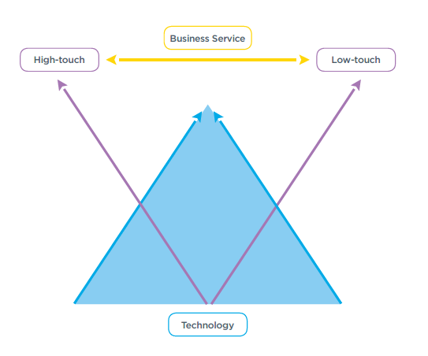

Solving this requires a bit of lateral thought. The starting point is to stop thinking about divergent high and low touch service lines and, instead, consider the technology underpinning them. This, then, allows a standard (low touch) and a premium (high touch) service to be interlinked and share resources. The next step is to view the separation between these two as a permeable membrane though which orders can travel in either direction. Naturally this will be at the discretion of the end client, but really all that separates the two is the higher fee charged whenever the order is in the high touch/premium service zone.

**Smokestack Lightning**

It is a simple fact that low touch service lines were established after high touch ones and so this inevitably led to the creation of a whole new technology stack. Often the reasons given for this were that faster market access was required or that broader market coverage was needed. In some cases it was just that shinier, newer technology was available. Either way the net result was a new set of market gateways, a super-lite OMS that could support low touch algos and a FIX interface for receiving client order flow. But, by then, the high touch desk was receiving the bulk of their orders electronically too and, of course, sending them out to market the same way.

A more sensible approach today, then, is to collapse all those pieces of technology that support the standard service level – market access, algo frameworks and FIX-based client connectivity. This enables more effort to be put into market and asset class coverage, performance, speed and resilience. Naturally this is to the benefit of both service lines. This simple approach can be extended to other desks too, such as program trading, and even between asset classes or completely separate business units.

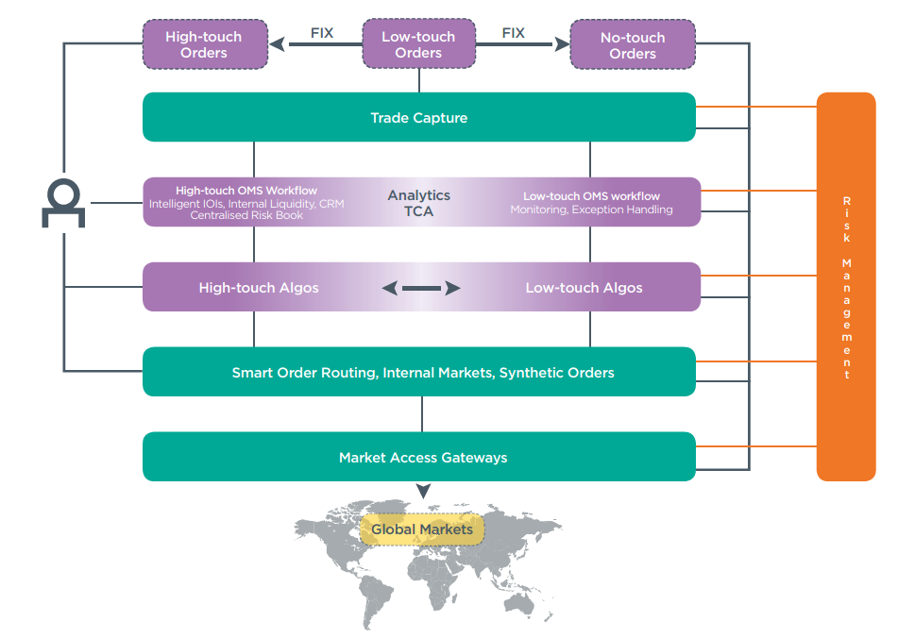

**Cross Cut Saw**

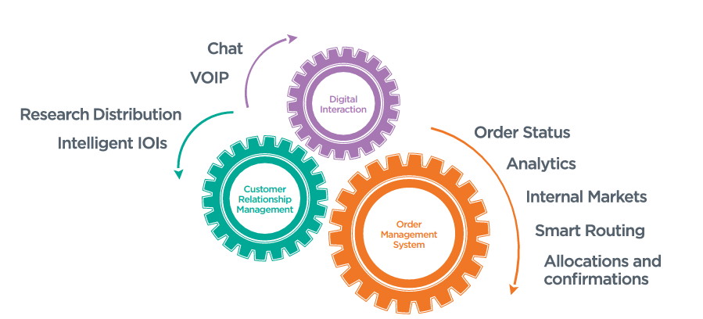The premium zone is where the real differentiating technology can be found, but because it is now sitting on a converged stack its operational costs are much lower. And so now resource is freed up to deploy cool high touch tools that mean no liquidity problem remains unsolved for long.

Intelligent IOIs are one way to do this, but only if they can be underwritten by genuine merchandise. Another will be pulling together all the information held within a firm about a particular stock. Other decision support tools will all form part of a more sophisticated, but above all technology-fueled, high touch service.

This then allows for some intriguing approaches to solving trading problems for clients. One example is that an investment manager may be using a low touch channel simply to minimise his execution cost. It may be, however, that a smart IOI has uncovered a large block in the same stock over in the high touch world. Provided the client has allowed this to be shared, it's now easy to communicate the block opportunity and execute if necessary.

So, what this is leading to is a blending of how client orders navigate these two different worlds. Naturally a more sophisticated charging regime will be required, but this should be to the benefit of both the buy- and the sell-side as it’s a true reflection of the actual execution difficulty involved.

**This is Hip**

Our digital lives are all about choice and, more importantly, being able to make that choice on an increasingly granular, flexible and mobile basis. Suppliers are geared up to meet our needs in nearly every dimension, including cost, time, location and volume. The increased complexity of our daily lives would seem unmanageable otherwise and so we take such tools for granted.

In contrast, the terms high touch and low touch seem clunky and outdated and are simply too crude a reflection of the practical realities of trading in capital markets today. They might well be part of the lexicon of our industry but they imply a separation of technology that simply doesn't have to be there. Not only does this ratchet up cost but it also contributes to poorer execution outcomes for clients.

While it is true that the spectrum of trading challenges is getting broader, truly effective trading is about allowing clients to blend a range of different services in order to meet their needs in much the same way as we consume anything in our personal lives.

Firms that are implementing the blended approach described here will be able to dominate liquidity in their chosen areas. What's more they will operate at lower costs whilst providing a more valuable service to clients.

They really will have the key to the highway.