DFM Performance – September 2013

The Dubai Financial Market General Index up 9.5% to 2762.5 points at the end of September compared to 2523.1points at the end of August. At the sectoral level, indexes of six out of the nine sectors represented on DFM ended the month in the green, with the Services sector increasing the most by 17.6%, followed by the Banking sector by 11.9%, and the Real Estate and Construction sector by 11.5%. The Industrial sector down 12.9%, the Consumer Staples index down 9.9% followed by Telecommunication sector by 3.4%.

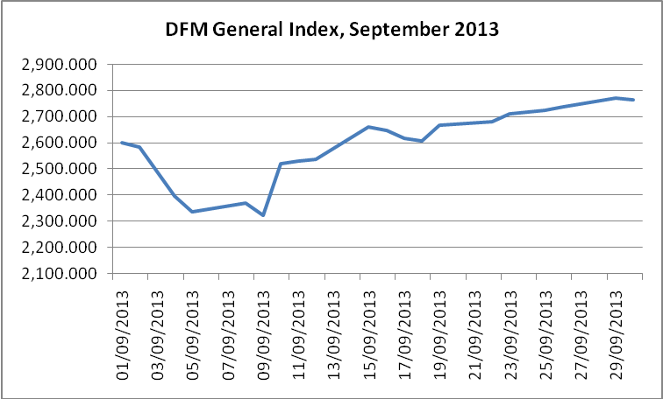

The market capitalization increased at the end of this month by 7% amounting to AED 249.1 billion compared to AED 232.8 billion at the end of previous month. The value of shares traded reached during this month AED 21.651 billion, compared to AED 14.929 billion recorded during August, up by 45%. The number of shares traded up by 86.7% to reach 21.553 billion shares during this month compared to 11.546 billion shares were traded during August. The number of transactions executed during September increased by 59.1% to reach 181.2 thousands compared to 113.9 thousand deals carried out during the previous month.

As for the sectors’ contribution to trading volumes, the Real Estate and Construction sector ranked first in terms of the traded value, to reach AED 11.295 billion, or 52.2% of the total traded value in the market. The Banking sector ranked second at AED 3.125 billion or 14.4%, followed by the Financial & Investment services sector with AED 2.251 billion or 10.4%, the Transportation sector with AED 2.224 billion or 10.3%, the Services sector with AED 2.114 billion or 9.8%, the Insurance sector with AED 356.3 million or 1.6%, the Telecommunication sector with AED 285.2 million or 1.3%, while the other sectors shared the rest of trading values.

The value of stocks bought by foreign investors during this month reached AED 8.786 billion comprising 40.6% of the total traded value. The value of stocks sold by foreign investors during the same period reached AED 8.942 billion comprising 41.3% of the total value traded. Accordingly, DFM net foreign investment out-flow reached AED 155.6 million.

Trading activity by nationality (September 2013)
 | Value of Stocks Bought - AED | Value of Stocks Sold - AED | Net Investment - AED
Arab | 4,739,942,559 | 4,805,822,755 | (65,880,196)
GCC | 1,752,084,188 | 1,875,888,026 | (123,803,838)
Others | 2,294,338,725 | 2,260,227,984 | 34,110,740
Total Non UAE | 8,786,365,471 | 8,941,938,765 | (155,573,294)
UAE | 12,864,347,712 | 12,708,774,418 | 155,573,294
Grand Total | 21,650,713,183 | 21,650,713,183 | 0

On the other hand, The value of stocks bought by institutional investors during this month reached AED 4.563 billion comprising 21.1% of the total traded value. The value of stocks sold by institutional investors during the same period reached AED 4.378 billion which constitutes 20.2% of the total value traded. DFM net institutional investment in-flow amounted to AED 185.4 million.

Trading activity by client type (September 2013)
 | Value of Stocks Bought - AED | Value of Stocks Sold - AED | Net Investment - AED
Institutions | 4,563,046,852 | 4,377,630,256 | 185,416,596
Individuals | 17,087,666,331 | 17,273,082,927 | (185,416,596)
Total | 21,650,713,183 | 21,650,713,183 | 0

