Attachment for SET Release issue no. 135/2012

SET-listed companies’ performances in Q1/2008-Q3/2012

Unit: THB million

Sales
Net Profit (Loss)

Net profits of the eight industry groups for first nine months of 2012

Unit: THB million
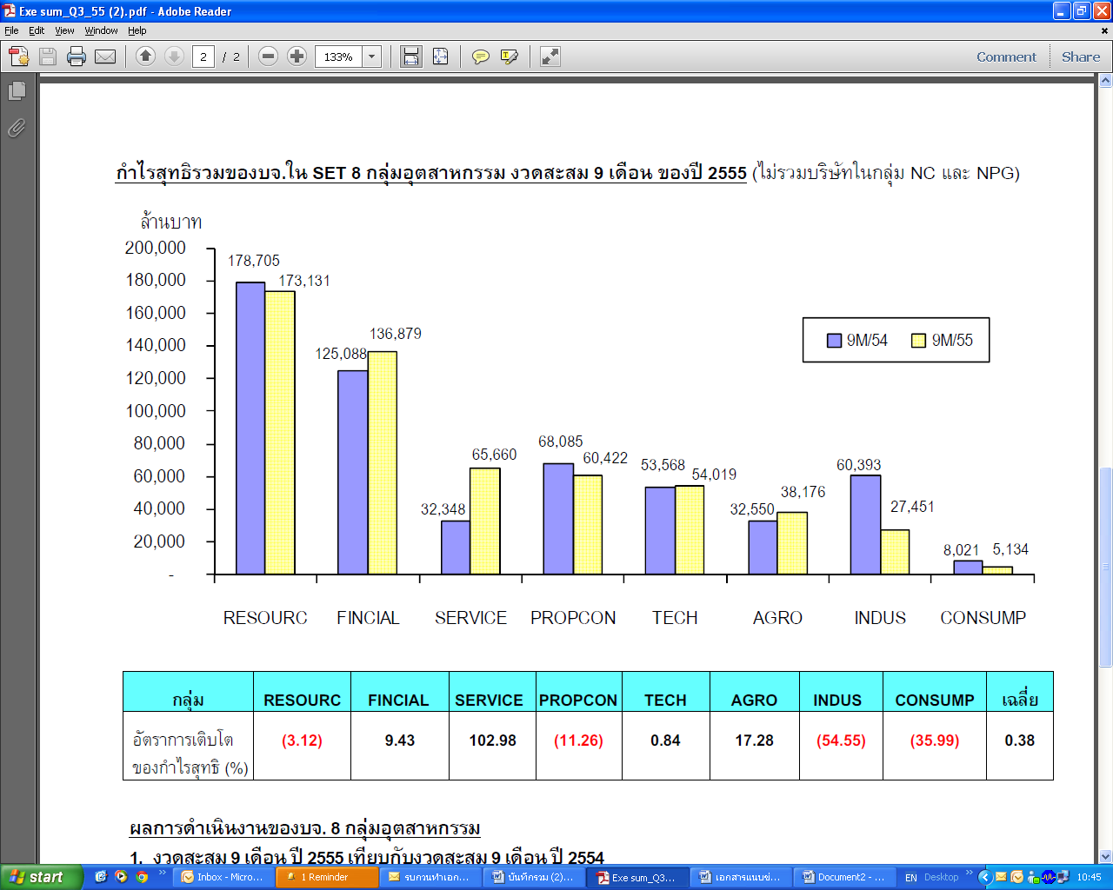
9M/11
9M/12
Million Baht

Industry Group | RESOURC | FINCIAL | SERVICE | PROPCON | TECH | AGRO | INDUS | CONSUMP
NET Profit Growth (%) | (3.12) | 9.43 | 102.98 | (11.26) | 0.84 | 17.28 | (54.55) | (35.99)

Three Sectors making continued growth of profits and sales in the past three quarters of 2012
Sectors | Sales (THB Mil.) |  |  | Net Profit (THB Mil.)
Sectors | Q1/2012 | Q2/2012 | Q3/2012 | Q1/2012 | Q2/2012 | Q3/2012
- Banking | 168,109 | 176,316 | 183,343 | 41,361 | 44,269 | 45,444
- Property Development | 75,648 | 86,478 | 97,230 | 8,616 | 9,341 | 13,228
- Property Fund | 2,029 | 2,144 | 2,271 | 1,523 | 1,774 | 1,923

Top Twenty Listed Firms (excluding non-compliance, non-performing groups, property Fund)
with Largest Net profits, Sale and Assets for the first nine months of 2012

Unit: THB million

