Attachment 1

Attachment for SET Release issue no. 88/2012

SET-listed companies’ performances in Q1/2008-Q2/2012

Unit: THB million

Q2/12

Attachment 2

Net profits of the eight industry groups for H1/2012

Unit: THB million
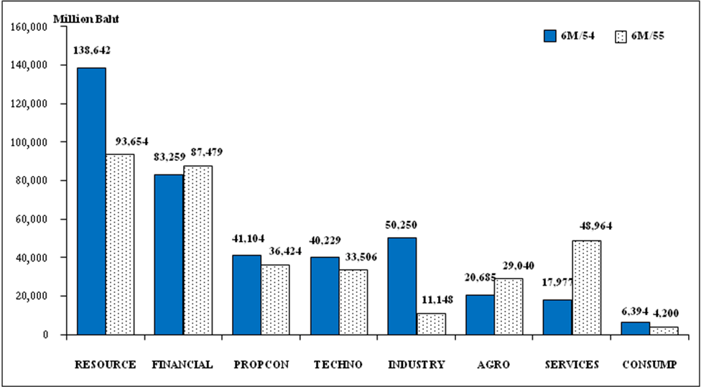
6M/11
6M/12

Industry Group | RESOURCE | FINANCIAL | PROPCON | TECHNO | INDUSTRY | AGRO | SERVICES | CONSUMP
Net profit change (%) | (32.45) | 5.07 | (11.39) | (16.71) | (77.81) | 40.39 | 172.37 | (34.31)

Top Five Most Profitable Sectors for H1/2012

Sectors | Net profit (THB mil.) |  | Growth  (%) | (%) of all listed firms’ net profit | (%) of all  industry's net profits
Sectors | H1/2012 | H1/2011 | Growth  (%) | (%) of all listed firms’ net profit | (%) of all  industry's net profits
Energy & utilities | 93,828 | 138,455 | (32.23) | 27.07 | 100.19
Banking | 85,628 | 73,854 | 15.94 | 24.70 | 97.88
Information&Communication Technology | 29,541 | 35,643 | (17.12) | 8.52 | 88.17
Food and Beverage | 27,742 | 16,247 | 70.75 | 8.00 | 95.53
Property Development | 18,376 | 15,057 | 22.04 | 5.30 | 50.45

Attachment 3

Top Twenty Listed Firms with Largest Net Profits, Sales, and Assets for the first half of 2012

Unit: THB million
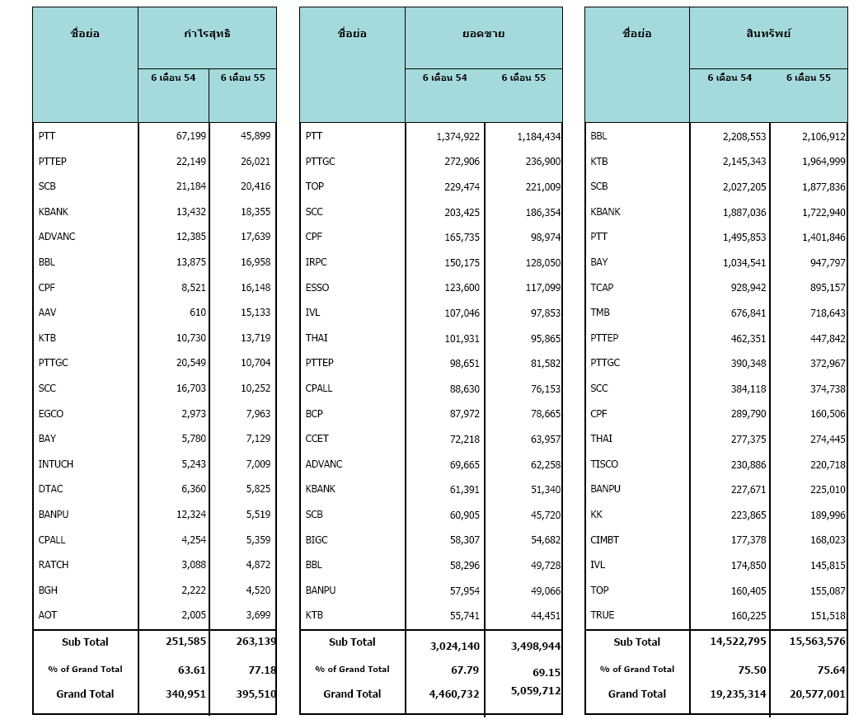
Symbol
Net profit
H1/2011
H1/2012
Symbol
Sales
Symbol
Assets
H1/2011
H1/2011
H1/2012
H1/2012

Attachment 4

Lists of top five highest net profit growth sectors in the second quarter and the first six months of 2012

Top five highest net profit growth sectors in Q2/2012
Sector | Net Profit (THB mln)
Sector | Q2/11 | Q2/12 |  | growth
1. Banking | 35,847 | 44,269 |  | 8,422
2. Information & Communication Technology | 11,212 | 15,025 |  | 3,813
3. Commerce | 6,224 | 7,448 |  | 1,224
4. Property Development | 8,346 | 9,341 |  | 995
5. Food & Beverage | 9,005 | 9,426 |  | 421
Top five highest net profit growth sector in H1/2012
Sector | Net profit (THB mln)
Sector | 6 M/11 | 6 M/12 |  | growth
1. Banking | 73,854 | 85,628 |  | 11,774
2. Food & Beverage | 16,247 | 27,742 |  | 11,495
3. Commerce | 12,142 | 15,764 |  | 3,622
4. Property Development | 15,057 | 18,376 |  | 3,319
5. Health Care Services | 4,440 | 7,477 |  | 3,037

